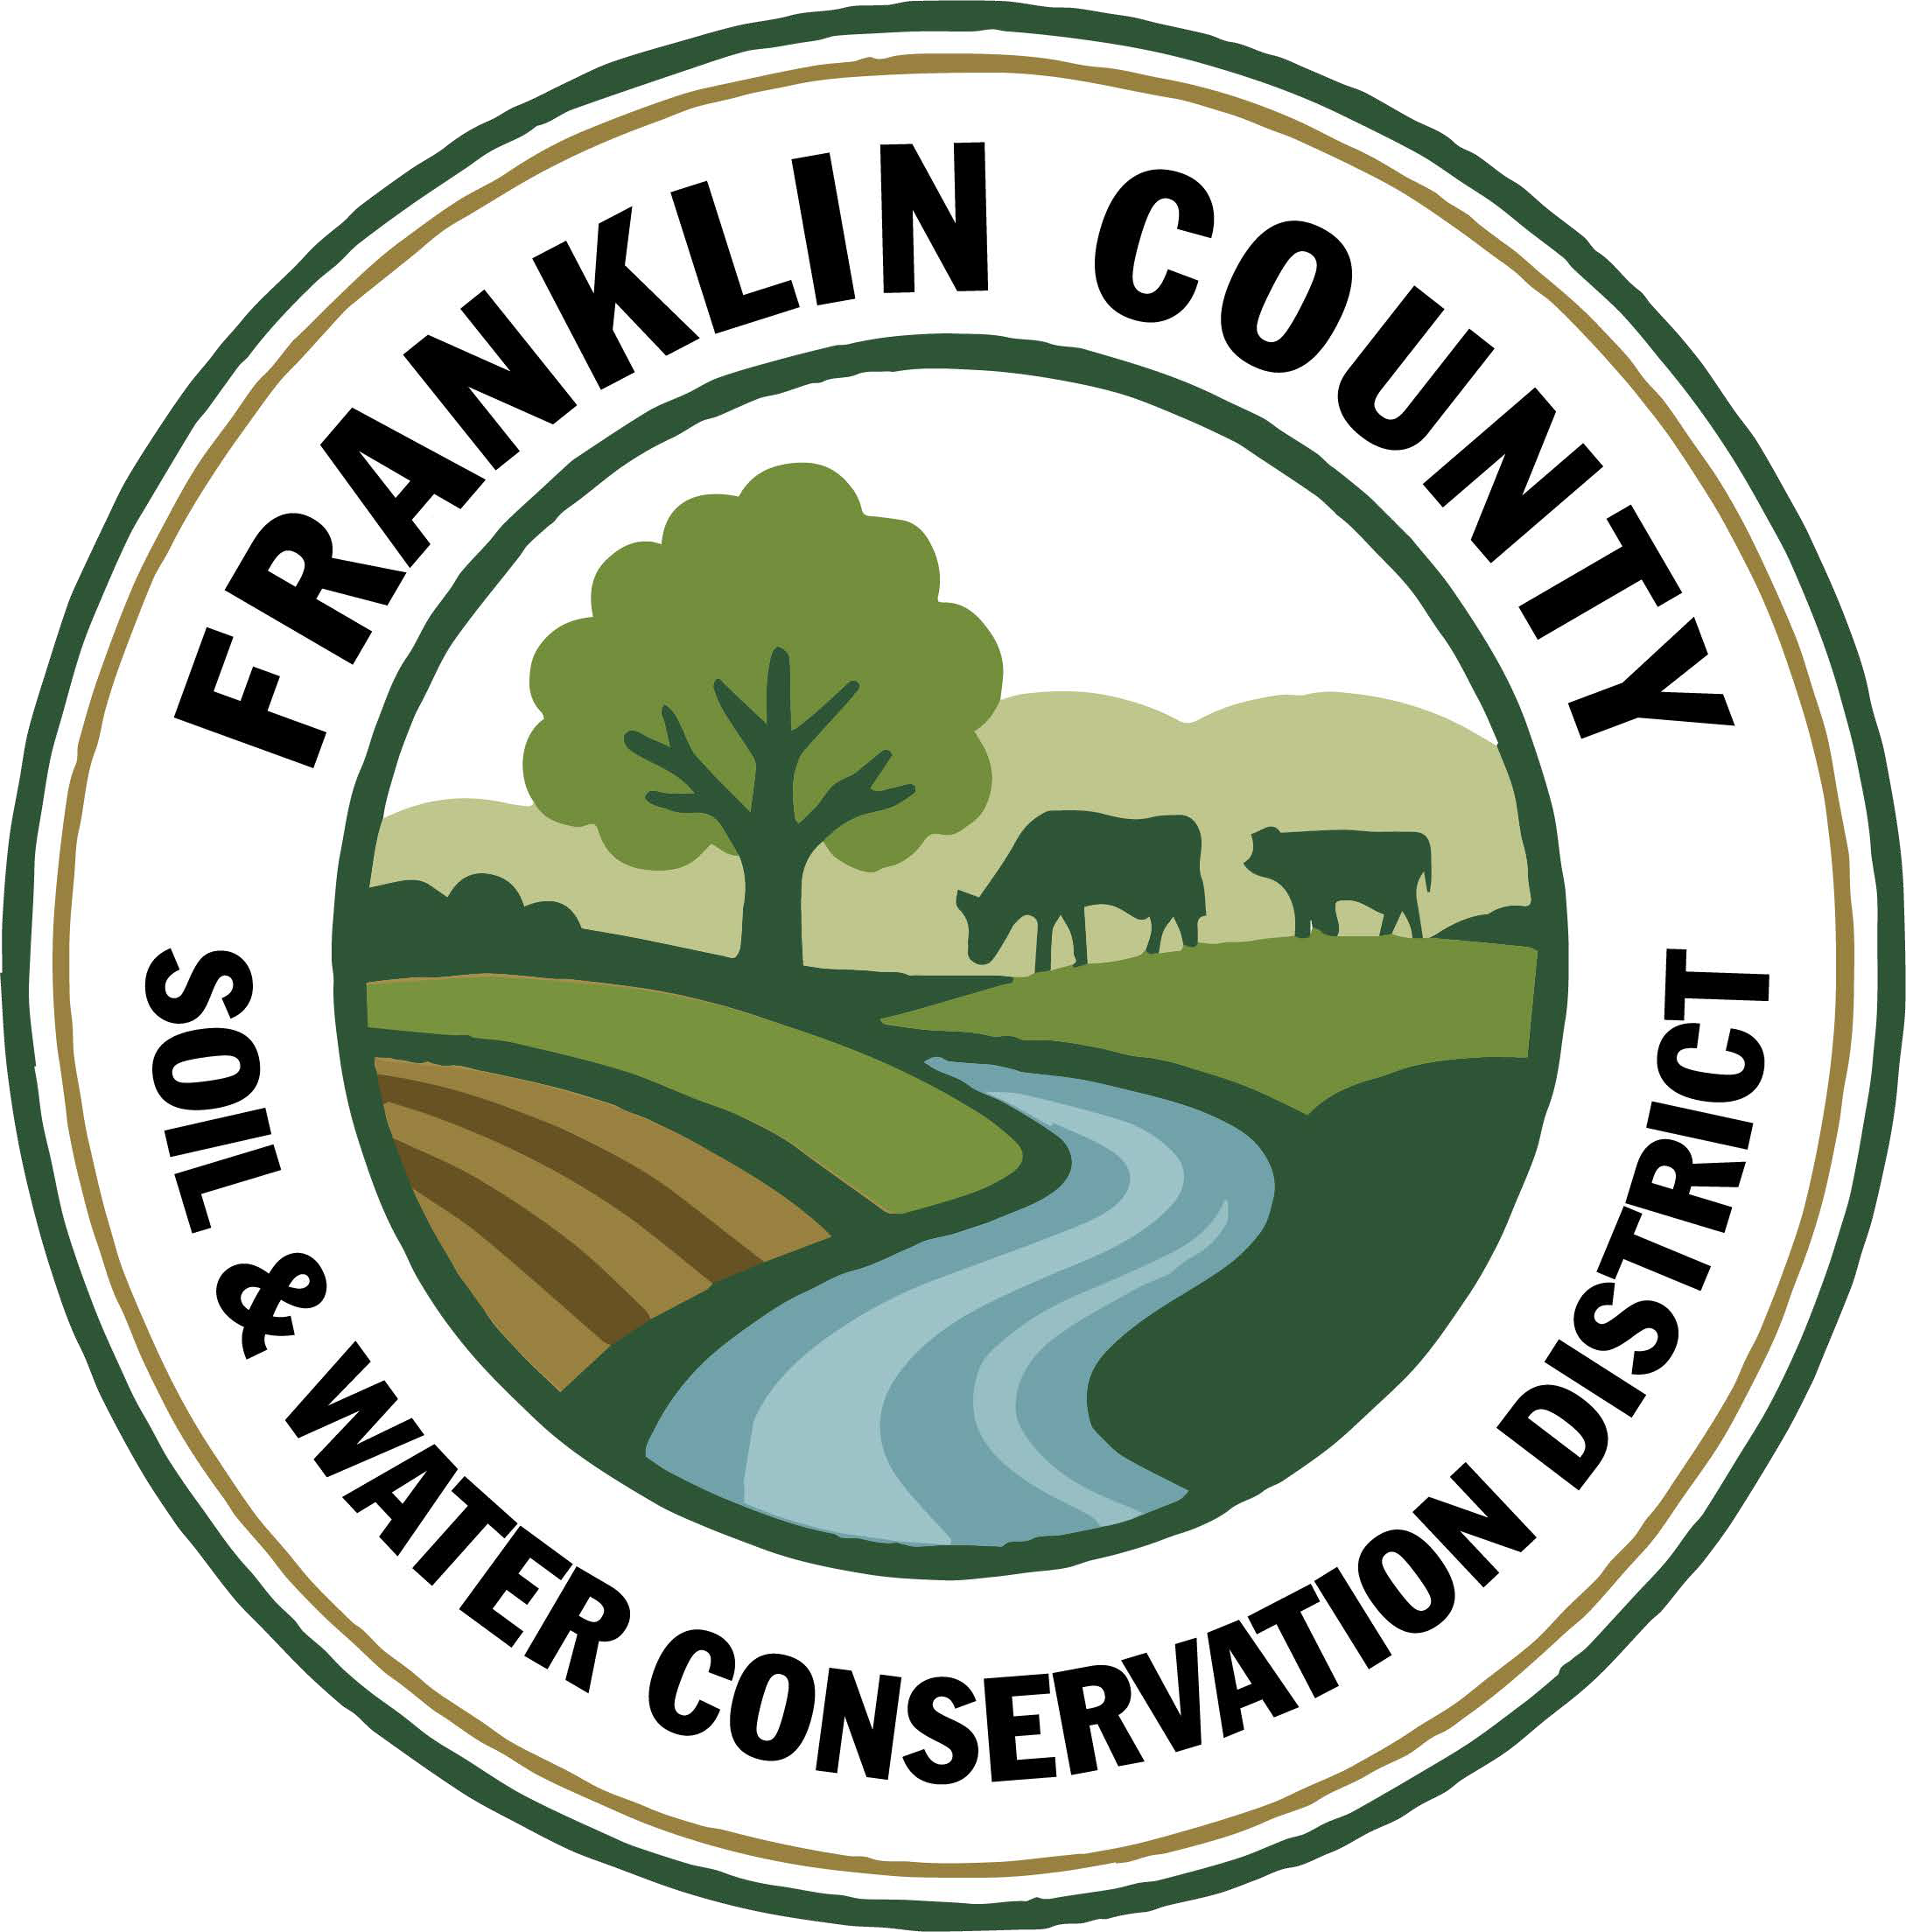
Franklin County Soil and Water Conservation District
174 Finney Blvd
Malone, NY 12953
(518) 651-2097
www.fcswcd.org

ATTENDANCE:
MINUTES OF THE REGULAR MEETING OF THE BOARD OF DIRECTORS June 16th, 2026

Directors:
Ralph Child
Dennis Egan
Tommy Derouchie
Steve Gokey
Jacques DeMars
Andrea Dumas
Rod Lauzon
Staff:
Kristin Ballou
Devin Normandeau
Sarah Otis
Shayla Aubrey
Kelly Freeman
Hannah Manchester
Jeb Shea
Nathan Helmuth

1. Meeting was called to order: Chairman, Ralph Child, called meeting to order at 9:01 AM - Quorum present
2. Approval of May 19th Meeting Minutes: Motion made by Rod Lauzon, 2nd by Dennis Egan. Motion carried.
3. Report of Officers:
- Chairman Report: Occasionally stops in to sign checks
- Board Member Reports: No Reports
- Correspondence: M&T Statement, Grassroots newsletter, NYACD Report, CCE 4-H Donor Form, NACD 2025 Annual Report, NCF 2025 Annual Report, email from Rhonda about Financials
4. Business:
1. Approval to purchase more lumber to build bird/bat houses: Motion made to purchase up to $300 made by Rod Lauzon, 2nd by Dennis Egan. Motion carried.
2. Stormwater Permit Violation Request for Assistance: Motion made to deny, as the District does not have the proper credentials to offer the assistance required, by Andrea Dumas, 2nd by Dennis Egan. Motion carried.
3. Natural Resource Violation Assistance Policy discussion: Motion made to adopt policy from Warren County SWCD made by Steve Gokey, 2nd by Andrea Dumas. Motion carried. Andrea asked if we should also have a Hold Harmless Agreement which we will address at the next meeting, after looking into it.
4. Approval to reimburse towns for Salt Reduction Projects: Motion to approve payment to Town of Bellmont, Town of Constable and Town of Franklin made by Andrea Dumas, 2nd by Rod Lauzon. Motion carried.
5. 2026 Performance Measure review of activities to date: We have completed most of the criteria needed. After our next meeting, that will check off another as complete. The last item is the submission of Annual Plan of Work to be completed in October.
6. Pre-approval of parking lot expenses: Towns of Franklin and Chateaugay are fixing our driveway/parking lot. They are not charging for equipment or labor. Stone base to be provided by the Town of Chateaugay. Motion to approve expenses for binder, topcoat, drainage pipe & fittings up to $20,000 made by Steve Gokey, 2nd by Dennis Egan. Motion carried.
7. 2027 Budget & Part C discussion: We were able to lower a few budget lines since we have changed companies for our printer, lawn care and snow removal. Other areas had to be raised due to rising costs, like propane, fuel, employee training & travel, & postage. Andrea suggested trying to get a better price for our insurance by working with the county. We kept salary for two conservation student aide positions as Jeb & Hannah have been invaluable this year. Part C funding has an increase for staff time, Salt Reduction Program and Tire Recycling Program, and a decrease for Backyard Biodiversity Bonus.
8. Backyard Biodiversity Bonus applications for approval: Motion made to approve Loon Lake Homeowner Community Association by Dennis Egan, 2nd by Steve Gokey. Motion carried.
9. Credit card rewards: FNBO offers reward points for purchases that can be redeemed for gift cards to various stores/restaurants. Discussion to determine which gift cards to purchase with points. Motion made for staff to use their own discretion by Jacques DeMars, 2nd by Rod Lauzon. Motion carried.
10. Building Maintenance Bids: Provided an update on the status of the bids. We have received 2 and are waiting for a third before a motion can be made. Tabled until the next meeting.
11. Approval to have the 2018 Chevrolet transmission fluid changed and serpentine belt serviced by Franklin County Highway Dept. Garage: Motion made by Steve Gokey, 2nd by Rod Lauzon. Motion carried.
12. Approval to reimburse Shipman Farm $20,928.38 for manure injection through CRF 8: Motion made by Steve Gokey, 2nd by Dennis Egan. Motion carried.

5. Financials:
a. Approval to transfer $1,500 from Building Fund account to Checking account: Payment to Northern Seamless Gutters made from Checking account as Building Fund is savings account. Motion made by Rod Lauzon, 2nd by Dennis Egan. Motion carried.
b. Approval to transfer $4,769.24 from CWICNY Coordinator account to Checking account for May 29, June 5, June 12, June 19 payrolls: Motion made by Rod Lauzon, 2nd by Dennis Egan. Motion carried.
c. Tupper Lake School Assistance Program check discussion: Check was made out to Lauren Connell for $468.66 on November 25, 2025. After ensuring the check had not been cashed, Sarah sent an email to ask if there was an issue with it. She replied that she had misplaced the check. Motion made to stop payment on check and reissue a new check by Steve Gokey, 2nd by Rod Lauzon. Motion carried.

6. Budget Approval: Motion made by Rod Lauzon, 2nd by Steve Gokey. Motion carried.

7. Financial Report Approval: Motion made by Rod Lauzon, 2nd by Dennis Egan. Motion carried.

8. Reports:

- Kristin Ballou, District Manager
- AEM
  - Working on Forest Conservation Plans as time allows
  - Site visit with staff regarding current and future projects
- Part B – 4 Forest Management Plans – 2026 4 Forest Management Plans Approved
- Meetings/Workshops/Other
  - CWICNY
  - CWICNY Watershed Coordinator on boarding
  - EFRP – restoration plan development – site visits and restoration plans completed in Essex County, NY
  - Meeting with producers regarding funding opportunities
  - NYS Envirothon – event
  - Grant reporting and vouchers
  - 2026 North Country Stormwater Tradeshow and Conference Planning
  - Environmental education events
  - Franklin County Highway Association Meeting
  - North Country Field Day – Staff Training
  - Managers Meeting

- Grants:
  - Ag. NPS Round 27 – project construction completed, closeout in process
  - Adirondack Community Foundation – Invasive species grant – waiting for contract
  - CRF 7 – projects implemented for year 2
  - CRF 8 – projects implemented for year 1
  - CAFO ENMP – 1 project awarded – waiting on District/Landowner Contract
  - EFRP – award letter signed and executed. Project site visits and plans needed in Hamilton County
  - Franklin County Septic Grant – application review and closeout document review and approval. Round 5 Funding staff completed an evaluation of eligible waterbodies to determine the number of potential applicants
  - LCBP Covered Barnyard Project – working on contractor bids
  - LCBP Organizational Support – received award, waiting for contract
  - Lake Champlain Watershed Capacity Contract – Year 2 in underway. Meeting with grant manager on 6/10/26 to clarify reporting and reallocating un-used funds
  - Nature Conservancy Planting with a Purpose Grant – 2026 implementation complete, reporting submitted
  - RRAMP and Forest Roads 2 (CWICNY) –all projects completed – waiting on extension - closeout to begin
  - RRAMP and Forest Roads 3 (CWICNY) – contract executed, extension received and planning projects for summer 2026
  - Smart Growth Grant – year 2 underway, Franklin County SWCD to assist with fieldwork
  - WQIP Hydroseeding – fieldwork under way
  - WQIP NAACC – fieldwork for 2026 to begin this month
  - WQIP Collins Brook Culvert Replacement – funding awarded, contract documents received (need to be reviewed and signed)
Next Month – site visits, work with CWICNY Watershed Coordinator, LCBP Covered Barnyard Project, Forest Management Plans, septic grant application and closeout material review, grant closeouts, EFRP site visits and restoration plan development, Bombay Tire recycling, CWICNY, 2026 North Country Stormwater Tradeshow and Conference Planning Meeting, stream crossing site visits, NAACC assessments

b. Devin Normandeau, District Technician
AEM
Tier 3A plans for Tier 4 Cost Share Projects
Soil sampling
Creating contracts for implementation projects

Agricultural District
Processing applications and making maps
Farmland Protection Board Meeting – July 1st at 6:00 p.m.

Ag NPS
Rd. 27 (Trumble)
- Working on close out

CAFO ENMP
CARSADA Dairy

CRF Rd 7
Nothing to report

CRF 8
Shipman Farm injected in April

Part C
Clinton County Field Day (Water sampling, drones, surveying equipment)

No-Till Drills
Sent out once – 17 acres
Calibrated no-till drill
Replaced rods/springs

Meetings/Events
NYS Envirothon – 5/25-28

Next Month
AEM Tier 2 and 3s
AEM 19 Applications/projects

c. Sarah Otis, District Technician
AEM
- Soil sampling for Craig Tucker
No-Till
- Calibration training
Part C
- NYS Envirothon
- Families R Us aquatic invertebrate program
- Septic Replacement Fund meeting
- Clinton County river sampling and drone training
- Petrova Elementary Garden Club erosion program
- Invasive Species Awareness Week program at Davis
- Applied insecticide for EAB at Coles Creek State Park with St. Lawrence County

WQIP Hydroseeding
- Site visits and seed pickup
- Landowner in Malone
- Town of Duane
- Homeward Bound Adirondacks
- Rented out to 2 contractors

WQIP NAACC
- Sites in Westville with Jeb and Hannah

Next Month
Honey Suckle treatment, WQIP application for road salt and hydroseeding
d. Shayla Aubrey, District Technician

Part C

Municipal
- Salt Reduction Grant awardees have been notified – Town of Franklin, Town of Bellmont, Town of Constable
- 2026 Tire recycling locations – Bombay date July 9th, Town of Franklin August 5th, Town of Bellmont September 10th

Tree Sale
- PWP invoice has been sent to TNC

Backyard Biodiversity Bonus
- Plans began, 2 applications submitted
- 5 site visits planned for applications

CWICNY
- Monthly meetings
- SWTS – Presenters finalized and PIE credits being finalized. Vendor emails being sent out by July 1st

Grants
- Organizational Support – LCBP. Awarded & awaiting final word. Tech has been notified. Ready to place orders as soon as LCBP communicates ability to begin
- ALCOA Foundation Grant – submitted 4/20/26

Meetings and Site Visits Attended
- Highway Meeting @ Donovan’s (5/19)
- Trinque Stream Bank Restoration (5/20)
- VT Fish Science (5/20)
- CWICNY (5/21)
- FEN Meeting TNC (5/26)
- Envirothon (5/27-28)
- CC Drone meeting (6/15)

Next Month: BBB Program site visits, CWICNIC, Warrensburg Pack Forest, Bombay Tire recycling, SWTS, etc

e. Kelly Freeman, Secretary
Regular Office Duties
- Assisting customers in person & over the phone
- Bank deposits
- Update abstract
- Processing payroll, Deferred Comp & 941 taxes
- NYS-1 Taxes, NYSLRS & Health Insurance in QB
- Bank Statements & Reconciliations
- NYSLRS Report
- Bank Transfers
- Assist staff with any requests
Board meeting prep
- Draft minutes from previous meeting
- Update approved minutes on website
- Update Budget
- Financial Report
- Print checks for payments
- Stuff binders
Miscellaneous
- Called AME Contracting for bid
- Started organizing 2025 paperwork to file
- CWICNY Watershed Coordinator Insurance submitted
- Talked with Melissa about credit card refunds and how to track in QB
- Pulled checks from closed accounts to be shredded
- Worked with Auditor
- Emptied file drawer
- Organized downstairs cupboards
- Removed Sue Hagar from NYSLRS

f. Hannah Manchester, Intern
AEM
-Soil Sampling
-Forestry Management Plan
Part C
- Education Outreach
-New York State Envirothon
WQIP
-NAACC Culvert Assessments
-Hydroseeding
-Homeward Bound Site Visit
ADMIN
-Office Duties
-Mailing out Packages
-Cleaning the Office
-Organizing Storage Room
Meetings
-CWICNY Westport Meeting
-Essex & Clinton Field Day
Upcoming
-Spring Newsletter
-PACT Forestry Day
-Tire Recycling
-NAACC Culverting Assessments

g. Jeb Shea, Intern
AEM:
- Soil sampling for Tucker Farms
- Soil sampling & signatures (Fort Covington, Hogansburg, Moira)
- Learned how to calibrate no-till
WQIP:
- Hydroseeded on Valley Rd, Town of Duane Church, and Homeward Bound Veterans Non-profit
- Culvert assessments (NAACC)
Part C
- Volunteered at Envirothon (Activities Monitor Day/Night and Assistant at Forestry Stand)
- Education outreach: Aquatic invertebrate lesson with Families R Us
- Field day with Clinton County
- Education outreach: Lesson on erosion for Garden Club at Petrova Elementary School in Saranac Lake
- Education outreach: Invasive species awareness at Davis Elementary in Malone
Admin
- Packaged and mailed soil samples
- Culvert assessment training (NAACC)
- Organized Google photos into albums
- More organization of storage room and cleaning of the office
Meetings
- CWICNY in Westport, NY
Next Month
- Culvert Assessments
- Stream and culverts crossing permitting
- River sampling
- Finishing spring newsletter
- Bombay tire recycling and poster

h. Nathan Helmuth, CWICNY Watershed Coordinator
- Visited 5 Districts
- Priority Projects with Kristin
- GIS onboard
- CWICNIC
- Stake holder meeting end of July
- CWICNY newsletter/quarterly
- Engineering proposal with Alice & Kristin
i. Ben Luskin, NYS SWCC
NYS SWCC News
New SWCC Staff: The SWCC is pleased to announce Maren Stoddard as the newest member of our team. Maren will be assuming the role of Program Analyst with the Division, specializing in data and environmental modeling work. Maren started her career in NYS conservation with the Warren County Soil and Water Conservation District, where she developed and grew programming for the District in the areas of Agricultural Environmental Management (AEM), stormwater, forestry management, conservation education and more. Please join me in welcoming Maren to AGM and the SWCC! maren.stoddard@agriculture.ny.gov, (518) 925 – 5753

SFY 2026-2027 Environmental Protection Fund: The Enacted SFY 2026-2027 Budget is now available at www.budget.ny.gov. This year, the overall EPF remined level at $425 million. Line items of interest to SWCDs include:
- $27 million for Farmland Protection, including up to $175,000 for the Cornell Land Classification and Master List of Soils; $1M for Capacity grants
- $18.7 million for Agricultural Nonpoint Source Pollution Control Projects, including $250,000 for Cornell PMEP;
- $19 million for Soil and Water Conservation Districts; This represents a $1 Million increase.
- $26 million for the Oceans and Great Lakes Initiative;
- $6.6 million for NYS Climate Adaptation, including $20,000 for the Wood Products Development Council. WPDC remains at a reduced level due to a large amount of available reappropriations;
- $20.5 million for the Climate Resilient Farms Program, including up to $700,000 for the Cornell Soil Health program; up to $1,000,000 for agrivoltaics; up to $2,000,000 for Cornell University satellite farms

June SWCC Meeting: The next meeting of the NYS Soil and Water Conservation Committee will be on Tuesday, June16th starting at 10:00 AM. The agenda for this meeting was sent out on June 9th. Reminder – participation at a SWCC meeting is eligible toward PM1, Part C of State Aid to Districts.

Conservation Approval Authority Update: The SWCC has approved changes to the Conservation Approval Authority (CAA) program, expanding its scope and available certification tracks. All conservation standards not requiring a PE license, CAA certificate, CNMP certificate or Professional Animal Scientist license are now included in the program. Participants can earn certification in 3 ways:
- Coursework to earn a Basic Certificate
- Mentored course follow-up projects to earn an Advanced Certificate
- Evaluation of Education and Experience to earn an Advanced Certificate
The CAA program is intended to help train district staff and help document their knowledge, skills and abilities to give district boards confidence in them. The CAA policy and accompanying Approval Authority Definitions for SWCC Programs spreadsheet are available on the SWCC SharePoint engineering page. Questions can be directed to Tim Clark, tim.clark@agriculture.ny.gov

Director Training: A reminder that your Regional AEA is available to present training modules to your Board of Directors. Most notably the District Law training module which is training required every 3 years under the Performance Measure 1. Please reach out to your Regional AEA if you have any training needs. Additionally, the District Law training module is available to complete virtually via VIMEO: https://vimeo.com/446525792

Soil Science Watch Party Continues: A group of SWCC Staff, district staff, and partners are working their way through 39 hours of Soil Science lectures from Cornell University’s Jonathan Russell-Anelli. The group meets virtually on Monday mornings at 9:00 am to watch prerecorded lectures and answer discussion questions. CCA credits are available for each session. The group uses Webex to coordinate and the recurring meeting link is: https://meetny-gov.webex.com/meetny-gov/j.php?MTID=m872f0a411cf3434a744799dc62f873fd . Contact Tim Clark for more information.

Other Events
From Planning To Action - Municipal Training Series: New York Sea Grant has announced educational opportunities for municipal leaders involved with land use management planning and implementation along New York's Great Lakes and connecting river channels. A two-part Coastal Community Development webinar series will feature information on coastal processes that impact the shorelines along Lake Erie, the Niagara River, Lake Ontario, and St. Lawrence River.
- June 9, 2026, from 1:00 PM - 2:00 PM, Keeping your Plan off the Shelf - a panel of local government representatives who have successfully developed and implemented land use planning goals will share tips for keeping an active process moving after completing a local plan to accomplish the desired objectives and benefits for the local community. https://cornell.zoom.us/meeting/register/-Ge8x470QFOtYB6ji_YvjA#/registration

2026 NY Soil Health and Climate Resiliency Field Days: The NY Soil Health Alliance Group will convene a series of Soil Health & Climate Resiliency Field Day’s throughout the State during 2026. Registration is now live for the June 25th event at Sheland Farm, located in Jefferson County and the June 30th event at the Nichols Farm in Cattaraugus County. Visit, https://www.newyorksoilhealth.org/fielddays/ for more information and to register.

NACD Northeast Regional Meeting – Save the Date: The 2026 Northeast Region Meeting, hosted by the Delaware Association of Conservation Districts, will be held on August 24-27, 2026, at the Chase Center on the Riverfront in Wilmington, DE. https://dacdnet.org/2026NACDNE/

Other Grant Opportunities
Resilient Watersheds Grant (RWG) Program Application Period is Now Open: At least $60 million of Environmental Bond Act funding is available for implementation of flood mitigation projects across New York State. Minimum grant amount: $150,000; maximum grant amount: $10,000,000. Applications are due Friday June 26th, 2026, at 4:00 PM. https://dec.ny.gov/environmental-protection/water/water-quantity/resilient-ny

h. USDA NRCS: No Report
i. USDA FSA
County Committee Elections:
The County Committee election process is underway. County Committees are a critical component of the day-to-day operations of FSA and allow grassroots input and location administration of federal farm programs. This year the election is being held for Local Administrative Area (LAA) #2, which consists of the towns of Bangor, Bellmont, Brandon, Brighton, Duane, Franklin, Harrietstown, Malone and Santa Clara. Nomination forms are due to the FSA office by August 3rd.
Acreage/Crop Reporting:
We are working on 2026 crop reports. The deadline for most crops including hay, grazing land, spring seeded small grains, vegetables, berries, corn and soybeans is July 15th. Some programs require a timely filed crop report. Producers are encouraged to contact the office to make an appointment to report their crop acreage and grazing land.
Supplemental Disaster Relief Program (SDRP):
Covers crop, tree, and vine losses due to wildfires, hurricanes, floods, derechos, excessive heat, tornadoes, winter storms, freeze (including a polar vortex), smoke exposure, excessive moisture, qualifying drought, and related conditions occurring in calendar years 2023 and/or 2024. The Sign-up deadline is August 12, 2026.
Assistance for Specialty Crop Farmers:
Program signup is underway through August 7th. Producers had to have filed their 2025 specialty crop acreage to be eligible. FSA used national average revenue per crop as a metric for developing the ASCF program payment categories and payment rates listed below.
  - Tier 1 - $650/acre
  - Tier 2 – $225/acre
  - Tier 3 - $65/acre
  - Tier 4 - $25/acre
Reporting Weather Impacts:
The Farm Service Agency offers a wide range of programs to assist producers in times of natural disasters and severe weather impacts. Some are regular programs already in place, others require a Secretarial Disaster Designation and others are passed as part of new legislation. We would like to encourage producers who do experience weather related losses to let us know.
Filing crop reports and maintaining good records are vital when applying for disaster assistance. Crop yield and quality records, livestock inventories, honey bee inventories, management records, etc are all examples of records to have on hand. Thorough records help the application process by providing the documentation needed to support a disaster program application.
Price Support Interest Rates (June 2026):
- Marketing Assistance (Commodity) Loans: 4.75%

- Farm Storage Facility Loans:

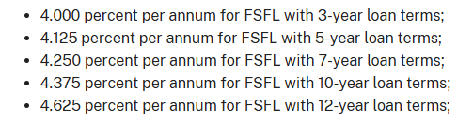
Farm Loan Program Interest Rates (June 2026):

- Operating Loans 5.00%
- Ownership Loans 5.875 %
- Emergency Loans 3.75%

Feel free to reach out if you have any questions.

10. Next Meeting: July 21, 2026 @ 9am

11. Adjournment: 10:45am Motion to adjourn meeting: Made by Rod Lauzon, 2nd Jacques DeMars, motion carried.

Respectfully Submitted
Kelly Freeman

