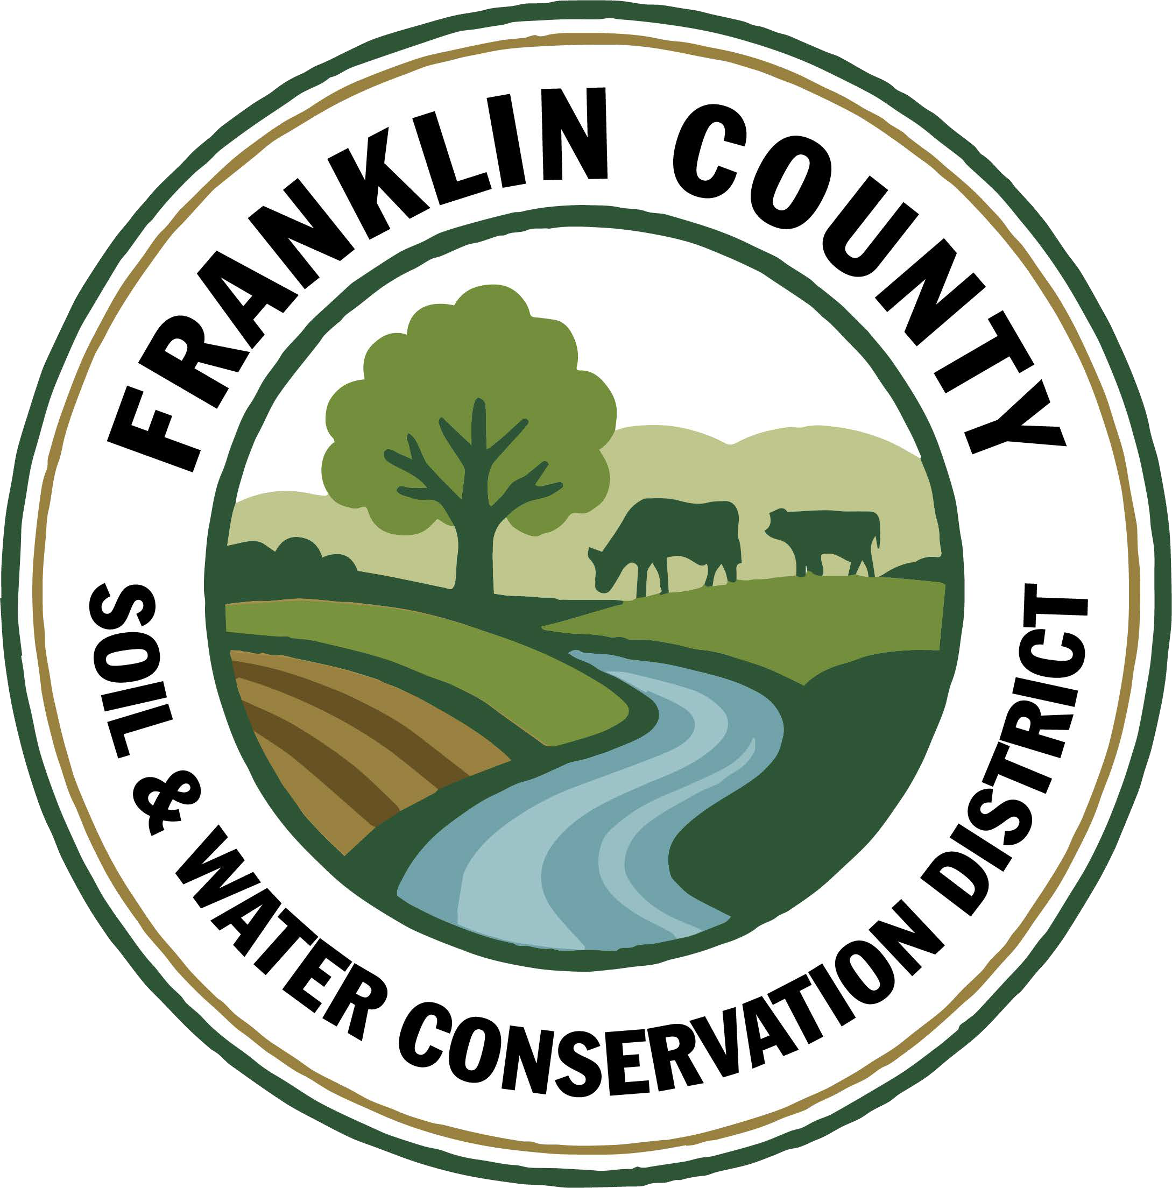
Franklin County Soil and Water Conservation District
174 Finney Blvd
Malone, NY 12953
(518) 651-2097
www.fcswcd.org

ATTENDANCE:
MINUTES OF THE REGULAR MEETING OF THE BOARD OF DIRECTORS May 19th, 2026

Directors: Ralph Child Dennis Egan
Steve Gokey
Andrea Dumas
Rod Lauzon
Staff:
Kristin Ballou
Devin Normandeau
Sarah Otis
Shayla Pfendler
Kelly Freeman
Hannah Manchester
Jeb Shea

1. Meeting was called to order: Chairman, Ralph Child, called meeting to order at 9:07 AM - Quorum present
2. Approval of April 21st Meeting Minutes: Motion made by Rod Lauzon, 2nd by Dennis Egan. Motion carried.
3. Report of Officers:
- Chairman Report: No Report
- Board Member Reports: No Reports
- Correspondence: M&T Statement, Grassroots newsletter, NYACD Report, CCE 4-H Donor Form, NACD 2025 Annual Report, NCF 2025 Annual Report, email from Rhonda about Financials
4. Business:
1. ADK Community Foundation Invasive Species Grant: Grant provides $5,000 over 2 years. 1st year $3,500, 2nd year $1,500. For purchase of invasive species removal equipment and to provide educational workshops. Backpack Sprayers, Stem Injectors, & Removal Tool Kits among other essentials will be available for rental to Counties, Towns & Homeowners with a $20 deposit.
a. Approval to sign Grant Contract: Motion made by Rod Lauzon, 2nd by Andrea Dumas. Motion carried.
b. Approval to open a Checking Account for Grant: Motion made by Dennis Egan, 2nd by Rod Lauzon. Motion carried.
c. Approval to purchase materials funded through the Contract: Motion made by Steve Gokey, 2nd by Dennis Egan. Motion carried.
d. Approval to use Hamilton County SWCD Landowner Assumption of Risk & Release of Liability as a template for Grant Contract/Deposit Receipt: Motion made by Dennis Egan, 2nd by Rod Lauzon. Motion carried.
2. Building Maintenance Bids: Provided an update on the status of the bids. Tabled until next meeting as there was only one bid completed.
3. Approval for 3 Tire Recycling Events Through Winterbottom Trucking, including Bombay($3,300), Tupper Lake($3,500), & Malone($3,200), Tupper Lake & Malone are not confirmed at this time: Motion made by Dennis Egan, 2nd by Rod Lauzon. Motion carried.
4. AEM Implementation Project Approval: Approval of new resolution to support AEM 19 implementation projects at Full Circle Farm and Oakdale Farm. Motion made by Rod Lauzon, 2nd by Dennis Egan. Motion carried.
5. Pre-Approval to reimburse Participants for Planting With Purpose when we receive funding from The Nature Conservancy: Motion made by Rod Lauzon, 2nd by Steve Gokey. Motion carried.
6. Backyard Biodiversity Bonus Application Approval: Shayla Pfendler submitted an application. Interns Jeb and Hannah did a site visit and are working on plans to include shrubs, wildflowers, a small salamander pond, compost bin, & gutters/rain barrel. The wildflower pollinator garden area will also qualify for Shayla’s Pollinator Steward Certification. Max reimbursement is $500. Motion made by Rod Lauzon, 2nd by Andrea Dumas. Motion carried.

5. Financials:
a. Transfer Watershed Coordinator payroll($2,384.62) from CWICNY Coordinator account to Checking account: Motion made by Rod Lauzon, 2nd by Dennis Egan. Motion carried.
b. Transfer $3,500 from Checking account to ADK Community Foundation Invasive Species Grant account: Motion made by Steve Gokey, 2nd by Rod Lauzon. Motion carried.

6. Budget Approval: Motion made by Dennis Egan, 2nd by Steve Gokey. Motion carried.

7. Financial Report Approval: Motion made by Steve Gokey, 2nd by Dennis Egan. Motion carried.

8. Reports:

- Kristin Ballou, District Manager
- AEM
  - Working on Forest Conservation Plans as time allows
  - Site visit with staff regarding current and future projects
- Part B – 4 Forest Management Plans – 2026 4 Forest Management Plans Approved
- Meetings/Workshops/Other
  - CWICNY
  - CWICNY Watershed Coordinator meetings, advertising position and interviews, reporting
  - EFRP – restoration plan development – scheduling site visits
  - Meeting with producers regarding funding opportunities
  - North Adirondack Regional Envirothon – Planning underway for 2026 event
  - Grant reporting and vouchers
  - 2026 North Country Stormwater Tradeshow and Conference Planning
  - Environmental education events
  - Tree sale

- Grants:
  - Ag. NPS Round 27 – project construction completed, closeout in process
  - Adirondack Community Foundation – Generous Acts Grant – application submitted to support environmental education programing – did not receive funding
  - CRF 7 – projects implemented for year 2
  - CRF 8 – projects implemented for year 1
  - CAFO ENMP – 1 project awarded – waiting on District/Landowner Contract
  - EFRP – award letter signed and executed. Project site visits needed in Essex and Hamilton Counties
  - Franklin County Septic Grant – application review and closeout document review and approval. Round 5 Funding staff completed an evaluation of eligible waterbodies to determine the number of potential applicants
  - LCBP Covered Barnyard Project – working on contractor bids
  - LCBP Organizational Support – received award, working on plan of work
  - Lake Champlain Watershed Capacity Contract – Watershed Coordinator Year 1 reporting submitted, working on DEC comments regarding the Priority project list. Interviews were held on 3/5/2026
  - Nature Conservancy Planting with a Purpose Grant – 2026 implementation underway
  - RRAMP and Forest Roads 2 (CWICNY) –all projects completed – waiting on extension - closeout to begin
  - RRAMP and Forest Roads 3 (CWICNY) – contract executed and planning projects for summer 2026
  - Smart Growth Grant – Year 1 field work completed and reimbursed, planning for year 2
  - WQIP Hydroseeding – planning 2026 sites
  - WQIP NAACC – planning fieldwork for 2026
  - WQIP Collins Brook Culvert Replacement – funding awarded, waiting on contract documents
Next Month – site visits, CWICNY Watershed Coordinator position, LCBP Covered Barnyard Project, Forest Management Plans, septic grant application and closeout material review, grant closeouts, EFRP site visits and restoration plan development, tree plantings, environmental education events, Arbor Day Event, Ranger School Professionals Day

b. Devin Normandeau, District Technician
AEM
AEM 19 Project Site Visits (Tier 2/3)
Assisted St. Regis Mohawk Tribe Agriculture Program with community soil samples
Saranac Lake BOCES Career Day

Ag NPS
Rd. 27 (Trumble)
- Working on close out

CAFO ENMP
CARSADA Dairy

CRF Rd 7
Nothing to report

CRF 8
Shipman Farm injected in April
- Waiting on invoices and documents

Part C
Assisted with tree planting programs
Arbor Day event – Saranac Lake
Earth Day Clean Up – Tupper Lake

Regional Envirothon

No-Till Drills
Sent out once – 10 acres

Meetings
AgPAC – 5/6

Next Month
AEM Tier 2 and 3s
AEM 19 Applications
NYS Envirothon

c. Sarah Otis, District Technician

Part C
- Plant trees for J. Staib in Chateaugay
- Tree planting demonstration at St. Joe’s
- Arbor Day celebration
- Submitted grant application for Adirondack Community Foundation terrestrial invasive species grant
- Davis Elementary tree planting demonstration

NARE
- Solicited to businesses, set up for event

WQIP Hydroseeding
- Site visits
- Seeding ditch for Town of Constable

WQCC
- 2nd Quarter meeting – next meeting July 30

Next Month
Highway Association meeting, Saranac Lake garden care education program, Hydroseeding in Malone, finalize paperwork for Invasive species rental equipment program, NYS Envirothon, Hydroseed for town of Duane, Aquatic Invertebrates Lesson for homeschool group, Clinton County education day on no-till, water quality probe, and drone, NYS Invasive Species Week education program at Davis, Pesticide application with St Lawrence County
d. Shayla Pfendler, District Technician

Part C

Municipal
- Salt Reduction Grant awardees have been notified – Town of Franklin, Town of Bellmont, Town of Constable
- 2026 Tire recycling locations – Bombay date July 9th, awaiting word from Tupper Lake & Franklin County
- Highway meeting May 19th

Tree Sale
- PWP plantings are final and site visits complete. Controls assessed

Backyard Biodiversity Bonus
- Plans began, 2 applications submitted
- 5 other interested parties

CWICNY
- Monthly meetings
- SWTS – Presenters finalized and PIE credits being finalized. Vendor emails being sent out by July 1st

Grants
- Organizational Support – LCBP. Awarded & awaiting final word. Tech has been notified. Ready to place orders as soon as LCBP communicates ability to begin
- ALCOA Foundation Grant – submitted 4/20/26

Meetings and Site Visits Attended
- J. Staib Wetland planting (4/21)
- Arbor Day (4/24)
- Loon Lake BBB site visit (4/27)
- NARE (4/28)
- NCSC Meeting (4/7)
- Davis Tree Planting classes (5/8)
- Hydroseeding Constable (5/11)
- SWTS (5/12)
- FCWQCC (5/14)
- PWP Site visits (5/15)
- Loon Lake Restoration Meeting (5/18)

Next Month: BBB Program site visits, Highway Meeting @ Donovan’s, Trinque Streambank Plan, VT Fish Science Dam Zoom, CWICNY, FEN meeting, Envirothon, SWTS, NYS Invasive Species Week, Pack Forest in Warrensburg

e. Kelly Freeman, Secretary
Regular Office Duties
- Draft minutes from previous meeting
- Bank Statements & Reconciliations
- Retirement & Monthly taxes
- Updated minutes on website and fixed Jacques name in previous minutes
- Update Budget
- Called multiple businesses for building maintenance bids
- Corresponding with National Business Technologies to finalize contract
- Received credit for subscription from Quickbooks and sent in tax form so we can be reimbursed
- Listened to a Notary Public course training, section 2-Jurisdiction
- Created new business cards for employees, to be ordered once all information is confirmed
- Prepared Endyne bags

Out of Office
- Tree planting @ Staib’s
- Arbor Day Saranac Lake church
- St. Joe’s Arbor Day w/Sarah
- Envirothon

New Employees
- Prepared new employee paperwork for interns and watershed coordinator
- Added interns and coordinator to NY New Hire, QB, LENS, & NYSLRS
- Worked over phone with Rhonda to be sure new employees were added correctly and to go over financial report

f. Hannah Manchester & Jeb Shea, Interns
As interns have only been here a week, they did a verbal report. Hydroseeding with Sarah, soil sampling with Devin, attended WQCC meeting, PWP & Backyard Biodiversity site visits with Shayla, & Career Day in Saranac Lake. In between all that, they have been running errands, organizing our supply room, working on our newsletter and generally keeping quite busy.

g. Ben Luskin, NYS SWCC
NYS SWCC News
AEM Leopold Conservation Award 2026: NYSAGM is partnering once again with the Sand County Foundation to present the AEM Leopold Conservation Award to recognize landowners who inspire others with their dedication to ethical land, water, and wildlife habitat management on agricultural land. New York’s award recipient will be presented with the $10,000 award provided by the Sand County Foundation, in partnership with the Department, American Farmland Trust,
and Cornell Cooperative Extension. The deadline for applications is May 15th, 2026.

State Aid Part C/Performance Measures Check-In: As we move towards the half-way mark of the calendar year, SWCDs are encouraged to review their progress toward achieving their State Aid to Districts (Part C) performance measure goals. With roughly 6 months to go, now is an ideal time for directors and staff to evaluate current progress, identify any areas requiring additional attention, and plan accordingly to ensure all applicable performance measures are completed by year’s end. Part C has seen significant growth in recent years, and that growth could conceivably continue based upon current budget proposals. Proactive tracking and timely completion of these goals will help maximize each district’s potential Part C award. Please feel free to reach out to your Regional AEA, if you have questions.

EBM Pilot Stream Program: Congratulations to the awardees of the EBM Stream Corridor Management Pilot Program! 26 projects were awarded in this pilot program to protect water quality and the long-term health of the State’s waterways. Please see the press release below. More information about awards and plans for work will be forthcoming soon. In the meantime, questions can be directed towards Tim Sheldon (timothy.sheldon@agriculture.ny.gov) or to your Regional AEA.
May SWCC Meeting: The next meeting of the NYS Soil and Water Conservation Committee will be on Tuesday, May 19th starting at 10:00 AM. Further details and an agenda for this meeting will be sent out shortly. Reminder – participation at a SWCC meeting is eligible toward PM1, Part C of State Aid to Districts.

2026 NYS Envirothon - Volunteers Needed: The New York State Envirothon Committee is pleased to announce that we will host the 2025 New York State Envirothon at SUNY Cortland, on May 27th-28th, 2026. Volunteers are the heart of this event, and it doesn’t happen without assistance from SWCD Directors and staff. Please consider Volunteering! A description of the volunteer positions available as well as an online registration link are available here on the NYS Envirothon website, https://nysenvirothon.org/contact. Any questions can be directed to nysenvirothon@gmail.com.

Spring Managers Meetings – Save the Date: The following dates have been set for regional manager’s meetings this June! Meetings will be from 10am-2:30pm. Please participate in whichever date and location is most convenient but please be sure to RSVP to the appropriate Regional Coordinator by May 25th so we’ll have accurate counts for lunch orders. As always Directors are invited to attend, as this meeting can count towards Performance Measures.
- Region 1: June 2nd, Genesee County Office Building #2, 3837 West Main Street Road, Batavia, NY – Vic DiGiacomo
- Region 2: June 3rd, Yates County SWCD - 417 Liberty St Penn Yan, NY – PJ Emerick
- Region 3: June 1st, Chenango County SWCD – 99 North Broad Street, Norwich, NY 13815 – Scott Fickbohm
- Region 4: June 10th, Croghan Fire Department – 6680 Fire Hall St., Croghan, NY 13327 – Ryan Cunningham
- Region 5: June 11th, NYS DEC Office – 232 Golf Course Rd., Warrensburg, NY 12885 – Ben Luskin
- Region 6: June 9th, Rockland County SWCD – 50 Sanatorium Rd., Bldg. A 6th Floor, Pomona, NY 10970 - Travis Ferry

Soil Science Watch Party Continues: A group of SWCC Staff, district staff, and partners are working their way through 39 hours of Soil Science lectures from Cornell University’s Jonathan Russell-Anelli. The group meets virtually on Monday mornings at 9:00 am to watch prerecorded lectures and answer discussion questions. CCA credits are available for each session. The group uses Webex to coordinate and the recurring meeting link is: https://meetny-gov.webex.com/meetny-gov/j.php?MTID=m872f0a411cf3434a744799dc62f873fd . Contact Tim Clark for more information.

Ecological Restoration Species Selection Tool Finalized: New York State Department of Environmental Conservation and NY Natural Heritage Program finalized a Species Selection Tool that provides a list of native trees, shrub, and herbaceous species suitable for a project site. This tool matches a clicked site location and conditions like soil, geology, and other conditions to expected natural communities to narrow down the species list, and provides information on each species, including height, lifespan, shade tolerance, and climate adaptability. https://nynhp.shinyapps.io/speciesselectiontool/

New Waste Storage Facility (313) Standard: This standard has been updated and is posted on FOTG. NRCS NY received a variance on the standard to be able to continue using current design practices for concrete storages located in non-sensitive environmental settings. NRCS national has been advocating enhanced design standards for all concrete storages against opposition from many states. Other updates: updated rainfall maps, added operation and maintenance criteria for inspections to reduce damage to liners during agitation, added criteria requiring structural and visual components to all agitation and pumping locations, which may reduce the risk of accidental entry and damage to the liner during agitation.

Other Events
NY Center of Excellence in Healthy Water Solutions Annual Meeting: The NY Center of Excellence in Healthy Water Solutions is hosting its annual meeting at SUNY ESF in Syracuse, NY, May 19th-21st. This meeting will bring researchers, partners and stakeholders together for in-depth discussions and networking as we look to find cooperative ways to address current and emerging water issues in New York. The event is free to attend. Please follow this link for more information and to register for the event: https://healthywaters.org/annual-meeting/. This event qualifies for Performance Measure 1g – Participation at a State, Regional, and National meeting or function.

From Planning To Action - Municipal Training Series: New York Sea Grant has announced educational opportunities for municipal leaders involved with land use management planning and implementation along New York's Great Lakes and connecting river channels. A two-part Coastal Community Development webinar series will feature information on coastal processes that impact the shorelines along Lake Erie, the Niagara River, Lake Ontario, and St. Lawrence River.
- May 26, 2026, from 1:00 PM - 2:00 PM, Great Lake Coastal Processes for Municipal Leaders in NY - New York Sea Grant staff will provide information on how shorelines respond to the natural, dynamic and changing action of the waters along New York's Great Lakes and connecting river channel shorelines. https://cornell.zoom.us/meeting/register/8uA0bfuOSR-n15ZyJhWTcg#/registration
- June 9, 2026, from 1:00 PM - 2:00 PM, Keeping your Plan off the Shelf - a panel of local government representatives who have successfully developed and implemented land use planning goals will share tips for keeping an active process moving after completing a local plan to accomplish the desired objectives and benefits for the local community. https://cornell.zoom.us/meeting/register/-Ge8x470QFOtYB6ji_YvjA#/registration

NACD Northeast Regional Meeting – Save the Date: The 2026 Northeast Region Meeting, hosted by the Delaware Association of Conservation Districts, will be held on August 24-27, 2026, at the Chase Center on the Riverfront in Wilmington, DE. https://dacdnet.org/2026NACDNE/

Other Grant Opportunities
Resilient Watersheds Grant (RWG) Program Application Period is Now Open: At least $60 million of Environmental Bond Act funding is available for implementation of flood mitigation projects across New York State. Minimum grant amount: $150,000; maximum grant amount: $10,000,000. Applications are due Friday June 26th, 2026, at 4:00 PM. https://dec.ny.gov/environmental-protection/water/water-quantity/resilient-ny

h. USDA NRCS : No Report
i. USDA FSA
Conservation Reserve Program (CRP):
The Farm Service Agency (FSA) is accepting offers for Grassland CRP until May 29, 2026. This CRP option provides an annual rental payment on grassland maintained for grazing or wildlife purposes. In addition, cost-share can be available for practices to support grazing such as water development, fencing and animal trails/walkways. We are still able to accept offers for Continuous CRP which covers buffers and filter strips.
Acreage/Crop Reporting:
We are working on 2026 crop reports. The deadline for most crops including hay, spring seeded small grains, vegetables, berries, corn and soybeans is July 15th. Certain programs require a timely crop report.
Supplemental Disaster Relief Program (SDRP):
Covers crop, tree, and vine losses due to wildfires, hurricanes, floods, derechos, excessive heat, tornadoes, winter storms, freeze (including a polar vortex), smoke exposure, excessive moisture, qualifying drought, and related conditions occurring in calendar years 2023 and/or 2024. Phase 2 of this program is now available for producers who did not receive insurance or NAP payments but suffered crop losses due to an eligible weather event. The Sign-up deadline has been extended to August 12, 2026 for both phase 1 and 2.
Assistance for Specialty Crop Farmers:
USDA’s Farm Service Agency is providing $1 billion through a one-time bridge payment for specialty crops, sugar, and commodities not covered through the Farmer Bridge Assistance (FBA) program. These bridge payments are authorized under the Commodity Credit Corporation Charter Act. ASCF payments are based on reported 2025 planted acres. We are still waiting to hear what the payment rates will be and when signup begins.
Price Support Interest Rates (May 2026):
- Marketing Assistance (Commodity) Loans: 4.75%
**The deadline to request a 2025 corn or soybean loan is May 31st. **

- Farm Storage Facility Loans:

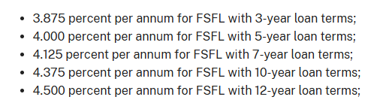
Farm Loan Program Interest Rates (May 2026):

- Operating Loans 4.75%
- Ownership Loans 5.75 %
- Emergency Loans 3.75%

Feel free to reach out if you have any questions.

10. Next Meeting: June 16, 2026 @ 9am

11. Adjournment: 10:12am Motion to adjourn meeting: Made by Rod Lauzon, 2nd Steve Gokey, motion carried.

