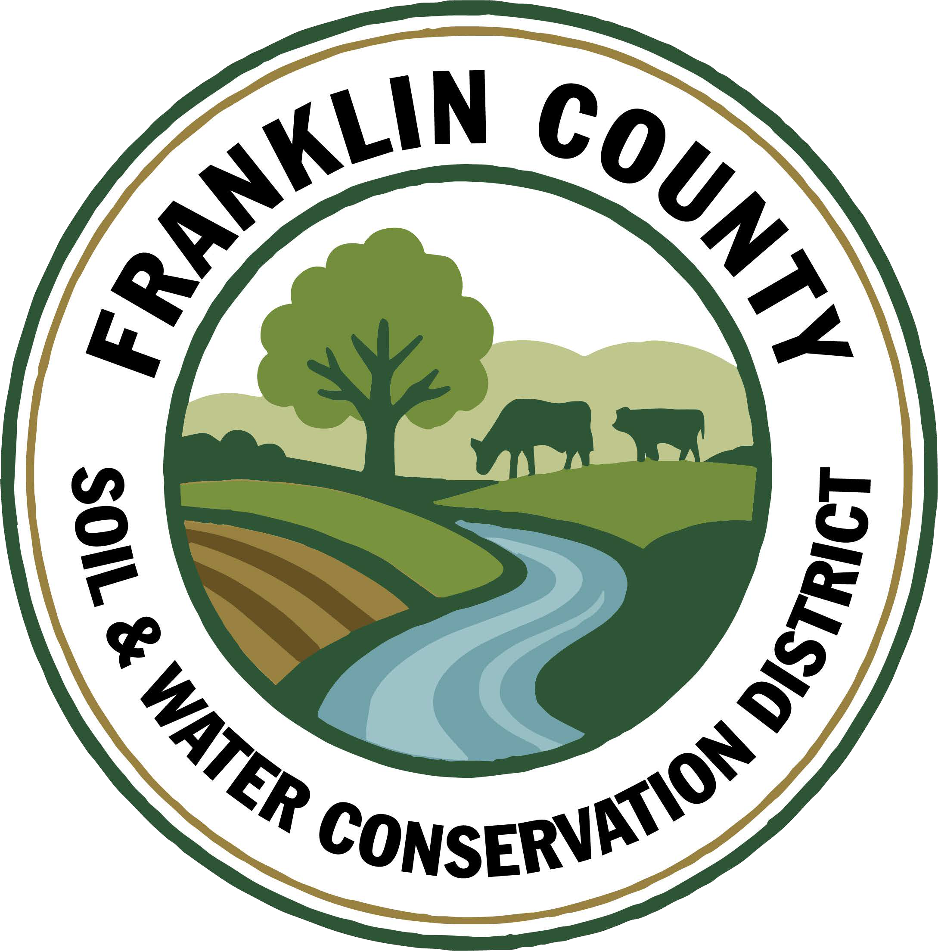
Franklin County Soil and Water Conservation District
174 Finney Blvd
Malone, NY 12953
(518) 651-2097
www.fcswcd.org

ATTENDANCE:
MINUTES OF THE REGULAR MEETING OF THE BOARD OF DIRECTORS April 21st, 2026

Directors: Ralph Child Dennis Egan
Jacques DeMars
Andrea Dumas
Rod Lauzon
Staff:
Kristin Ballou
Devin Normandeau
Sarah Otis
Shayla Pfendler
Kelly Freeman

1. Meeting was called to order: Chairman, Ralph Child, called meeting to order at 9:01 AM - Quorum present
2. Approval of March 17th Meeting Minutes: Motion made by Andrea Dumas, 2nd by Rod Lauzon. Motion carried.
3. Approval of April 8th Special Meeting Minutes: Motion made by Andrea Dumas, 2nd by Rod Lauzon. Motion carried.
4. Report of Officers:
- Chairman Report: No Report
- Board Member Reports: No Reports
- Correspondence: M&T Statement, Grassroots newsletter, NYACD Invoice, Report & District Board Roles & Responsibilities, NACD Report
5. Business:
1. AEM 19 Implementation Resolution Approval: Motion made by Rod Lauzon, 2nd by Dennis Egan. Motion carried.
2. Approval to list old Hydroseeder on Auctions International: Motion made by Dennis Egan, 2nd by Rod Lauzon. Motion carried.
3. Update on Watershed Coordinator Applicants: Nathan Helmuth accepted our offer and starts May 11th at $62,000 salary, which is funded by the DEC.
4. School Assistance Program Applicants: Brushton-Moira Central School, Chateaugay Central School, Malone Central School, & Saranac Lake Central School applied for our School Assistance Program. Saranac Lake is requesting $1,172.45. The others are all requesting the limit of $2,000.00. Motion to approve applications made by Rod Lauzon, 2nd by Dennis Egan. Motion carried.
5. Salt Reduction Program Applicants: Town of Franklin, Town of Bellmont and Town of Constable all submitted applications requesting the maximum of $2,000.00 as reimbursement for live edge blades. Motion to approve applicants, but reiterate that there is a correct process to grant applications, made by Dennis Egan, 2nd by Rod Lauzon. Motion carried. As Jacques DeMars is Representative for Town of Franklin he abstains.
6. Approval of AEM District/Landowner Contract: Motion made by Dennis Egan, 2nd by Rod Lauzon. Motion carried.
7. Approval to sign the 2026 LCBP Organizational Support Grant: Motion made by Dennis Egan, 2nd by Rod Lauzon. Motion carried.
8. Approval to have gutters replaced by Northern Seamless Gutters for $1500: Motion made by Rod Lauzon, 2nd by Dennis Egan. Motion carried.
9. Discussion about looking into funding options to support an updated website and incorporate an online ordering platform for the Tree & Shrub sale. All members in favor of researching funding and options.

6. Financials:
a. Transfer $146.94 from Part C account to Savings account to replenish March fund transfer: Motion made by Dennis Egan, 2nd by Rod Lauzon. Motion carried.
b. Close AEM 18 Implementation account: Motion made by Andrea Dumas, 2nd by Rod Lauzon. Motion carried.
c. Close AEM 18 Soil Samples account: Motion made by Dennis Egan, 2nd by Rod Lauzon. Motion carried.
d. Transfer $162,000 from Part C account to Savings account for staff time: Motion made by Rod Lauzon, 2nd by Jacques DeMars. Motion carried.
e. Transfer $10,000 from Part C account to Building account: Motion made by Rod Lauzon, 2nd by Dennis Egan. Motion carried.
f. Approval to pay 2026 Envirothon Event Team Registration for 3 counties(Essex, Franklin & St. Lawrence): Motion made by Rod Lauzon, 2nd by Andrea Dumas. Motion carried.
g. Approval for up to 6 employees to attend 2026 NYS Envirothon($50 each): Motion made by Dennis Egan, 2nd by Rod Lauzon. Motion carried.
h. Transfer supplemental payment of $7,500 from Checking account to RRAMP 3 account: Motion made by Rod Lauzon, 2nd by Dennis Egan. Motion carried.
i. Transfer $42,041.76 from Checking account to CWICNY Coordinator account for Year 1 Contract Reimbursement once received: Motion made by Rod Lauzon, 2nd by Andrea Dumas. Motion carried.
j. Transfer $ from Checking account to CWICNY Coordinator account for Year 2 25% Contract Advance once received: Motion made by Rod Lauzon, 2nd by Andrea Dumas. Motion carried.
k. Open a checking account for 2026 LCBP Organizational Support Grant: Motion made by Dennis Egan, 2nd by Rod Lauzon. Motion carried.
l. Open a checking account for WQIP Collins Brook Culvert Replacement Project: Motion made by Rod Lauzon, 2nd by Dennis Egan. Motion carried.
m. Approval to reimburse up to $2000 to Brushton-Moira Central School FFA: Motion made by Rod Lauzon, 2nd by Andrea Dumas. Motion carried.
7. Financial Report Approval: Motion made by Dennis Egan, 2nd by Rod Lauzon. Motion carried.
8. Budget Approval: Motion made by Rod Lauzon, 2nd by Dennis Egan. Motion carried.
9. Reports:
- Kristin Ballou, District Manager
- AEM
  - Working on Forest Conservation Plans as time allows
  - Site visit with staff regarding current and future projects
- Part B – 4 Forest Management Plans – 2026 4 Forest Management Plans Approved
- Meetings/Workshops/Other
  - CWICNY
  - CWICNY Watershed Coordinator meetings, advertising position and interviews, reporting
  - EFRP – restoration plan development – scheduling site visits
  - Meeting with producers regarding funding opportunities
  - North Adirondack Regional Envirothon – Planning underway for 2026 event
  - Grant reporting and vouchers
  - 2026 North Country Stormwater Tradeshow and Conference Planning
  - Environmental education events
  - Tree sale

- Grants:
  - Ag. NPS Round 27 – project construction completed, closeout in process
  - Adirondack Community Foundation – Generous Acts Grant – application submitted to support environmental education programing – did not receive funding
  - CRF 7 – projects implemented for year 2
  - CRF 8 – projects implemented for year 1
  - CAFO ENMP – 1 project awarded – waiting on District/Landowner Contract
  - EFRP – award letter signed and executed. Project site visits needed in Essex and Hamilton Counties
  - Franklin County Septic Grant – application review and closeout document review and approval. Round 5 Funding staff completed an evaluation of eligible waterbodies to determine the number of potential applicants
  - LCBP Covered Barnyard Project – working on contractor bids
  - LCBP Organizational Support – received award, working on plan of work
  - Lake Champlain Watershed Capacity Contract – Watershed Coordinator Year 1 reporting submitted, working on DEC comments regarding the Priority project list. Interviews were held on 3/5/2026
  - Nature Conservancy Planting with a Purpose Grant – 2026 implementation underway
  - RRAMP and Forest Roads 2 (CWICNY) –all projects completed – waiting on extension - closeout to begin
  - RRAMP and Forest Roads 3 (CWICNY) – contract executed and planning projects for summer 2026
  - Smart Growth Grant – Year 1 field work completed and reimbursed, planning for year 2
  - WQIP Hydroseeding – planning 2026 sites
  - WQIP NAACC – planning fieldwork for 2026
  - WQIP Collins Brook Culvert Replacement – funding awarded, waiting on contract documents
Next Month – site visits, CWICNY Watershed Coordinator position, LCBP Covered Barnyard Project, Forest Management Plans, septic grant application and closeout material review, grant closeouts, EFRP site visits and restoration plan development, tree plantings, environmental education events, Arbor Day Event, Ranger School Professionals Day

b. Devin Normandeau, District Technician
AEM
AEM 19 Project Site Visits (Tier 2/3)

Ag NPS
Rd. 27 (Trumble)
- Working on close out
Rd. 31
- Applications submitted 4/20

CAFO ENMP
CARSADA Dairy

CRF Rd 7
Nothing to report

CRF 8
Shipman Farm injected in April
- Waiting on invoices and documents

Tree Sale
Assisted with Tree Sale

Part C
Assisted with school programs in St. Regis Falls and Chateaugay

Meetings

Next Month
AEM Tier 2 and 3s
AEM 19 Applications

c. Sarah Otis, District Technician
Part C
- Submitted grant application for Great Lakes Basin Program Small Grant
- World Water Day soil type filtration experiment– 74 interactions
- Saint Regis Falls Earth Science Stream Table Lab- 8 students
- Chateaugay Central School tree planting demonstration- 160 students
- Bloomingdale Elementary tree planting demonstration- 68 students
- Saranac Lake 9th and 10th grade dendrology class- 75 students
- Coordinated with Tupper Lake Lions Club for Earth Day Community Clean-Up
- Arbor Day meeting and prep

School Assistance Program
- Reviewed applications

NARE
- Solicited to businesses

Tree Sale
- Orders, mailings, packing, distributing

WQIP Hydroseeding
- Scheduled dates for May in Constable and Chateaugay

Next Month
- Tree plantings, hydroseeding site visits, St. Joes tree planting demonstration, Arbor Day planting, Earth Day clean-up in Tupper Lake, NARE, Davis Elementary tree planting demonstration, WQCC meeting May 14, Finish Adirondack Community Foundation invasive species grant application, Prepare for WQIP road salt reduction and hydroseeding applications

d. Shayla Pfendler, District Technician

Part C

Municipal
- Salt Reduction application for 2026 sent out. 3 applications submitted – Town of Franklin, Constable, and Bellmont.
- 2026 Tire recycling locations – Bombay, Tupper, Malone. Dates pushed back due to Trailer availability.

Tree Sale
- PWP plans began – 300 trees planted, 3 landowner’s total
- 200+ orders. Designated trees for Education & Outreach, Arbor Day, School plantings, Akwesasne Reservation
- Over 17,000 plants sold

CWICNY
- Monthly meetings
- SWTS Planning has begun. Communication with presenters has been established

Grants
- Organizational Support – LCBP. Awarded!!
- ALCOA Foundation Grant – submitted 4/20/26

Meetings and Site Visits Attended
- ALCOA Grant meeting (3/18)
- CWICNY (3/19)
- SWTS (3/24)
- Tree Sale Packing (4/8-4/13)
- Vermontville Tree Sale (4/14)
- Malone Tree Sale (4/15)
- CWICNY (4/16)

Next Month: BBB Program site visits, J. Staib planting, Arbor Day in Saranac Lake
Loon Lake planting visit, NARE, PWP post-planting visits, NSCS meeting, SWTS, WQCC, Davis Elementary tree planting, Pollinator Steward classes

e. Kelly Freeman, Secretary
Daily
- Assisting people with water test questions & samples
- Assisting with Tree Sale
- Update Abstract
Weekly
- Bank transfers & deposits
- Processing payroll, taxes, & deferred comp
- Tree sale invoices & receipts
Monthly
- Print Statements & do reconciliations
- NYS-1 Taxes, Retirement & Health Insurance in QB
- Retirement submission
- Board meeting prep
Misc
- World Water Day w/Sarah
- Worked with Rhonda over phone to do Quarterly taxes and to change payroll info(taking more taxes out, retirement change, & insurance stipend)
- Auditor came
- Bloomingdale School to plant trees w/Sarah

f. Ben Luskin, NYS SWCC
NYS SWCC News
UPDATE - Managing Interest During Close Outs of SWCC Cost-Share Programs: NYS AGM’s Fiscal Division recently advised all Department programs of a change to how interest earned on contracts must be returned to the Department when requesting a final payment at close out. We ask that all SWCD please use the new protocol for all future close outs; note, no change is needed for approved closed outs where claims for final payment have already been submitted to BSC.

This represents a change in the process, such that we can no longer offset the final payment to the District by the amount of interest earned during the contract. Note, the process of returning interest when a vendor (District) is returning funds at close out remains the same. The Claim for Payment / Return Funds Coversheet has been updated to reflect the change in the process of returning interest when requesting final payment. The updated close out process as well as the updated CFP coversheet have been emailed to SWCD and is available on SharePoint. Please familiarize yourself with this new protocol and coversheet and save them with your records. Feel free to reach out to the respective SWCC Program Manager or your Regional Coordinator if you have questions about the change during upcoming close outs.

Round 31 Agricultural Non-Point Source Program: The SWCC has made a total of $25 million available through the AgNPS Round 31 RFP for SWCD’s to propose AEM Tier 3 Planning and Tier 4 Implementation projects. Proposal submission uploaded to SharePoint is due Monday, April 20, 2026 by 4:30 PM.

AEM Round 19 - Tier 4 projects are due by May 1st, 2026. Make sure if you have not already gotten your Resolutions for the support of your Tier 4 Implementation projects passed you will need to at your April Board Meetings. If you have any questions please do not hesitate to reach out to Chas, chastity.miller@agriculture.ny.gov.
AEM Leopold Conservation Award 2026: NYSAGM is partnering once again with the Sand County Foundation to present the AEM Leopold Conservation Award to recognize landowners who inspire others with their dedication to ethical land, water, and wildlife habitat management on agricultural land. New York’s award recipient will be presented with the $10,000 award provided by the Sand County Foundation, in partnership with the Department, American Farmland Trust,
and Cornell Cooperative Extension. A Formal announcement, and application materials were emailed to Districts in the first week of February 2026. The deadline for applications is May 15th, 2026.

SWCC Meeting: The next meeting of the NYS Soil and Water Conservation Committee will be held on Tuesday April 21st, 2026, starting at 10:00 AM. The meeting will be held in person at the NYS Department of Environmental Conservation Office in Syracuse, NY located at: 5786 Widewaters Parkway, Syracuse, NY 13214; lunch will be provided. To ensure we have an accurate count of attendees, please respond to Melissa Gordon (melissa.gordon@agriculture.ny.gov) no later than April 7th, 2026. All Districts are encouraged to attend and participate in SWCC meetings. Each meeting agenda provides an opportunity for Conservation Districts to provide reports, updates, or feedback to the SWCC. Reminder – participation at a SWCC meeting is eligible toward PM1, Part C of State Aid to Districts.

2026 NYS Envirothon - Volunteers Needed: The New York State Envirothon Committee is pleased to announce that we will host the 2025 New York State Envirothon at SUNY Cortland, on May 27th-28th, 2026. Volunteers are the heart of this event, and it doesn’t happen without assistance from SWCD Directors and staff. Please consider Volunteering! A description of the volunteer positions available as well as an online registration link are available here on the NYS Envirothon website, https://nysenvirothon.org/contact. Any questions can be directed to nysenvirothon@gmail.com.

Soil Science Watch Party Continues: A group of SWCC Staff, district staff, and partners are working their way through 39 hours of Soil Science lectures from Cornell University’s Jonathan Russell-Anelli. The group meets virtually on Monday mornings at 9:00 am to watch prerecorded lectures and answer discussion questions. CCA credits are available for each session. The group uses Webex to coordinate and the recurring meeting link is: https://meetny-gov.webex.com/meetny-gov/j.php?MTID=m872f0a411cf3434a744799dc62f873fd . Contact Tim Clark for more information.
Other Events
2026 NYS Wetlands Forum Annual Conference: Save the Date. The New York State Wetlands Forum 2026 Annual Conference and Business Meeting will take place on April 14th and 15th, in Oswego, NY. To register, please visit: http://www.wetlandsforum.org/2026Conference.html

Spring 2026 Great Lakes Action Agenda (GLAA) Sub-Basin Work Group Meetings: DEC’s Great Lakes Program will be hosting a virtual kickoff meeting followed by in-person sub-basin workgroup meetings for regionally focused discussions. Meeting objectives include sharing DEC Regional, Program, and Great Lakes Program updates, hearing updates from partners, reviewing and discussing the Sub-Basin work planning process, as well as discussing upcoming funding and collaboration opportunities. Register for in-person meetings here: https://www.eventbrite.com/cc/spring-2026-glaa-sub-basin-work-group-meetings-4822191?msockid=21332227e8c46ffd0a9f350be9a36ec5
- Virtual Kickoff Meeting on April 24th, from 1:00 PM – 2:30 PM via Webex. Register here: https://meetny-gov.webex.com/weblink/register/r0fa7144931175dd29a55ddf5b23e3d6e
- April 30: Lake Erie Sub-Basin Work Group meeting: Isaías González-Soto Branch Library in Buffalo, NY
- May 4: Southeast Lake Ontario Sub-Basin Work Group meeting: Cayuga Lake Nature Center in Ithaca, NY
- May 5: Southwest Lake Ontario Sub-Basin Work Group meeting: William Udicious Pavillion in Rush, NY
- May 7: Northeast Lake Ontario/St. Lawrence River Sub-Basin Work Group meeting: Grasse River Natural Heritage Community Room in Canton, NY

NACD Northeast Regional Meeting – Save the Date: The 2026 Northeast Region Meeting, hosted by the Delaware Association of Conservation Districts, will be held on August 24-27, 2026, at the Chase Center on the Riverfront in Wilmington, DE. https://dacdnet.org/2026NACDNE/

Other Grant Opportunities
Great Lakes Sediment and Nutrient Reduction Program: The Great Lakes Sediment and Nutrient Reduction Program (GLSNRP) Request for Proposals was recently announced, for projects that reduce nutrients and sediments entering the Great Lakes. This year’s program will focus on helping nonfederal units of government, tribes, or incorporated nonprofit organizations reduce phosphorus contributions to waters within the Great Lakes basin. Applicants are invited to submit proposals for sediment and nutrient reduction activities associated with one of two project types: 1) agricultural non-point; and 2) shoreline or stream. The due date for applications is April 27th, 2026, at 5:00 p.m. EST. https://www.glc.org/work/sediment/apply-now

NYSP2I 2026-2027 Community Grants Program: The New York State Pollution Prevention Institute (NYSP2I) is accepting applications for the 2026-2027 cycle of the Community Grants Program. This program seeks projects that raise awareness and understanding of pollution prevention, and that lead to implementation of best practices at the local level. Eligible applicants may receive up to $20,000 to support their project. Applications are due April 24th, 2026. https://www.rit.edu/affiliate/nysp2i/community-grants

g. USDA NRCS: No Report

h. USDA FSA: No Report

10. Next Meeting: May 19, 2026

11. Adjournment: 10:15am Motion to adjourn meeting: Made by Dennis Egan, 2nd Rod Lauzon, motion carried.

Respectfully submitted,
Kelly Freeman, Secretary

