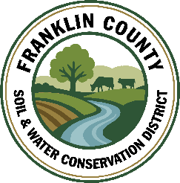
Franklin County Soil & Water Conservation District
174 Finney Blvd
Malone, NY 12953
(518) 651-2097
www.fcswcd.org

MINUTES OF THE SPECIAL MEETING OF THE BOARD OF DIRECTORS
April 8, 2026

ATTENDANCE:
Directors:
Ralph Child
Tommy Derouchie
Steve Gokey
Rod Lauzon
Andrea Dumas

Staff:
Kristin Ballou
Sarah Otis
Shayla Pfendler
Kelly Freeman

- Meeting called to order: Chairman, Ralph Child, called the meeting to order at 9:02 AM-Quorum present
- Ralph Child recused himself from the meeting at 9:03am : Ralph Child’s farm is included in an AgNPS 31 project application, therefore he recused himself.
- SWCD Business
Resolution to support the District submitting 4 applications for AG NPS 31: Discussion of applications ensued. Motion made by Steve Gokey, 2nd by Rod Lauzon. Motion carried.
4. Ralph Child returned to the meeting at 9:06am
Watershed Coordinator: Approval to offer Nathan Helmuth the Watershed Coordinator position with an offer of a salary range of $60,000-62,000 per year, which the DEC funds. Motion made by Rod Lauzon, 2nd by Steve Gokey. Motion carried.
5. Adjournment: Motion to adjourn meeting at 9:14 AM by Andrea Dumas, 2nd by Rod Lauzon. Motion carried.

Respectfully submitted,
Kelly Freeman, Secretary

