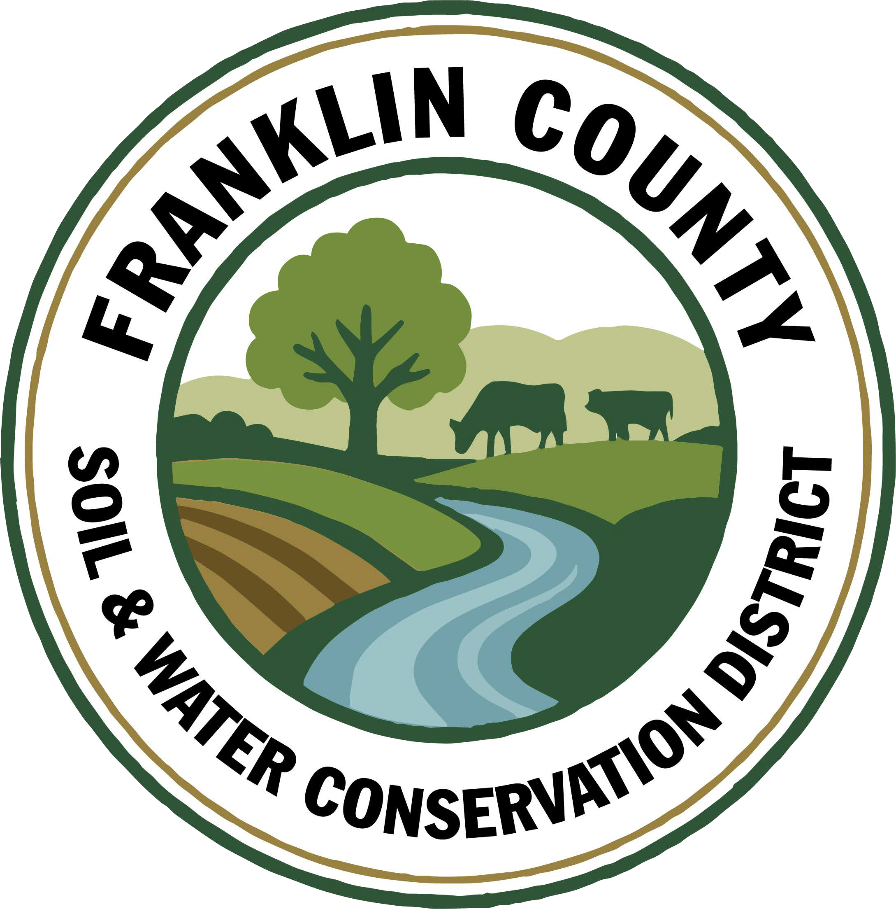
Franklin County Soil and Water Conservation District
174 Finney Blvd
Malone, NY 12953
(518) 651-2097
www.fcswcd.org

ATTENDANCE:
MINUTES OF THE REGULAR MEETING OF THE BOARD OF DIRECTORS March 17th, 2025

Directors: Ralph Child Dennis Egan
Tommy Derouchie
Jacques DeMars
Staff:
Kristin Ballou
Devin Normandeau
Sarah Otis
Shayla Pfendler
Kelly Freeman

1. Meeting was called to order: Chairman, Ralph Child, called meeting to order at 9:07 AM - Quorum present
2. Division V Merit Award Recognition: Devin Normandeau was nominated for and received The Division V Merit award at the annual Water Quality Symposium in Rochester, March 12th . This award recognizes current District employees who have shown outstanding effort in promoting their District and it’s activities. Recording of the presentation was shown.
3. Meeting Minutes:
3a. Motion to approve February 10, 2026 meeting minutes: made by Tommy Derouchie, 2nd by Dennis Egan, motion carried.
3b. Motion to approve December 19, 2025 meeting minutes: made by Dennis Egan, 2nd by Tommy Derouchie, motion carried.
3c. Motion to approve December 29, 2025 special meeting minutes: made by Tommy Derouchie, 2nd by Dennis Egan, Motion carried.
5. Report of Officers:
- Chairman Report: No Report
- Board Member Reports: Dennis commends everyone for the work involved with putting together our annual report and all the work portrayed for the year.
- Correspondence: NACD memo, NYACD letter, NYACD guide for prospective directors, NYACD report, Dept. of Ag & Markets thank you letter, M&T Bank collateral statement, BLM letter w/flyer
6. Business:
1. 2026 Budget Revision: Motion made to approve revision by Dennis Egan, 2nd by Tommy Derouchie, motion carried.
2. 2026 Part C Budget Revision: Motion made to approve revision by Tommy Derouchie, 2nd by Dennis Egan, motion carried.
3. Conservation Student Aide Applicants: Motion to hire Hannah Manchester @ $17.50/hr and Jeb Shea @ $17.00/hr from mid May-mid August, made by Dennis Egan, 2nd by Jacques DeMars, motion carried.
4. Conservation District Technicians Civil Service Test: Technicians Devin Normandeau, Sarah Otis & Shayla Pfendler took the Civil Service Exam and passed. Motion to hire them from the Civil Service List made by Jacques DeMars, 2nd by Dennis Egan, motion carried.

7. Financials:
a. CWICNY Ag Engineering Reimbursements: Motion made to reimburse Norman Ridge Farmstead for $1,770 and Kate Mountain Farm for $2,310 made by Dennis Egan, 2nd by Jacques DeMars, motion carried.
b. Transfer $146.94 from Savings to Part C to cover credit card expenses: Motion made by Dennis Egan, 2nd by Tommy Derouchie, motion carried.
c. Open new bank account AEM Yr 19 Soil Samples: Motion made by Tommy Derouchie, 2nd by Dennis Egan, motion carried.
d. Balances of $13,284(AEM Yr 18 Soil Samples), $17,914.55(AEM Yr 18 Implementation), & $24,639.68(vouchered, to receive at the end of the month): Motion made to transfer balances to Savings made by Dennis Egan, 2nd by Jacques DeMars, motion carried.
e. Transfer $2,000 from AEM Yr 19 Technical Assistance to AEM Yr 19 Soil Samples: Motion made by Dennis Egan, 2nd by Jacques DeMars, motion carried.
f. Transfer remaining interest balance from AG NPS Rd 28 Choiniere to Savings: Motion made by Dennis Egan, 2nd by Jacques DeMars, motion carried.
g. Approval of Adobe Acrobat 1 yr renewal, charged to credit card on file on March 19th for $239.88: Motion made by Tommy Derouchie, 2nd by Jacques DeMars, motion carried.
h. Approval to renew Avenza subscription for $290.97: Motion made by Jacques DeMars, 2nd by Tommy Derouchie, motion carried.
8. Financial Report Approval: Motion made by Dennis Egan, 2nd by Tommy Derouchie, motion carried.
9. Reports:
- Kristin Ballou, District Manager
- AEM
  - Working on Forest Conservation Plans as time allows
  - Site visit with staff regarding current and future projects
- Part B – 4 Forest Management Plans – 2026 4 Forest Management Plans Approved
- Meetings/Workshops/Other
  - CWICNY
  - CWICNY Watershed Coordinator meetings, advertising position and interviews
  - EFRP – restoration plan development – 2 more plans completed
  - Meeting with producers regarding funding opportunities
  - North Adirondack Regional Envirothon – Planning underway for 2026 event
  - WQS planning Forestry Track
  - Grant reporting and vouchers
  - 2026 North Country Stormwater Tradeshow and Conference Planning
  - Tree sale and bird house construction
  - NRCS Local Working Group Meeting
  - WQS
- Grants:
  - Ag. NPS Round 27 – project construction completed, closeout in process
  - Ag. NPS Round 28 – close out complete
  - Adirondack Community Foundation – Generous Acts Grant – application submitted to support environmental education programing
  - CRF 7 – projects implemented for year 2
  - CRF 8 – projects implemented for year 1
  - CAFO ENMP – 1 project awarded – executed contract received
  - EFRP – award letter signed and executed. Project site visits needed in Essex and Hamilton Counties
  - Franklin County Septic Grant – application review and closeout document review and approval. Round 5 Funding staff completed an evaluation of eligible waterbodies to determine the number of potential applicants
  - LCBP Covered Barnyard Project – working on contractor bids
  - LCBP Organizational Support – Application submitted to support a technology upgrade
  - Lake Champlain Watershed Capacity Contract – Watershed Coordinator Year 1 reporting submitted, working on DEC comments regarding the Priority project list. Interviews were held on 3/5/2026
  - Nature Conservancy Planting with a Purpose Grant – planning for 2026
  - RRAMP and Forest Roads 2 (CWICNY) –all projects completed – waiting on extension - closeout to begin
  - RRAMP and Forest Roads 3 (CWICNY) – contract executed and planning projects for summer 2026
  - Smart Growth Grant – Year 1 field work completed and reimbursed, planning for year 2
  - WQIP Hydroseeding – planning 2026 sites
  - WQIP NAACC – planning fieldwork for 2026
  - WQIP Collins Brook Culvert Replacement – funding awarded, waiting on contract documents
Next Month – site visits, CWICNY Watershed Coordinator position, LCBP Covered Barnyard Project, Forest Management Plans, septic grant application and closeout material review, grant closeouts, EFRP site visits and restoration plan development, WQS, tree sale, Franklin County Road Stream Crossing Meeting, tree plantings, environmental education events

b. Devin Normandeau, District Technician
AEM
AEM 18 Close Out Claim for Payment submitted
Ag Assessment/Ag District Workshop
Planning AEM 19 Projects
Tier 3A Plans
Tier 1/2 Site Visits

Agricultural Assessments
Completed Ag Assessments up to March first

Ag NPS
Rd. 27 (Trumble)
- Working on close out
Rd. 31
- Working on applications

CAFO ENMP
CARSADA Dairy

CRF Rd 7
Nothing to report

CRF 8
Nothing to report

Tree Sale
Built bird houses, bat boxes, and duck boxes

Meetings
Adirondack Water Quality Conference – 2/17
Water Quality Symposium

Next Month
Tier 3A Plans
AEM Tier 4 Applications
AgNPS 31 applications

c. Sarah Otis, District Technician
AEM
- Site visits to Jason Ingles and the Cook Farm
- NRCS meeting

Part C
- Civil Service Exam
- Adirondack Applied Water Quality Conference
- Continued contacting schools interested in tree planting demonstrations to plan and schedule programs
- Annual report newsletter mail
- Winter Tracks program for Saranac Lake Free Library
- Woodshop days for bird and bat houses
- Coordinated with Tupper Lake Lions Club for Earth Day Community Clean-Up
- Adirondack Terrestrial Invasive Species Management Grant Application
- Arbor Day meeting

NARE
- Solicited to businesses

WQCC
- Meeting held on 2/24
- Meeting with Guy Middleton and ADK action for future WQIP salt reduction grant

Next Month
- World Water Day, Tree Sale, School tree planting demonstrations, Robinson’s Pit, Schedule hydroseeding

d. Shayla Pfendler, District Technician

Part C
Municipal
- Salt Reduction application for 2026 sent out. 3 applications submitted – Town of Franklin, Constable, and Bellmont.
- 2026 Tire recycling locations – Bombay, Tupper, Malone
Tree Sale
- PWP plans began – 600 trees so far, 5 landowners interested
- 140+ orders. Designated trees for Education & Outreach, Arbor Day, School plantings, Akwesasne Reservation

CWICNY
- World Water Day event planning with LCBP – Event Saturday, March 21
- Database for watershed projects being implemented by Tyler Knapp at Ag & Markets

Grants
- Organizational Support – LCBP. Updates by end of March on status of application

Meetings and Site Visits Attended
- Introduction to Pollinators 2/13
- Cooks BBB interview 2/13
- Water Quality Conference @ Paul Smith’s 2/17
- CWICNY monthly meeting 2/19
- WQCC 2/24
- Tree Sale Woodshop 2/25
- NRCS Local Working Group Meeting ¾
- PWP Site visits 3/9
- WQS 3/10-3/13

Next Month: BBB Program site visit, WQC Paul Smith’s, Animal Tracks Workshop, CWICNY monthly meeting, Soil Formation & Processes, SWTS, Tree Sale, World Water Day, J. Staib Planting, Tree Class in Chateaugay, Tree class Bloomingdale, Saranac Lake high school Tree ID

e. Kelly Freeman, Secretary
Daily
- Assisting people with water test questions & samples
- Assisting with Tree Sale
- Update Abstract
- Keep up with emails
Weekly
- Bank transfers & deposits
- Processing payroll, taxes, & deferred comp
- Tree sale invoices & receipts
Monthly
- Print Statements & do reconciliations
- NYS-1 Taxes, Retirement & Health Insurance in QB
- Retirement submission
- Board meeting prep
Misc
- Updated documents in personnel folders that need to be done every year
- 2024 paperwork filed
- 2026 Chevy recall for manual @ Ellis’/oil change appt @ Highway Garage
- Sent non-renewal notification for printer lease(email & certified)
- Mailed out Annual Report newsletter
- Worked with Rhonda over phone to do monthly tax payments, retirement, health insurance, financial reports & sales tax payment
- Tree sale bird/bat houses and duck boxes assembly
- Attend WQS March 10-14th
- LENS updated
f. Ben Luskin, NYS SWCC
NYS SWCC News
Round 31 Agricultural Non-Point Source Program: The SWCC has made a total of $25 million available through the AgNPS Round 31 RFP for SWCD’s to propose AEM Tier 3 Planning and Tier 4 Implementation projects. Questions on the RFP are due in writing to Jason Kokkinos (Jason.kokkinos@agriculture.ny.gov) by March 2nd, 2026, and proposal submission to SharePoint is due Monday, April 20, 2026 by 4:30 PM.

AEM Round 19 - Round 19 has kicked off! If you have not sent your 25% Technical Assistance CFP request, please do so before the blackout period! Tier 4 projects are due by May 1st, 2026, so please begin thinking about those projects!

AEM Leopold Conservation Award 2026: NYSAGM is partnering once again with the Sand County Foundation to present the AEM Leopold Conservation Award to recognize landowners who inspire others with their dedication to ethical land, water, and wildlife habitat management on agricultural land. New York’s award recipient will be presented with the $10,000 award provided by the Sand County Foundation, in partnership with the Department, American Farmland Trust,
and Cornell Cooperative Extension. A Formal announcement, and application materials were emailed to Districts in the first week of February 2026. The deadline for applications is May 15th, 2026.

SWCC Meeting: The next meeting of the NYS Soil and Water Conservation Committee will be held March 17th, 2026. Further details and an agenda for this meeting will be sent out in advance of the meeting. All Districts are encouraged to attend and participate in SWCC meetings. Each meeting agenda provides an opportunity for Conservation Districts to provide reports, updates, or feedback to the SWCC. Reminder – participation at a SWCC meeting is eligible toward PM1, Part C of State Aid to Districts.

2026 NYS Envirothon - Volunteers Needed: The New York State Envirothon Committee is pleased to announce that we will host the 2025 New York State Envirothon at SUNY Cortland, on May 27th-28th, 2026. Volunteers are the heart of this event, and it doesn’t happen without assistance from SWCD Directors and staff. Please consider Volunteering! A description of the volunteer positions available as well as an online registration link are available here on the NYS Envirothon website, https://nysenvirothon.org/contact. Any questions can be directed to nysenvirothon@gmail.com.

Soil Science Watch Party Continues: A group of SWCC Staff, district staff, and partners are working their way through 39 hours of Soil Science lectures from Cornell University’s Jonathan Russell-Anelli. The group meets virtually Monday mornings at 9:00 am to watch prerecorded lectures and answer discussion questions. They are only 5 hours in so plenty of opportunity to catch up if you join now. CCA credits are available for each session. The group uses Webex to coordinate and the recurring meeting link is: https://meetny-gov.webex.com/meetny-gov/j.php?MTID=m872f0a411cf3434a744799dc62f873fd . Contact Tim Clark for more information.
Other Events
Winter Webinar Series - Water Conservation for Small Farms: This series will examine how climate trends are impacting New York Farms, highlight agriculture's role in water quality and share practical strategies that farmers can implement to conserve water, increase resilience to extreme weather, and support improved water quality statewide.
- March 19th, 12:00 PM – 1:00 PM: Beyond Soil Health: Integrating Water Conservation Strategies, https://us06web.zoom.us/meeting/register/MzqiiR0PSUSFS5pAa9huVg#/registration

2026 NYS Wetlands Forum Annual Conference: Save the Date. The New York State Wetlands Forum 2026 Annual Conference and Business Meeting will take place on April 14th and 15th, in Oswego, NY. To register, please visit: http://www.wetlandsforum.org/2026Conference.html

Other Grant Opportunities
NY Great Lakes Basin Small Grants Program: The New York Great Lakes Basin Small Grants Program supports stakeholder-driven efforts to restore and revitalize the Great Lakes region using ecosystem-based management and is funded through the EPF and administer by NY Sea Grant. NYSG is soliciting proposals for up to $40,000 in total costs for projects that advance the goals of the GLAA and implement actions identified in locally supported community
plans. Applications are due by March 27th, 2026, at 4:30 p.m. https://small-grants-program-ccegeomaps.hub.arcgis.com/pages/apply-for-funding

Great Lakes Sediment and Nutrient Reduction Program: The Great Lakes Sediment and Nutrient Reduction Program (GLSNRP) Request for Proposals was recently announced, for projects that reduce nutrients and sediments entering the Great Lakes. This year’s program will focus on helping nonfederal units of government, tribes, or incorporated nonprofit organizations reduce phosphorus contributions to waters within the Great Lakes basin. Applicants are invited to submit proposals for sediment and nutrient reduction activities associated with one of two project types: 1) agricultural non-point; and 2) shoreline or stream. The due date for applications is April 27th, 2026, at 5:00 p.m. EST. https://www.glc.org/work/sediment/apply-now

g. USDA NRCS: No Report

h. USDA FSA
Farmer Bridge Assistance Program: Signup is underway now through April 17th. Payments are based on 2025 reported crop acreage for the crops listed below.
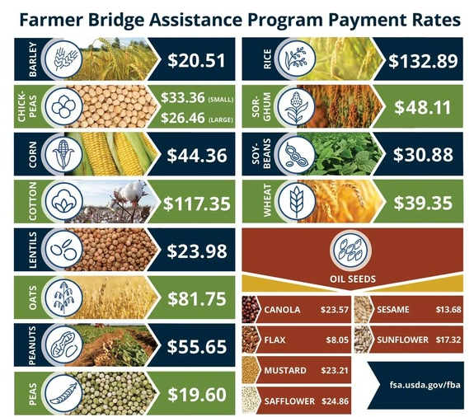
Assistance for Specialty Crop Farmers:
USDA’s Farm Service Agency is providing $1 billion through a one-time bridge payment for specialty crops, sugar, and commodities not covered through the Farmer Bridge Assistance (FBA) program. These bridge payments are authorized under the Commodity Credit Corporation Charter Act. ASCF payments are based on reported 2025 planted acres. Payment rates are expected to be announed later this month.
Conservation Reserve Program (CRP):
The Farm Service Agency (FSA) is accepting offers for Continuous CRP from Feb. 12, 2026, through March 20, 2026. Enrollment for General CRP will run from March 9, 2026, through April 17, 2026. FSA will announce dates for Grassland CRP signup in the near future.
Supplemental Disaster Relief Program (SDRP):
Covers crop, tree, and vine losses due to wildfires, hurricanes, floods, derechos, excessive heat, tornadoes, winter storms, freeze (including a polar vortex), smoke exposure, excessive moisture, qualifying drought, and related conditions occurring in calendar years 2023 and/or 2024. Phase 2 of this program is now available for producers who did not receive insurance or NAP payments but suffered crop losses due to an eligible weather event. The Sign-up deadline is April 30, 2026 for both phase 1 and 2.
Price Support Interest Rates (March 2026):
- Marketing Assistance (Commodity) Loans: 4.50%

- Farm Storage Facility Loans:

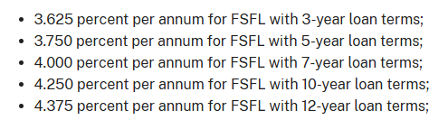
Farm Loan Program Interest Rates (March 2026):

- Operating Loans 4.75%
- Ownership Loans 5.875 %
- Emergency Loans 3.75%

Feel free to reach out if you have any questions.

10. Next Meeting: April 21, 2026

11. Adjournment: 10:23am Motion to adjourn meeting: Made by Jacques DeMars, 2nd Dennis Egan, motion carried.

