Franklin County Soil and Water Conservation District
174 Finney Blvd
Malone, NY 12953
(518) 651-2097
www.fcswcd.org

ATTENDANCE:
MINUTES OF THE REGULAR MEETING OF THE BOARD OF DIRECTORS February 10, 2026

Directors: Ralph Child
Rod Lauzon
Andrea Dumas
Tommy Derouchie

Staff:
Kristin Ballou
Devin Normandeau
Sarah Otis
Shayla Pfendler
Kelly Freeman
Guests:
Colin Bainbridge
Ben Luskin
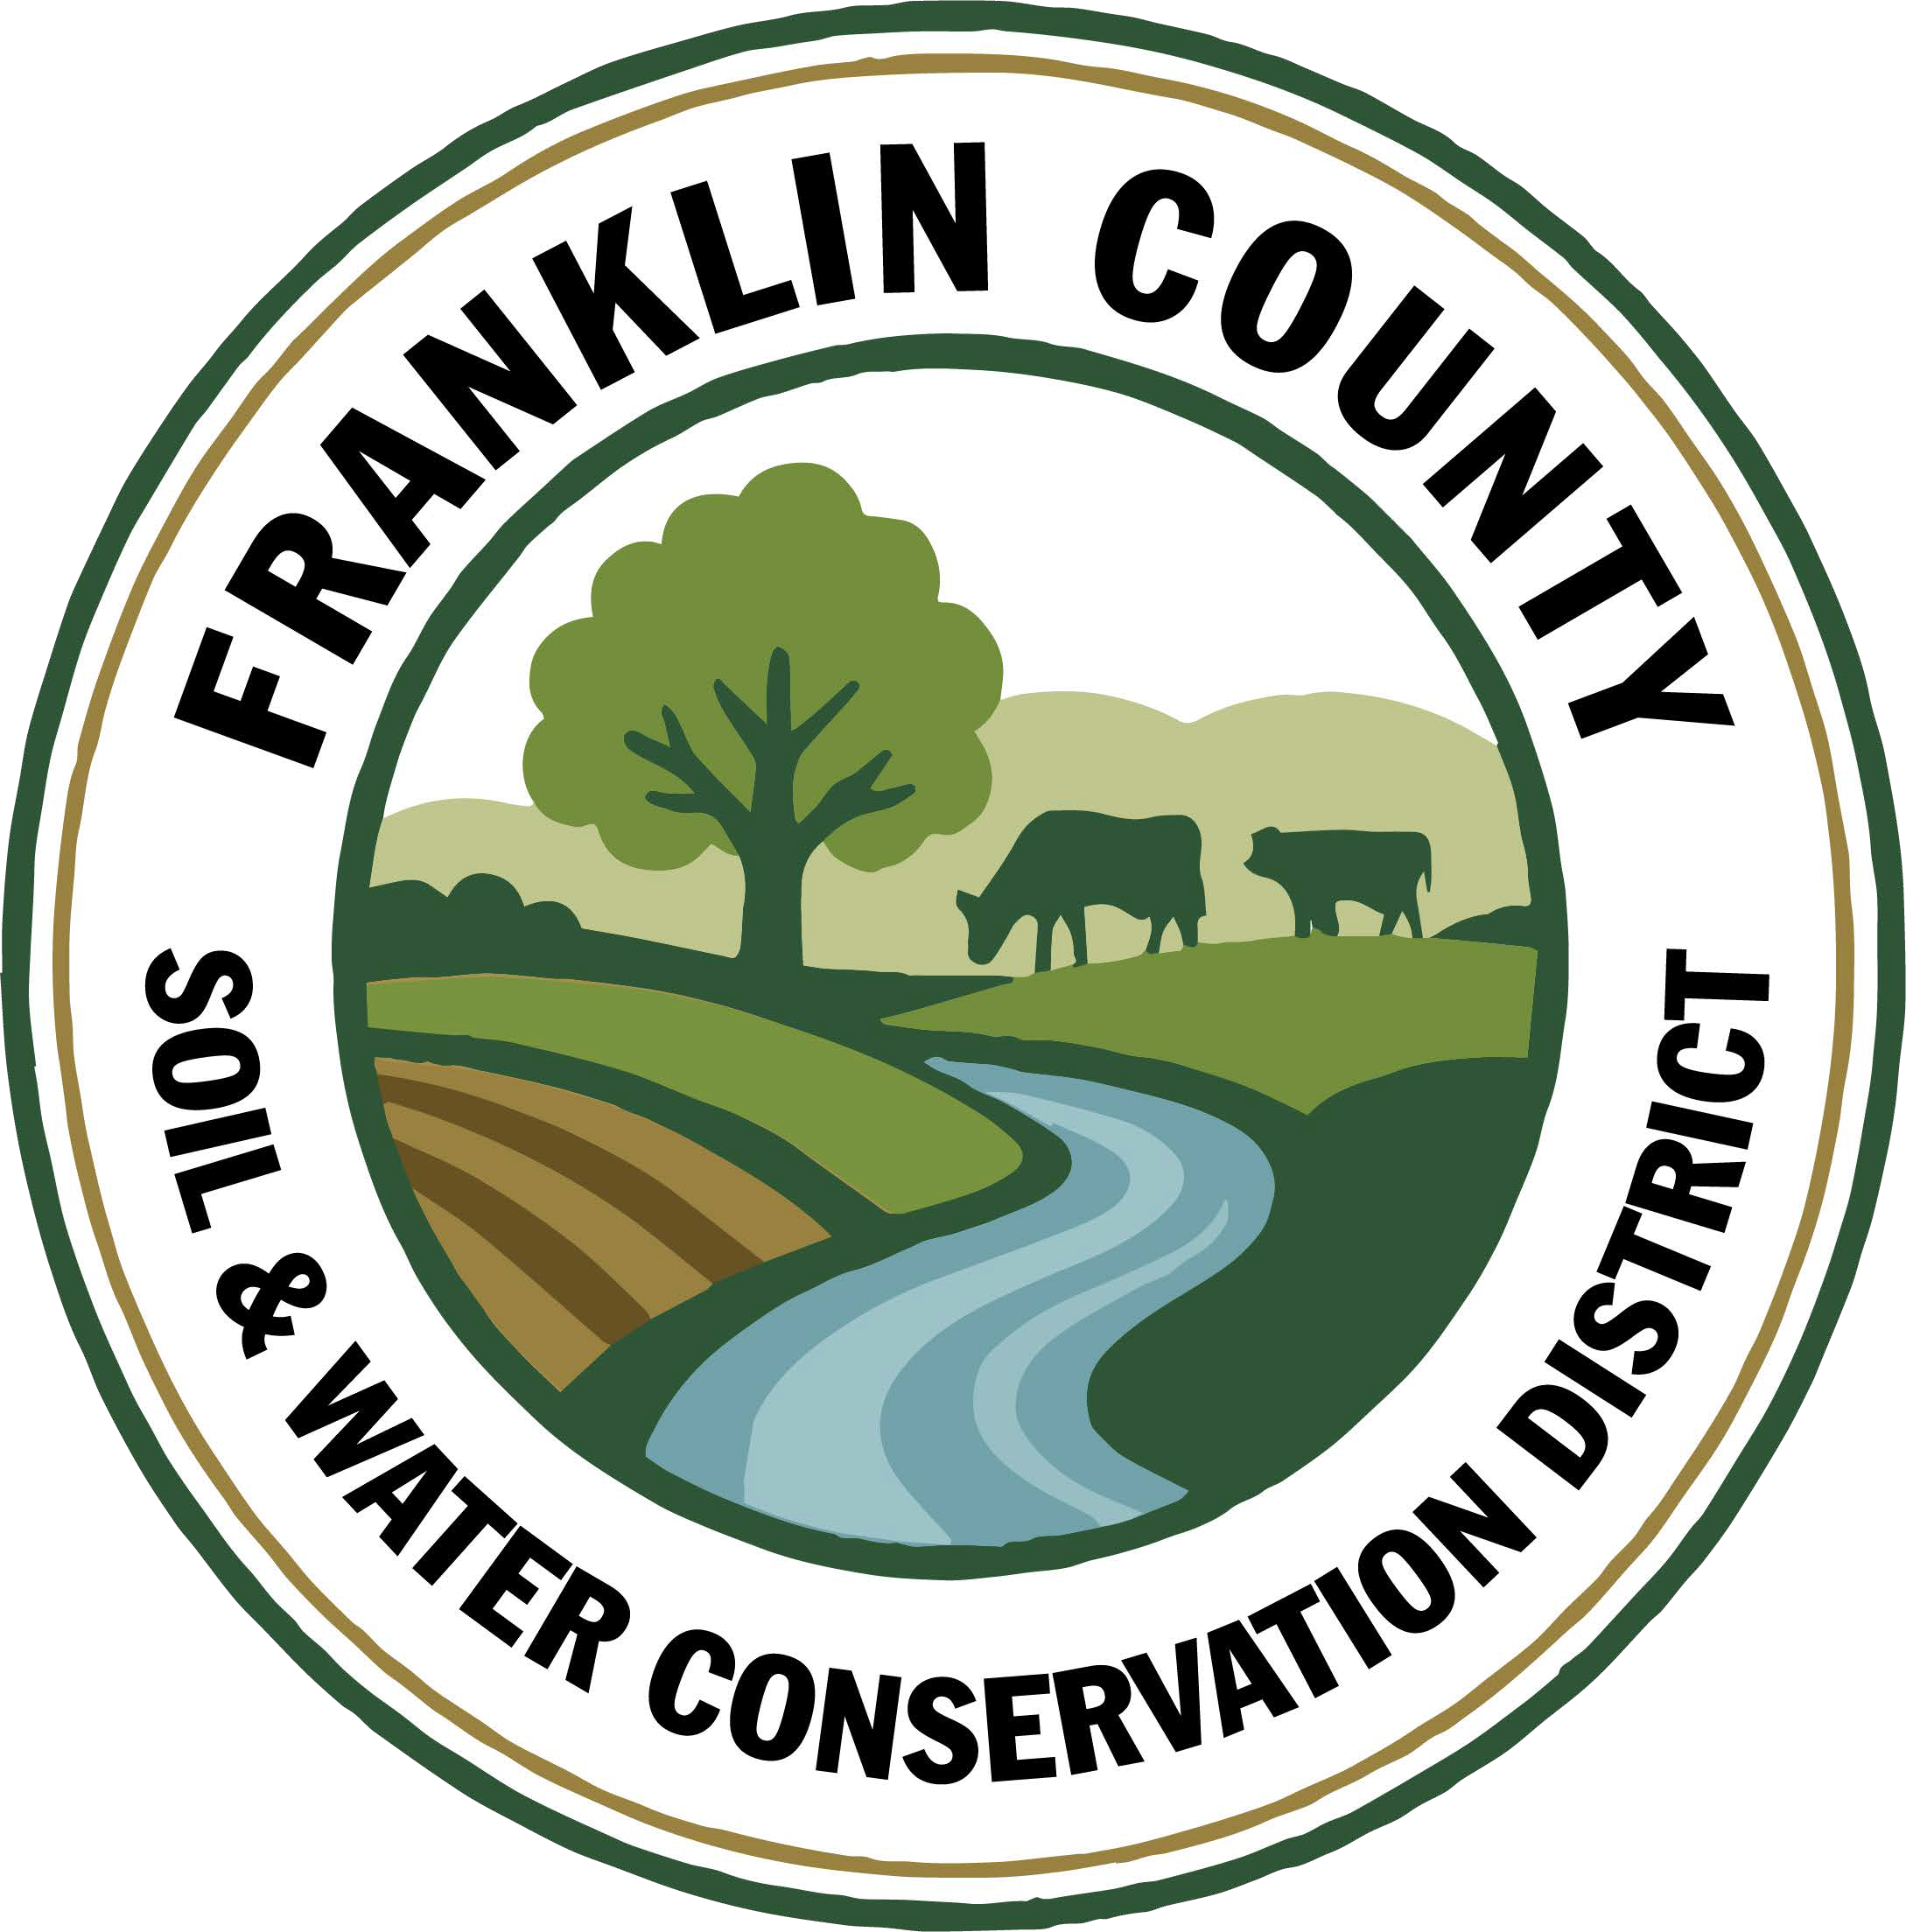
1. Meeting was called to order: Chairman, Ralph Child, called meeting to order at 8:56 AM - Quorum present
2. Meeting Minutes: Motion to approve January 20, 2026 meeting minutes: Motion made by Andrea Dumas, 2nd by Tommy Derouchie. Motion carried.
3. Meeting Minutes from December 19, 2025: Approval to be revisited at March meeting.
4. Meeting Minutes from December 29, 2026: Approval to be revisited at March meeting.
5. Report of Officers:
- Chairman Report: No Report
- Board Member Reports: No Reports
- Correspondence: Erie County SWCD newsletter, M&T Bank Statement, Forestry Source Newspaper, NYACD report, North Country Wind notice of intent, NYACD booklet.

6. Business:
1. Board Member Vacancy application from Jacques DeMars: Motion made to approve application made by Andrea Dumas, 2nd by Rod Lauzon. Motion carried.
2. Email from Donna Kissane regarding snow plowing: Shared correspondence from Donna Kissane, County Manager. Thank you to Andrea for contacting Donna concerning cost of plowing and Donna for contacting Ed at the Franklin County Highway Department to coordinate plowing for next season.
3. Resolution Establishing AEM Planning: Motion made to adopt the resolution for establishing AEM planning to assist staff in determining priority applications by Andrea Dumas, 2nd by Rod Lauzon. Motion carried.
4. Permission for Kristin to sign WQIP Collins Brook Culvert Replacement contract when received: Motion made by Rod Lauzon, 2nd by Tommy Derouchie. Motion carried. Andrea mentioned the need for Park Street culvert replacement, District staff to look into this.
5. 2025 State Reporting: Final reports passed around for any questions or corrections before submitting.
6. Conservation Student Aide Applications: To schedule in person interviews and let Board know when they are in case they would like to participate.
7. Office Repairs: Approval of getting estimates for rain gutters, screen door & solid exterior door for back entrance made by Andrea Dumas, 2nd by Rod Lauzon. Motion carried.
7. Financials:
a. Transfer $123.42 from Part C account to General checking account (Devin CC Part C expense): Motion made by Rod Lauzon, 2nd by Andrea Dumas. Motion carried.
b. Transfer remaining $7.33 from AG NPS Rd 28 Chioniere account to Savings account: Motion made by Rod Lauzon, 2nd by Tommy Derouchie. Motion carried.
c. Close AG NPS Choiniere bank account: Motion made by Rod Lauzon, 2nd by Tommy Derouchie. Motion carried.
d. Transfer $60,000 Part A reimbursement from General checking to Savings when received: Motion made by Rod Lauzon, 2nd by Tommy Derouchie. Motion carried.
e. Transfer $ Performance Measure Part C from General checking to PartC account when received: Motion made by Rod Lauzon, 2nd by Tommy Derouchie. Motion carried.
f. Open WQIP Collins Brook Culvert Replacement checking account: Motion made by Rod Lauzon, 2nd by Tommy Derouchie. Motion carried.
8. Financial Report Approval: Motion made by Rod Lauzon, 2nd by Tommy Derouchie. Motion carried.
9. Reports:
- Kristin Ballou, District Manager
- AEM
  - Working on Forest Conservation Plans as time allows
  - Site visit with staff regarding current and future projects
- Part B – 4 Forest Management Plans – 2026 4 Forest Management Plans Approved
- Meetings/Workshops/Other
  - CWICNY
  - CWICNY Watershed Coordinator meetings and advertising position
  - EFRP – restoration plan development – moving forward again
  - Meeting with producers regarding funding opportunities
  - North Adirondack Regional Envirothon – Planning underway for 2026 event
  - WQS planning Forestry Track
  - Grant reporting and vouchers
  - 2026 North Country Stormwater Tradeshow and Conference Planning
  - State Programs Advisory Committee Meeting
- Grants:
  - Ag. NPS Round 27 – project construction completed, closeout in process
  - Ag. NPS Round 28 – close out documentation submitted – need to return funds
  - Adirondack Community Foundation – Generous Acts Grant – application submitted to support environmental education programing
  - CRF 7 – projects implemented for year 2
  - CRF 8 – projects implemented for year 1
  - CAFO ENMP – 1 project awarded – executed contract received
  - EFRP – award letter signed and executed. Project site visits completed in Franklin and Warren Counties, Forest Restoration Plans being completed – resuming planning
  - Franklin County Septic Grant – application review and closeout document review and approval. Round 5 Funding staff completed an evaluation of eligible waterbodies to determine the number of potential applicants
  - LCBP Covered Barnyard Project – working on contractor bids
  - LCBP Organizational Support – Application submitted to support a technology upgrade
  - Lake Champlain Watershed Capacity Contract – Watershed Coordinator Year 1 reporting submitted, working on DEC comments regarding the Priority project list. Applications for position due 2/20/2026
  - Nature Conservancy Planting with a Purpose Grant – planning for 2026
  - RRAMP and Forest Roads 2 (CWICNY) –all projects completed – waiting on extension - closeout to begin
  - RRAMP and Forest Roads 3 (CWICNY) – contract executed and will be implementing projects next summer, working on an extension
  - Smart Growth Grant – Year 1 field work completed and reimbursed, planning for year 2
  - WQIP Hydroseeding – submitted reporting and voucher for 2024 and 2025 work
  - WQIP NAACC – planning fieldwork for 2026
  - WQIP Collins Brook Culvert Replacement – funding awarded, waiting on contract documents
Next Month – site visits, CWICNY Watershed Coordinator position interviews, LCBP Covered Barnyard Project, Forest Management Plans, septic grant application and closeout material review, grant closeouts, EFRP site visits and restoration plan development, WQS, tree sale prep and bird house construction, NRCS local working group meeting, WQCC meeting
b. Devin Normandeau, District Technician
AEM
Tier 2 site visit
Working on AEM 18 Close Out
Planning AEM 19 conservation plans and projects

Agricultural Assessments
9 completed

Ag NPS
Rd. 27 (Trumble)
- Working on close out
Rd. 31
- Working on applications

CAFO ENMP
CARSADA Dairy

CRF Rd 7
Sent out final 2025 checks

CRF 8
Sent out final 2025 check

Meetings
AgPAC – 2/5

Next Month
AEM 18 Close Out
Tier 3A Plans
AEM Tier 4 Applications
AgNPS 31 applications
Ag Assessment/District Workshop

c. Sarah Otis, District Technician
Part C
- Continued contacting schools interested in tree planting demonstrations to plan and schedule programs
- Annual reporting write ups
- Submitted Generous Acts Grant through Adirondack Community Foundation – asking for $4,700 in funding for more environmental education supplies
- Finished Annual Report Newsletter
- Planned Winter Tracks program for Saranac Lake Library and World Water Day demonstration
- Adirondack Terrestrial Invasive Species Management Grant Application due (4/30)

NARE
- Contacted schools who have not participated in the past

WQCC
- Scheduled next meeting for 2/24 (original date conflict with Adirondack Park Invasive Plant Program partner meeting)

Next Month
- Continue scheduling educational programs with schools and libraries, schedule Arbor Day event, National Invasive Species Awareness week Facebook posts, Designing Flood Resilient Road-Stream Crossings Zoom, World Water Day meeting (2/11), CCE grant writing workshop (2/11), Adirondack Applied Water Quality Conference (2/17), Saranac Lake Free Library animal winter tracks program (2/18), WQCC meeting (2/24), North Country Stream Coalition meeting (3/5),make bird houses, World Water Day(3/21)

d. Shayla Pfendler, District Technician

Part C

Municipal
- Salt Reduction application for 2026 sent out. 2 applications submitted – Town of Franklin, Constable. Bellmont and Bangor are interested
- 2026 Tire recycling locations – Bombay, Tupper, Malone

Tree Sale
- PWP plans began – 200 trees so far, 1 more landowner interested
- 30+ orders. Designated trees for Education & Outreach, Arbor Day, School plantings, Akwesasne Reservation

CWICNY
- SWTS location 2026-2027 finalized. Contacting presenters.
- World Water Day event planning with LCBP
- Database for watershed projects being implemented by Tyler Knapp at Ag & Markets

Grants
- Organizational Support – LCBP

Meetings and Site Visits Attended
- St. Regis Falls site visit – 1/22
- Intro to Soil Health – 1/26
- CWICNY Constant Contact – 1/28
- CWICNY Secretary Bank Account – 1/29
- Moira Stream Crossing – 2/4
- AEM Deliverables – 2/5
- M. Fournier PWP – 2/6
- GFL & Soil Architecture – 2/9

Next Month: Ag District Workshop, CCE Grants Workshop, BBB Program site visit, WQC Paul Smith’s, Animal Tracks Workshop, CWICNY monthly meeting, Soil Morphology, Soil Formation, WQCC, Tree Sale Woodshop, National Invasive’s Week, Soil Formation & Processes, 2026 Local Work Group Meeting, NCSC Meeting, WQS, SWTS, Tree Sale

e. Kelly Freeman, Secretary
Office duties
- Bank transfers & deposits
- NYSLRS report
- Processing Payroll, 941 taxes, & deferred comp
- Bank Statements & reconciliations
- Shredding old paperwork from meeting binders
- Adding information to QB Enterprise
- Updating website
- Assisting other staff with requests
- Worked with Rhonda over the phone in QB Enterprise
- Registered for WQS
- Meeting Minutes
- Updating Working Budget
- Worked with Rhonda over the phone for payroll, reports, reconciliations, monthly payments, etc.
- Rearranging files
Year End
- W-2’s printed out & given to employees (mailed to others)
- 1099 information put together & brought to H&R Block
- 1099’s picked up and mailed to recipients
- Assisted Kristin with yearly reporting
- Reached out to Melissa (SLCSWCD) regarding retirement numbers for report
Tree Sale
- Mailed out flyers
- Entered products in Enterprise
- Invoicing orders
- Creating sales receipts for orders

f. Ben Luskin, NYS SWCC
NYS SWCC News
2025 State Aid to Districts – DUE 2/15: All 2025 annual reporting documents (State Aid, Treasurers Report, Annual Report, etc.) are now available on the SWCC SharePoint https://nysemail.sharepoint.com, under Resources for Districts – State Aid to Districts. All reports are due to the State Committee by February 15, 2026. Please contact Bethany.bzduch@agriculture.ny.gov or your Regional AEA with any questions. If you have questions on the Treasurer’s Report, it is suggested to contact OSC representative directly. This link (http://www.osc.state.ny.us/localgov/contact.htm) will provide regional contact information.

AEM Base Program Round 18 - A reminder that the Final Report/Close Out package for Round 18 of the AEM Base Program is due to the State Committee by February 28th, 2026, (please upload files to your District’s AEM18 folder on SharePoint and email your Regional AEA and Chastity Miller once uploaded). AEM18 close out packages and their CFPs won’t likely be paid until after the Blackout Period if sent after February 20th (depending on the number of Districts submitting and needs for report updates). While it varies, that could mean delays in payments until July 2026. Round 18 documents can be found on SharePoint: https://nysemail.sharepoint.com/sites/Agriculture/SWCC/SitePages/AEM.aspx

AEM Round 19 - Round 19 has kicked off! If you have not sent your 25% Technical Assistance CFP request, please do so before the blackout period! Tier 4 projects are due by May 1st, 2026, so please begin thinking about those projects!
Round 31 Agricultural Non-Point Source Program: The SWCC has made a total of $25 million available through the AgNPS Round 31 RFP for SWCD’s to propose AEM Tier 3 Planning and Tier 4 Implementation projects. Questions on the RFP are due in writing to Jason Kokkinos (Jason.kokkinos@agriculture.ny.gov) by March 2nd, 2026, and proposal submission to SharePoint is due Monday, April 20, 2026 by 4:30 PM.

Claim for Payment Black Out Period Approaching: We are approaching the “Blackout Period” for Fiscal Year 2025-2026. The “Blackout Period” is the time of year (starting April 1st, 2026, lasting until June/July 2026) when payments for programs supported by the Environmental Protection Fund (AGNPS, CRF, EBM, AEM) cannot be processed due to end of the year reporting/accounting. If you will need to request a 25% Advance, 65% BMP Implementation Payment, Subsequent/Interim Payment, or Final Payment prior to the start of the black out period, please email the CFP packet to the appropriate State Committee program manager, regional coordinator and Maureen Irish by Friday, February 20th, 2026. Please remember to only submit claims for payment for contracts that have been fully executed. Questions can be directed to your Regional Coordinator or appropriate Program Manager.

SWCC Meeting: The next meeting of the NYS Soil and Water Conservation Committee will convene on February 17th, 2026. Further details and an agenda for this meeting will be sent out in advance of the meeting. All Districts are encouraged to attend and participate at SWCC meetings. Each meeting agenda provides an opportunity for Conservation Districts to provide reports, updates, or feedback to the SWCC. Reminder – participation at a SWCC meeting is eligible toward PM1, Part C of State Aid to Districts.

ACH Electronic Checks: This day and age, paper check payments are at an all-time high risk of being stolen, forged, or improperly cashed. Based upon these findings, OSC is pushing back on payments that are not being remitted electronically. Agencies are being instructed that there is no guarantee that OSC will continue to remit payments via paper check in the future. If your District is not currently set up with ACH, it is advised that you do so ASAP to avoid any potential delay in payments. Questions can be directed to your Regional AEA.

Funding Finder: https://environmentalbondact.ny.gov/pages/funding-opportunities - This tool allows grant seekers to search for available grant opportunities. The tool can sort grant opportunities by eligible applicant, project type, project phase, etc. For example, Soil and Water Conservation Districts can search for available grant opportunities by selecting “Soil and Water Conservation Districts” in the Eligible Applicant filter option.

Tools and References Wiki Update: The Tools and References Wiki has just been updated for 2025. This is a useful resource for new employees to learn about resources used in New York State conservation planning and design and related fields. Check it out! https://apps.agriculture.ny.gov/SoilWater/tools_references.html

Other Events
Winter Webinar Series - Water Conservation for Small Farms: This series will examine how climate trends are impacting New York Farms, highlight agriculture's role in water quality and share practical strategies that farmers can implement to conserve water, increase resilience to extreme weather, and support improved water quality statewide.
1. Feb 19th, 12:00 PM – 1:00 PM: It Starts with the Soil: Soil Health Practices for Water Conservation, https://us06web.zoom.us/meeting/register/ncFVqHh4SESGb-P7zoue_w#/registration
2. March 19th, 12:00 PM – 1:00 PM: Beyond Soil Health: Integrating Water Conservation Strategies, https://us06web.zoom.us/meeting/register/MzqiiR0PSUSFS5pAa9huVg#/registration

Other Grant Opportunities
NY Great Lakes Basin Small Grants Program: The New York Great Lakes Basin Small Grants Program supports stakeholder-driven efforts to restore and revitalize the State’s Great Lakes region using ecosystem-based management and is funded through the EPF, and administer by NY Sea Grant. NYSG is soliciting proposals up to $40,000 in total costs for projects that advance the goals of the GLAA and implement actions identified in locally supported community
plans. Applications are due by March 27, 2026, at 4:30 p.m https://small-grants-program-ccegeomaps.hub.arcgis.com/pages/apply-for-funding
g. USDA NRCS: NRCS Local Working Group meeting on March 4th at the Saranac Lake library, potential funding announcement for EQIP in June 2026.
h. USDA FSA: No Report
10. Board Training provided by Ben Luskin: District Law & State Aid to Districts

11. Next Meeting: March 17, 2026 @ 9AM

12. Adjournment: Motion to adjourn meeting at 10:36am: Made by Andrea Dumas, 2nd by Rod Lauzon, motion carried.

