Franklin County Soil and Water Conservation District
174 Finney Blvd
Malone, NY 12953
(518) 651-2097
www.fcswcd.org

ATTENDANCE:
MINUTES OF THE REGULAR MEETING OF THE BOARD OF DIRECTORS December 19, 2025

Directors: Ralph Child Dennis Egan
Paul Lauzon Justus Martin Steve Gokey
Tommy Derouchie

Staff:
Kristin Ballou
Devin Normandeau
Shayla Pfendler
Kelly Freeman

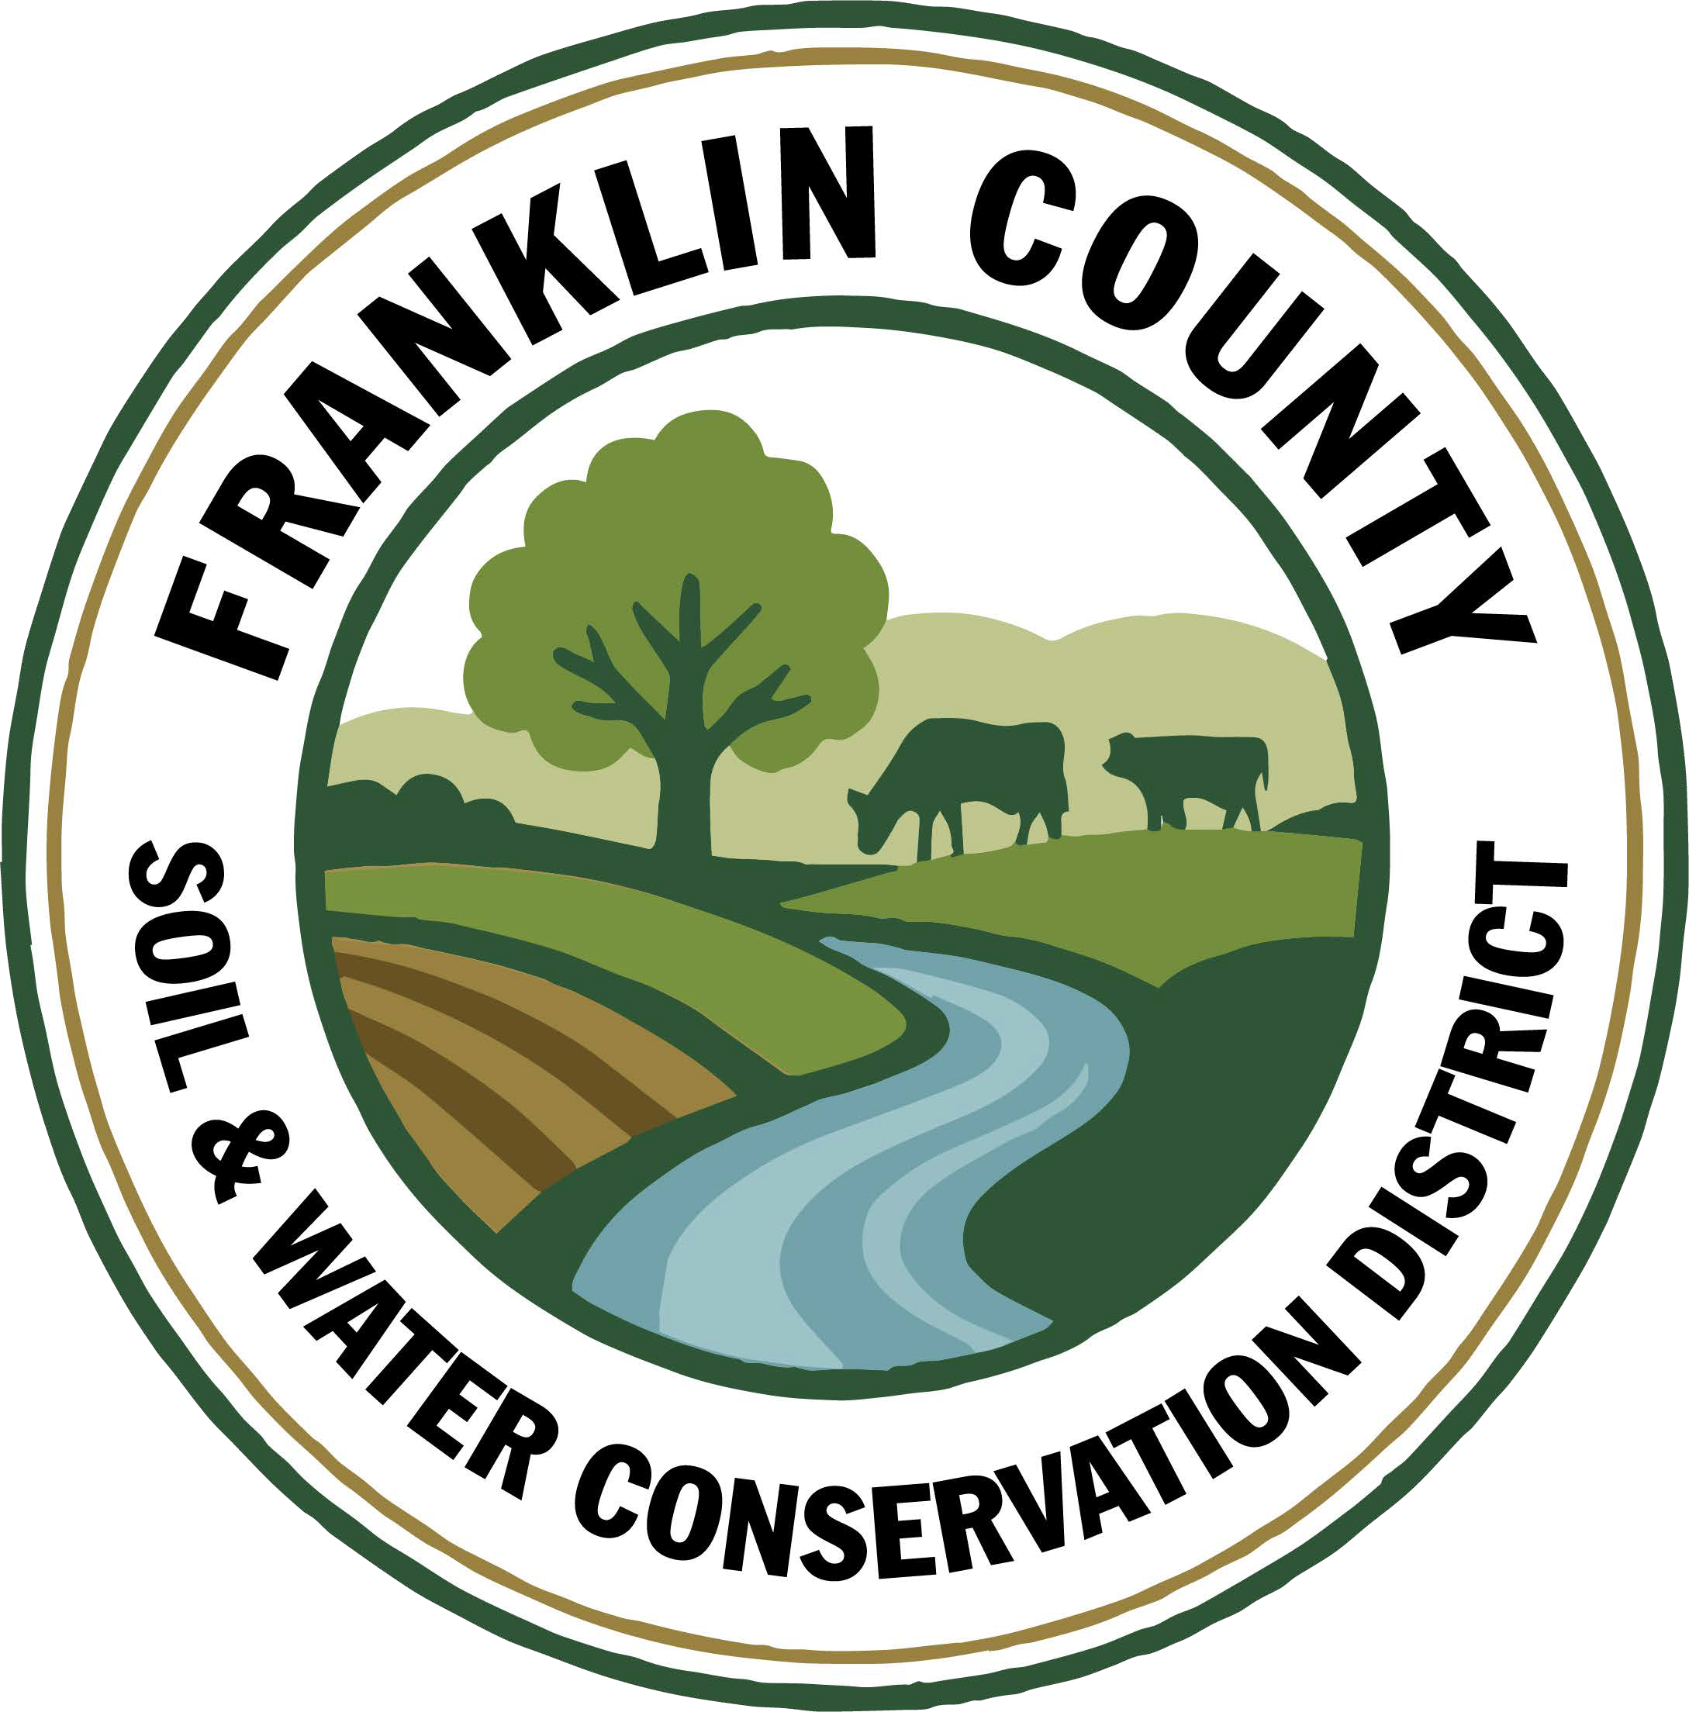
1. Meeting was called to order: Chairman, Ralph Child, called meeting to order at 8:25 AM - Quorum present
2. 8:31 AM Motion to Enter Executive Session to Discuss personnel matters: Made by Paul Lauzon, 2nd by Steve Gokey. Motion carried.
3. 9:11 AM Motion to Exit Executive Session: Motion made by Paul Lauzon, 2nd by Dennis Egan. Motion carried.
4. Meeting Minutes: Motion to approve November 18, 2025 Board meeting minutes: made by Dennis Egan, 2nd by Paul Lauzon, motion carried.
5. Report of Officers:
- Chairman Report: No Report
- Board Member Reports: Last meeting for Paul & Justus.
- Correspondence: NACD & NYACD updates, M&T Bank collateral statement, Blackburn catalog
6. Business:
1. 2026 Budget Approval: Motion made by Steve Gokey, 2nd by Paul Lauzon. Motion carried.
2. 2026 Salary Schedule: Motion made by Paul Lauzon, 2nd by Dennis Egan. Motion carried.
3. Merit Based Table: Motion made by Dennis Egan, 2nd by Steve Gokey. Motion carried.
4. Printer Lease-Quotes from National Business Technologies(current lease) and SymQuest: Motion made to switch to SymQuest by Steve Gokey, 2nd by Paul Lauzon. Motion carried.
5. Snow Removal Contract: Motion made to switch to a flat rate for the season(Nov/Dec bills to be credited to flat rate) by Dennis Egan, 2nd by Steve Gokey. Motion carried.
6. Yard Service Bids from Lavoie’s(current), Michael Gokey, and DarMel Enterprise: Steve Gokey abstains. Motion made to accept DarMel Enterprise bid by Dennis Egan, 2nd by Tommy Derouchie. Motion carried.
7. Franklin County Highway Department Agreement: Paul Lauzon abstains. Motion made to sign agreement by Steve Gokey, 2nd by Dennis Egan. Motion carried.
8. Part C Budget Discussion of Remaining Funds: Discussion tabled until January meeting.
9. AEM Strategy Approval: Motion made by Paul Lauzon, 2nd by Steve Gokey. Motion carried.
10. Norman Ridge AEM 18 Payment($50,000): Motion made by Dennis Egan, 2nd by Tommy Derouchie. Motion carried.
11. Approval to pay Tucker Farms reimbursement for CWICNY Cover Crops($5,000): Motion made by Paul Lauzon, 2nd by Dennis Egan. Motion carried.
12. Jefferson County CNMP Reimbursement: Motion made to cap payment at $6,000 by Dennis Egan, 2nd by Steve Gokey. Motion carried. Motion amended at Special Meeting on December 29th to include the extra $298 of total costs, by Paul Lauzon, 2nd by Dennis Egan. Motion carried.
13. Policies Review: Policies binders sent home with Board Members to review for January meeting.
14. Assignment of Payment: Motion made to hold to the current procedure on the reimbursement process for grants, through the reimbursement to a producer for grant expenditures and not an assignment of payment, by Dennis Egan, 2nd by Tommy Derouchie. Motion carried.

7. Financials:
a. Approval to transfer Sue’s portion of Paychex fee from CWICNY account to General Checking ($65.40): Motion made by Dennis Egan, 2nd by Justus Martin. Motion carried.
8. Financial Report Approval: Motion made by Steve Gokey, 2nd by Paul Lauzon. Motion carried.
9. Reports:
- Kristin Ballou, District Manager
- AEM
  - Working on Forest Conservation Plans as time allows
  - Site visit with staff regarding current and future projects
- Part B – 4 Forest Management Plans – 2026 4 Forest Management Plans Approved
- Meetings/Workshops/Other
  - CWICNY
  - CWICNY Watershed Coordinator meetings
  - EFRP – restoration plan development – moving forward again
  - Meeting with producers regarding funding opportunities
  - WQS planning
  - Town of Chateaugay DEC permit to directionally bore for a water line
  - Assisted Franklin County with identifying soils and their characteristics for the broadband pole replacement project
  - Grant reporting and vouchers
  - Meeting with NYS DOT regarding partnership opportunities
  - Ag Service Provider Gathering
  - EFRP Meeting
  - AEM Strategy Meeting
- Grants:
  - Ag. NPS Round 27 – project construction completed, closeout to begin once paperwork is received from producer
  - Ag. NPS Round 28 – contract expires in January 2026 – closing out
  - CRF 7 – projects implemented for year 2
  - CRF 8 – projects executed for year 1
  - CAFO ENMP – 1 project awarded – executed contract received
  - EFRP – award letter signed and executed. Project site visits completed in Franklin and Warren Counties, Forest Restoration Plans being completed – resuming planning
  - Franklin County Septic Grant – application review and closeout document review and approval. Awaiting release of Round 5 Funding announcement
  - LCBP Covered Barnyard Project – working on contractor bids
  - Lake Champlain Watershed Capacity Contract – Watershed Coordinator started July 7 Year 1 reporting submitted
  - Nature Conservancy Planting with a Purpose Grant – planning for 2026
  - RRAMP and Forest Roads 2 (CWICNY) –all projects completed – closeout to begin
  - RRAMP and Forest Roads 3 (CWICNY) – contract executed and will be implementing projects next summer, working on an extension
  - Smart Growth Grant – Year 1 field work completed and reimbursed
  - WQIP Hydroseeding – submitted reporting and voucher for 2024 and 2025 work
  - WQIP NAACC – fieldwork underway
Next Month – site visits, work with CWICNY Watershed Coordinator, LCBP Covered Barnyard Project, Forest Management Plans, septic grant application and closeout material review, grant closeouts, EFRP site visits and restoration plan development, WQS prep

b. Devin Normandeau, District Technician
AEM
AEM Round 18 Tier 4 Projects:
- Closed Out 6- Closed Out
- Closed Out 7- Closed Out
- Not completing project 8- Closed Out
- Not completing project 9- Closed Out
- Not completing project 10- Closed Out
11- Closed Out
2026-2030 AEM Strategy Plan Completed
ArcPro Training

Agricultural Assessments
1 completed
Working on Ag District/Ag Assessment Workshop

Ag NPS
Rd. 27 (Trumble)
- Collecting proofs of payment

CAFO ENMP
CARSADA Dairy
- Reviewing District-Landowner contract

CRF Rd 7
Waiting for CCA certification

CRF 8
Waiting for invoices and CCA certification

CWICNY-Champlain Basin Cover Crops Grant
Waiting on check

Meetings/Trainings
CCA Conference – 12/9-12/10
AEM Strategy Meeting – 12/11
CWICNY – 12/18

Next Month
AEM 18 Closeout Process
Tier 3A Plans
AEM Tier 4 Project Application

c. Shayla Pfendler, District Technician

Part C

Annual Report
- Began gathering information

Tree Sale
- Indiana Berry Preorder – Confirmed
- PWP plans began – 200 trees so far
- Tree tubes for J. Staib
- Finished Tree Sale Letter and Order form – awaiting Fasprint quote
- Christmas Tree Recycling advertised

CWICNY
- Submitted annual report article to coordinator about Septic Workshops
- Nominated as Secretary to the Committee for 2026

Grants
- Organizational Support – LCBP
  - Due Jan 5th, 2026
  - Funding to be advertised in March 2026, begin projects May 2026
  - Applying for updated technology, software & training

Meetings and Site Visits Attended
- CWICNY – Keene Valley (11/20)
- Tupper Lake SAP (11/25)
- LCBP Grant Writing Support (12/2)
- Ag-Service Provider Gathering @ ADK Food Hub (12/9)
- Stream Smart Workshop (12/17)
- CWICNY @ Fort Ann (12/18)

Next Month: CWICNY, PWP plans, Tree Sale order forms sent, Annual Report, Wood for Tree Sale wildlife houses, BBB application, DJI Account Verification, Submit LCBP Grant, STMW Meeting, Salt Reduction Applications 2026

d. CWICNY Watershed Coordinator
- Develop a priority project list and schedule for project implementation throughout the contract period.
- Data collected from the following existing lists:

  - Forest Erosion
  - 2021 Erosion Assessment
  - 2024 RRAMP
  - LCLGRPB NPS
  - 20-22 303(d) list
  - TMDL plan

Each list has its own formatting, data collection content and grading system. Lists may or may not have matching or overlapping data fields. Standardized criteria are recommended to combine lists.
Data in all existing lists have not been confirmed as outstanding, complete, obsolete or redundant. There is no mechanism of protocol to determine status for many of the lists. Soil and Water District staff will need to determine the status of existing data on these lists. Current total of listed priorities is 742.

- Outreach, Event Planning, Communications
- LCBP Large and Small Education and Outreach grants
  - Small Education and Outreach – North Country Stormwater Tradeshow and Conference -submitted
  - Large Education and Outreach – North Country Stormwater Tradeshow and Conference to be submitted by December 22nd
  - Large Education and Outreach – Waves of Discovery (Day in the Life program (schools), Fishing clinics (family), World Water Day (community) to be submitted by December 22nd

- Follow-up meeting with LCBP staff and Champlain Center Mall for World Water Day planning
- CWICNY Project Management
- Habby Design chosen as website/logo developer; contract signed. Invoice submitted to CWICNY for deposit. Work to begin January 2026 and expected to take four months if there is no client delays
Looking Forward
- Begin work with design house on logo and website
- Begin writing content for website
- Continue to update priority project list
- CWICNY members to determine completed projects from existing priority lists
- Begin development of CWICNY branded promotional pieces once logo is completed
- Begin World Water Day partner planning meetings

e. Kelly Freeman, Secretary
- Printed address labels/labelled Christmas Tree Recycling postcards
- Ordered Quickbooks Enterprise
- Sent Lawn Care RFP to DelMar, Secore, Lavoie’s, and Gokey(picked up)
- Kristin and I met with sales rep from SymQuest(printer)
- Emailed National Business Technologies for a new printer bid
- Updated people in Quickbooks that are 1099 eligible

Office Duties
- Payroll and Deferred Comp weekly
- Retirement submission
- Bank transfers and deposits
- Update minutes on website
- Keep up with email correspondence
- Assist people with water samples
- Make up Endyne sample bags
- Helping staff with any requests

Board Meeting Prep
- Draft minutes from November meeting
- Abstract updated daily
- Bank reconciliations
- Financial report
- Checks printed
- Binder paperwork printed and inserted
- Gathered information for Budget and Part C expenses
In the Next Month
- End of year reporting with Rhonda
- Start to do payroll through Quickbooks
- File away this years paperwork

f. Ben Luskin, NYS SWCC
NYS SWCC News
Happy Holidays & Merry Christmas! The holiday season is here again, a time for remembering our family and friends. Wishing you and all those close to you, a joyous holiday season and a new year of happiness! Travel safe and party smart.

NEW Stream Corridor Management Program: A new Request for Proposals (RFP) for Ecosystem Based Management has been released in the State Financial System (SFS). This opportunity, entitled, Stream Corridor Management Program (RFP0365), can be found in SFS Grants under the Event ID# SCMP25. The RFP and associated documents are now available through SFS. The RFP is posted at https://agriculture.ny.gov/funding-opportunities, as well as the SWCC SharePoint. Please be sure to read all documents carefully. For many, this will be a first time using SFS Grants. Assistance can be found at https://grantsmanagement.ny.gov/, in the form of videos, instructional documents and live training events. If you are unable to access SFS, please contact the SFS Help Desk at (518) 457-7717 or (855) 233-8363 (toll free). Applications for funding must be submitted through the SFS website by 4:00 PM December 8, 2025.

AEM Base Program: The end of AEM Round 18 is rapidly approaching…it’s time start thinking about your close out and all the files and paperwork that will be necessary to submit to the SWCC. Don’t forget to submit those claims for payments for 90% project implementation and interim reports so you have some funding in that account to pay for projects once they are complete this Fall! Also, AEM 5-year Strategies (2026-2030) are due no later than December 31st, 2025. If you need any assistance, please reach out to your AEA and/or Chas Miller (chastity.miller@agriculture.ny.gov)

SWCC Meeting: The next meeting of the NYS Soil and Water Conservation Committee will convene on December 16th, 2025. Further details and an agenda for this meeting will be sent out in advance of the meeting. All Districts are encouraged to attend and participate at SWCC meetings. Each meeting agenda provides an opportunity for Conservation Districts to provide reports, updates, or feedback to the SWCC. Reminder – participation at a SWCC meeting is eligible toward PM1, Part C of State Aid to Districts.

2025 Part C Performance Measures - The end of the year is rapidly approaching and SWCDs should be checking to make sure that your District is fulfilling their obligations for meetings, training, training plans, etc., to be able to earn all the funds that will be available. Please contact your Regional AEA with any questions.

State Aid to Districts: Reminder that 2025 Part B Projects need to be completed by 12/31/2025. Any revised requests need to be submitted to Bethany Bzduch (Bethany.bzduch@agriculture.ny.gov) and approved by 12/31/2025. The 2025 State Aid and Annual Reporting documents are expected to be released to Districts in mid-December.
Other Events
Broome–Tioga Stormwater Coalition Stormwater Winter Training: The Broome–Tioga Stormwater Coalition is inviting you to attend this year's Stormwater Winter Training Series, featuring sessions led by experts from NYSDOT, Cornell Local Roads, Chesapeake Stormwater Network, and more. Trainings run through December 2025 and virtual and in-person options are available. For more information and to register visit, https://forms.office.com/pages/responsepage.aspx?id=VXLj85KHn0ev_ntyH18aMCImQRCG11pPmxNRzPwRR-dUNVlPT1I1OVZTRUFJUEhWVlE1TTA3MkZPMi4u&route=shorturl
- December 4th - 1PM-2:30PM: Post Construction Stormwater Management Practices (SMPs)
- December 9th - 9:00AM-12:00PM: NYS DOT Snow & Ice Training + Facility Tour
- December 11th - 1:00PM-2:30PM: Illicit Discharge Detection and Elimination
- December 16th - 10:00AM-2:30PM: 4-Hour Erosion & Sediment Control

NACD 2026 Annual Meeting: The National Association of Conservation Districts' (NACD) 80th Annual will take place in San Antonio, TX from February 14th- 19th, 2026. Please save the date. To learn more and to register, please visit: https://www.nacdnet.org/event/2026-nacd-annual-meeting/

Other Funding Opportunities
Round 4 Invasive Species Grant Program: https://dec.ny.gov/nature/invasive-species/resources-regulations/invasive-species-grant-program - Applications are due 12/17/2025. An informational webinar was provided on October 16, 2025. The recording can be viewed here: https://meetny-gov.webex.com/recordingservice/sites/meetny-gov/recording/cdd45af08cc6103ebff6e2c52b97e0fc/playback

Great Lakes Restoration Community Grant Program: Restore America's Estuaries recently announced the Great Lakes Restoration Community Grant Program, in partnership with the U.S. Environmental Protection Agency (EPA) Region 5 and the Junction Coalition. Letters of Intent expressing interest in the first round of funding are being accepted through January 16th, 2026. The projects will be selected based on their ability to align with the Great Lakes Restoration Initiative (GLRI) Action Plan IV. Projects must be in the Great Lakes watershed boundaries and include community-led restoration projects, such as controlling invasive species incursions, addressing nonpoint source pollution, and fostering abundant populations of wildlife. https://estuaries.org/glgp-2025-request-for-applications/

g. USDA NRCS: No Report

h. USDA FSA
We have been very busy since the reopening of the government getting caught up on previous work, implementing a variety new diaster programs and starting to prepare for upcoming program enrollment and changes.
County Committee Elections: This year the FSA Committee election is being held to elect a representative for the area consisting of Brainardsville, Burke & Chateaugay. Voting will take place in January, with ballots being counted in February. Typically ballots are mailed in November and counted in December.
Emergency Livestock Relief Program: Enrollment ended November 21st. This program covers increase feed costs due to flooding/excessive rain in 2023 & 2024. Franklin County was on the national eligibility list for this program. Payment rates are established per head of eligible livestock. We are waiting for the National Office to calculate the payment factor.
Supplemental Disaster Relief Program (SDRP): SDRP was part of the Americn Relief Act 2025 to cover crop, tree, and vine losses due to wildfires, hurricanes, floods, derechos, excessive heat, tornadoes, winter storms, freeze (including a polar vortex), smoke exposure, excessive moisture, qualifying drought, and related conditions occurring in calendar years 2023 and/or 2024. Phase 2 of this program is now available for producers who did not receive insurance or NAP payments but suffered crop losses due to an eligible weather event. The Sign-up deadline is April 30, 2026 for both phase 1 and 2.
Milk Loss Program: Provides payments to eligible dairy operations for milk that was dumped or removed without compensation from the commercial milk market because of a qualifying weather event in 2023 and/or 2024. Deadline is Jan. 23, 2026.
On-Farm Stored Commodity Loss Program: Provides assistance to producers who suffered losses of eligible harvested commodities while stored in on-farm structures in 2023 and/or 2024 due to a qualifying natural disaster event. Deadline is Jan. 23, 2026.
Farmer Bridge Assistance Program: $11 billion to provide broad relief to row crop farmers who produce Barley, Chickpeas, Corn, Cotton, Lentils, Oats, Peanuts, Peas, Rice, Sorghum, Soybeans, Wheat, Canola, Crambe, Flax, Mustard, Rapeseed, Safflower, Sesame, and Sunflower. December 19, 2025 is the deadline to verify acreage reports on file with FSA. Payments are expected at the end of February. We do not have any additional information at this time.
Non-insured Crop Disaster Assistance Program
Upcoming deadline to obtain coverage for 2026 are:
- December 31st – Honey & Maple Sap
- February 1st – Greens, herbs, lettuce, onions
- March 15th – Spring Seeded crops
Price Support Interest Rates (December 2025):
- Marketing Assistance (Commodity) Loans: 4.625%

- Farm Storage Facility Loans:

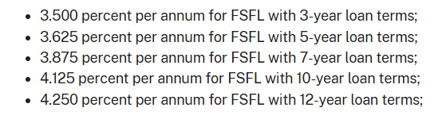

Farm Loan Program Interest Rates (December 2025):

- Operating Loans 4.625%
- Ownership Loans 5.75 %
- Emergency Loans 3.75%

Feel free to reach out if you have any questions!

10. Next Meeting: January 20, 2026

11. Adjournment: 10:23 Motion to adjourn meeting: Made by Paul Lauzon, 2nd Dennis Egan, motion carried.

Respectfully Submitted

Kelly Freeman, Secretary

