Franklin County Soil and Water Conservation District
174 Finney Blvd
Malone, NY 12953
(518) 651-2097
www.fcswcd.org

ATTENDANCE:
MINUTES OF THE REGULAR MEETING OF THE BOARD OF DIRECTORS January 20, 2026

Directors: Ralph Child Dennis Egan
Rod Lauzon
Andrea Dumas
Tommy Derouchie

Staff:
Kristin Ballou
Devin Normandeau
Sarah Otis
Shayla Pfendler
Kelly Freeman
Guests:
Colin Bainbridge
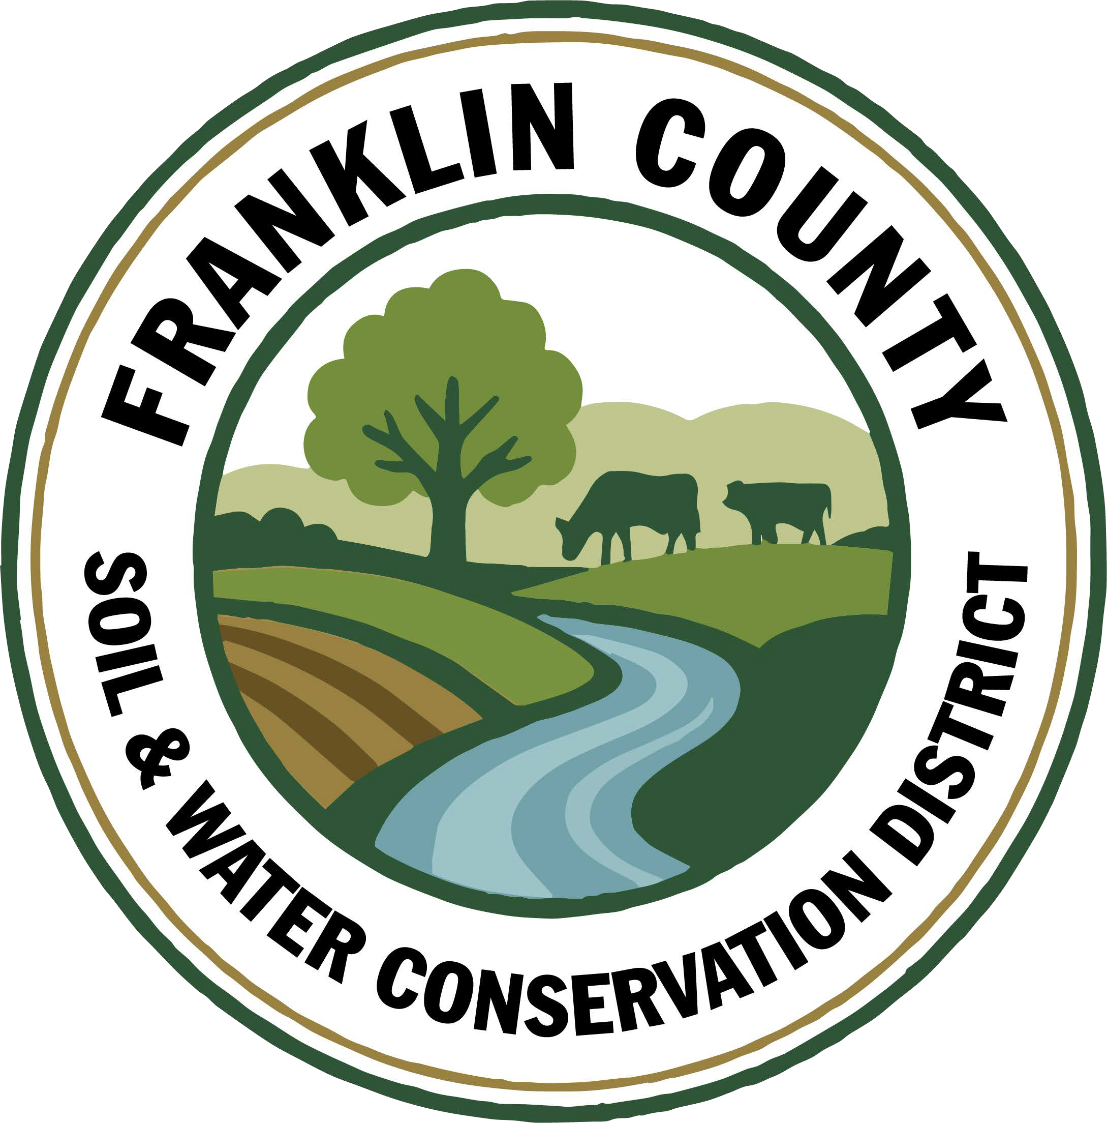
1. Meeting was called to order: Chairman, Ralph Child, called meeting to order at 9:00 AM - Quorum present
2. Introductions: All introduced and welcomed Andrea & Rod as new Legislative Representatives.
3. Ralph Child turned the meeting over to Kristin Ballou for Election of Officers.
Motion to Nominate Ralph Child to Chairman: Made by Dennis Egan, 2nd by Tommy Derouchie. Motion carried.
4. Kristin Ballou turned the meeting back over to Ralph Child.
Motion to Nominate Dennis Egan as Vice Chair: Made by Rod Lauzon, 2nd by Tommy Derouchie. Motion carried.
Motion to Nominate Thomas Derouchie as Treasurer: Made by Dennis Egan, 2nd by Andrea Dumas. Motion carried.
Motion to Appoint Kelly Freeman as Secretary to the Board: Made by Dennis Egan, 2nd by Andrea Dumas. Motion carried.
5. Appointment of Representatives
FCSWCD CWICNY Representative-Kristin Ballou, Sarah Otis as Alternate
NARE Representative-Kristin Ballou
St. Lawrence River Watershed Revitalization Committee Representatives-Sarah Otis & Kristin Ballou
FOIL Retention Officer-Kelly Freeman
AG PAC Representative-Devin Normandeau
WQCC Representatives-Sarah Otis & Shayla Pfendler
Motion to Approve All Representatives: Made by Dennis Egan, 2nd by Rod Lauzon. Motion carried.
6. Meeting Minutes: Motion to approve December 19, 2025 Board meeting and December 29, 2025 Special meeting minutes: Approval to be revisited at March meeting.
7. Report of Officers:
- Chairman Report: No Report
- Board Member Reports: No Reports
- Correspondence: NYACD & NACD Reports, NYCAD Invoice 2026 Assessment ($1500), Letter from Franklin County Legislature appointing Andea & Rod, M&T Bank statement, Grassroots newspaper.

8. Business:
1. Review and Approval of Policies & Employee Handbook: Agreed to revise Designated Holidays to remove Lunar New Year (late January/early February) and replace with Christmas Eve. Motion made by Rod Lauzon, 2nd by Dennis Egan. Motion carried.
2. Create a Meeting Schedule: Motion made to keep current schedule of every third Tuesday @ 9am. February’s meeting date changed to the 10th to accommodate for yearly report approval before due date. Motion made by Dennis Egan, 2nd by Tommy Derouchie. Motion carried.
3. Scheduling of 2026 Training for Board Members: To be scheduled for March.
4. Resolution to Support the District in Submitting up to 7 Applications for AG NPS 31: Motion made by Andrea Dumas, 2nd by Rod Lauzon. Motion carried.
5. Approval of Field Gear and Apparel for Staff up to $3000: Motion made by Andrea Dumas, 2nd by Rod Lauzon. Motion carried.
6. Vacant Board Position: Kristin to reach out to Jacques DeMars to find out if he would be interested.
7. Approval of advertising Conservation Student Aide Position: Motion made to advertise for 2 available positions made by Andrea Dumas, 2nd by Rod Lauzon. Motion carried.
8. Approval of 4 Staff to attend Water Quality Symposium March 10-13th in Rochester-$600 each for 3 Staff, 1 Staff no charge: Motion made by Rod Lauzon, 2nd by Dennis Egan. Motion carried.
9. Approval for 3 Staff to attend Adirondack Applied Water Quality Conference February 17th in Paul Smiths-$45 each: Motion made by Dennis Egan, 2nd by Rod Lauzon. Motion carried.
10. Approval for Kristin to sign RRAMP Rd 2 & RRAMP Rd 3 Contract Extensions: Motion made by Rod Lauzon, 2nd by Tommy Derouchie. Motion carried.
9. Financials:
a. Approval to transfer Sue’s portion of Paychex fee from CWICNY account to General Checking ($26.16): Motion made by Dennis Egan, 2nd by Rod Lauzon. Motion carried.
b. Transfer of $330 From Part C to Equipment/Vehicle Account: Motion made by Dennis Egan, 2nd by Rod Lauzon. Motion carried.
c. Part C remaining funds transfer of $22,535.33 to Equipment/Vehicle account: Motion made by Dennis Egan, 2nd by Rod Lauzon. Motion carried.
10. Financial Report Approval: Motion made by Rod Lauzon, 2nd by Dennis Egan. Motion carried.
11. Reports:
- Kristin Ballou, District Manager
AEM
  - Working on Forest Conservation Plans as time allows
  - Site visit with staff regarding current and future projects
Part B – 4 Forest Management Plans – 2026 4 Forest Management Plans Approved
Meetings/Workshops/Other
  - CWICNY
  - CWICNY Watershed Coordinator meetings and advertising position
  - EFRP – restoration plan development – moving forward again
  - Meeting with producers regarding funding opportunities
  - WQS planning Forestry Track
  - Grant reporting and vouchers
  - 2026 North Country Stormwater Tradeshow and Conference Planning
  - St. Lawrence River Watershed Project Meeting
Grants:
  - Ag. NPS Round 27 – project construction completed, closeout to begin once paperwork is received from producer
  - Ag. NPS Round 28 – contract expires in January 2026 – close out documentation submitted
  - CRF 7 – projects implemented for year 2
  - CRF 8 – projects executed for year 1
  - CAFO ENMP – 1 project awarded – executed contract received
  - EFRP – award letter signed and executed. Project site visits completed in Franklin and Warren Counties, Forest Restoration Plans being completed – resuming planning
  - Franklin County Septic Grant – application review and closeout document review and approval. Round 5 Funding staff completed an evaluation of eligible waterbodies to determine the number of potential applicants
  - LCBP Covered Barnyard Project – working on contractor bids
  - LCBP Organizational Support – Application submitted to support a technology upgrade
  - Lake Champlain Watershed Capacity Contract – Watershed Coordinator Year 1 reporting submitted, working on DEC comments regarding the Priority project list. Applications for position due 2/20/2026
  - Nature Conservancy Planting with a Purpose Grant – planning for 2026
  - RRAMP and Forest Roads 2 (CWICNY) –all projects completed – waiting on extension - closeout to begin
  - RRAMP and Forest Roads 3 (CWICNY) – contract executed and will be implementing projects next summer, working on an extension
  - Smart Growth Grant – Year 1 field work completed and reimbursed, planning for year 2
  - WQIP Hydroseeding – submitted reporting and voucher for 2024 and 2025 work
  - WQIP NAACC – planning fieldwork for 2026
Next Month – site visits, CWICNY Watershed Coordinator position, LCBP Covered Barnyard Project, Forest Management Plans, septic grant application and closeout material review, grant closeouts, EFRP site visits and restoration plan development, WQS prep

b. Devin Normandeau, District Technician
AEM
Working on AEM 18 Close Out
Planning AEM 19 Projects

Agricultural Assessments
1 completed
Ag District/Ag Assessment Workshop – Feb. 11

Ag NPS
Rd. 27 (Trumble)
- Collecting proofs of payment

Rd. 31
- Starting applications
  - Oakes – Manure injection equipment
  - J. Tucker – Covered Barnyard/Manure Storage
  - A. Carter – Covered Barnyard/Manure Storage
  - Poppydale Dairy/Ingle - CNMP

CAFO ENMP
CARSADA Dairy
- Reviewing District-Landowner contract

CRF Rd 7
Waiting for funds to fully reimburse 2025 cover crops

CRF 8
Getting manure injection proof of payment

Next Month
AEM 18 Close Out
Tier 3A Plans
AEM Tier 4 Plans/Applications

c. Sarah Otis, District Technician
Part C
- School Assistance Program- Created Google form application and sent it out to all school districts throughout the county
- Contacted libraries to schedule environmental education programs – Saranac Lake library is interested
- Contacted Schools interested in tree planting demonstrations to plan and schedule programs
- Annual report write ups
- Started application for Generous Acts Grant – asking for funding for more environmental education supplies
- Septic Replacement Program eligible properties list

Tree Sale
- Helped with mailings

WQCC
- Scheduled next meeting for 2/12

Meetings/Trainings
- World Water Day meeting

Next Month
- Continue Generous Acts grant application, Continue scheduling educational programs with schools and libraries, Finish annual report, Ag. Business workshop (1/29), Attend ag. PAC meeting (2/5), CCE grant writing workshop (2/11), WQCC meeting (2/12), Saranac Lake Free Library animal winter tracks program (2/18)

d. Shayla Pfendler, District Technician

Part C

Annual Report
- PWP, EAB, Tire recycling, Salt reduction, Tree sale, NAACC, Christmas tree recycling
- Part C Annual reporting
Municipal
- Salt Reduction application for 2026 sent out
- 2026 Tire recycling locations – Bombay, Tupper, Malone

Tree Sale
- PWP plans began – 200 trees so far
- Tree tubes for J. Staib
- Finished Tree Sale Letter and Order - prints nearly finished
- Christmas Tree Recycling advertised

CWICNY
- Nominated as Secretary to the Committee for 2026, voting member on SWTS committee
- SWTS location 2026-2027 finalized

Grants
- Organizational Support – LCBP
  - submitted Jan 5th, 2026
  - Funding to be advertised in March 2026, begin projects May 2026
  - Applied for updated technology, software & training

Meetings and Site Visits Attended
- CWICNY – 1/15
- SWTS, Warren County – 1/13
- Norman Ridge – 1/8

Next Month: Annual reporting, Tree Sale, SWTA call for Presenters, Ag Business Workshop, Intro to Soil Health Webinar, Soil Architecture, Soil Morphology, SWTS meeting, CCE Grants Workshop, WQCC, Pollinator Steward Certification classes

e. Kelly Freeman, Secretary
Office Duties
- Bank transfers and deposits
- NYSLRS report
- Employee paychecks switched to Fridays & submitted
- Final Paycheck for Sue submitted
- Working on 2025 Treasurer Report
- Updated 2025 Working Budget
- Organized 2025 Deferred Comp paperwork
- Updating address list as needed
- Mailed out Christmas Tree Recycling postcards
- Helped with Tree Sale Flyers
- Talked with Melissa(St. Lawrence) about yearly reporting
Training with Rhonda/Enterprise
- Gathered information for Rhonda to assist with setting up Enterprise
- Worked with Rhonda to add employees to Enterprise
- Did paychecks in Enterprise with Rhonda for first 2 weeks
- Put December transactions into Enterprise
- Reconciliations in both QuickBooks
Meeting Prep
- Organized special December meeting
- Update website minutes and special meeting date/time
- Attend Special meeting 12/30 to do minutes
- Meeting minutes from both Dec meetings drafted
- Cleaned out staff/board members binders

f. Ben Luskin, NYS SWCC
NYS SWCC News
Round 31 Agricultural Non-Point Source Program: The SWCC has made a total of $25 million available through the AgNPS Round 31 RFP for SWCD’s to propose AEM Tier 3 Planning and Tier 4 Implementation projects. This matches the record level of funding from last Round. RFP materials and the Application Form are available now through the Program’s SharePoint Site (AgNPS Round 31 SharePoint) and Department of Agriculture’s Funding Opportunities Website (AGM Funding Opportunities). An informational RFP Webinar will be held (and recorded) over Webex on January 20, 2026 from 10-11:30 AM, questions on the RFP are due in writing to Jason Kokkinos (Jason.kokkinos@agriculture.ny.gov) by March 2, 2026, and proposal submission to SharePoint is due Monday, April 20, 2026 by 4:30 PM.

2025 State Aid to Districts – DUE 2/15: All 2025 annual reporting documents (State Aid, Treasurers Report, Annual Report, etc.) are now available on the SWCC SharePoint https://nysemail.sharepoint.com, under Resources for Districts – State Aid to Districts. All reports are due to the State Committee by February 15, 2026. Please contact Bethany.bzduch@agriculture.ny.gov or your Regional AEA with any questions. If you have questions on the Treasurer’s Report, it is suggested to contact OSC representative directly. This link (http://www.osc.state.ny.us/localgov/contact.htm) will provide regional contact information.

AEM Base Program Round 18 - Options for AEM Base Round 18 Payments: A reminder that the Final Report/Close Out package for Round 18 of the AEM Base Program is due to the State Committee by February 29th, 2026, (please upload files to your District’s AEM18 folder on SharePoint and email your Regional AEA and Chastity Miller once uploaded). AEM18 close out packages and their CFPs won’t likely be paid until after the Blackout Period if sent after February 20th (depending on the number of Districts submitting and needs for report updates). While it varies, that could mean delays in payments until July 2026. Round 18 documents can be found on SharePoint: https://nysemail.sharepoint.com/sites/Agriculture/SWCC/SitePages/AEM.aspx

AEM Base Program Round 19 - If you have not submitted your Round 19 25% Technical Assistance Claim of Payments, please do so as soon as possible to beat that blackout period. Round 19 documents can be found on SharePoint: https://nysemail.sharepoint.com/sites/Agriculture/SWCC/SitePages/AEM.aspx. Questions, please feel free to contact your AEA or Chastity Miller chastity.miller@agriculture.ny.gov.

Claim for Payment Black Out Period Approaching: We are approaching the “Blackout Period” for Fiscal Year 2025-2026. The “Blackout Period” is the time of year (starting April 1st, 2026, lasting until June/July 2026) when payments for programs supported by the Environmental Protection Fund (AGNPS, CRF, EBM, AEM) cannot be processed due to end of the year reporting/accounting. We encourage Districts to consider what projects may be implemented in 2026 and what projects are eligible for advances or reimbursements. If you will need to request a 25% Advance, 65% BMP Implementation Payment, Subsequent/Interim Payment, or Final Payment prior to the start of the black out period, please email the CFP packet to the appropriate State Committee program manager, regional coordinator and Maureen Irish by Friday, February 20th, 2026. Please remember to only submit claims for payment for contracts that have been fully executed. Questions can be directed to your Regional Coordinator or appropriate Program Manager.

SWCC Meeting: The next meeting of the NYS Soil and Water Conservation Committee will convene on February 17th, 2026. Further details and an agenda for this meeting will be sent out in advance of the meeting. All Districts are encouraged to attend and participate at SWCC meetings. Each meeting agenda provides an opportunity for Conservation Districts to provide reports, updates, or feedback to the SWCC. Reminder – participation at a SWCC meeting is eligible toward PM1, Part C of State Aid to Districts.

SWCD Operations Sub-Committee Recording: A recording of the November 2025, SWCD Operations Sub-Committee meeting has been uploaded to Sharepoint. The next sub-committee meeting will convene January 29th, 2026, 1PM – 3PM, via Webex. Details to follow.
https://nysemail.sharepoint.com/:f:/r/sites/Agriculture/SWCC/Mangers%20Meetings/SWCD%20Operation%20Sub-Committee%20(2025)/November%206,%202025%20Meeting?csf=1&web=1&e=0h9d04

Migrating to ArcGIS Pro - Online Class: The Society of American Foresters (SAF), and LandMark Spatial Solutions, LLC are offering a "Migrating to ArcGIS Pro for Foresters: Basic Short Course." You can start the course at any time after January 6th, 2026. The course is designed to be self-paced with an expected completion time of just over 7.5 hours, divided into four sections intended to be completed over four weeks. For more info and to register, visit: https://learn.eforester.org/p/lmss-janfeb-2026?utm_source=Society+of+American+Foresters&utm_campaign=eace66f419-EMAIL_CAMPAIGN_2024_02_23_01_16_COPY_01&utm_medium=email&utm_term=0_-74c5fc6bea-525959153&mc_cid=eace66f419&mc_eid=e9613e17fc#tab-product_tab_overview

Other Events
NACD 2026 Annual Meeting: The National Association of Conservation Districts' (NACD) 80th Annual will take place in San Antonio, TX from February 14th- 19th, 2026. Please save the date. To learn more and to register, please visit: https://www.nacdnet.org/event/2026-nacd-annual-meeting/

2026 Water Quality Symposium: The New York State Conservation District Employees' Association and Soil and Water Conservation Committee are thrilled to announce the 2026 Water Quality Symposium will convene in Rochester, NY. March 10th – 13th, 2026. Please save the dates. Registration information will be available from CDEA shortly.

g. USDA NRCS:
Processing applications for EQIP
h. USDA FSA
Dairy Margin Coverage Program (DMC): Signup for the 2026 program is underway through February 26th. DMC is a risk protection program providing producers with price support to help offset milk and feed price differences. All dairy operations will establish new production history based on the highest pounds of milk marketed in either 2021, 2022 or 2023. New producers will use their first full calendar year of milk production. Tier 1 coverage was raised from 5 million pounds to 6 million. There is a premium discount for producers who lockin their coverage from 2026 through 2031. Milk marketing statements or other documentation is required for production history establishment.
Farmer Bridge Assistance Program: USDA announced the payment rates for the Farmer Bridge Assistance Program (FBA) for eligible commodity crops. FBA payments are based on 2025 planted acres, Economic Research Service cost of production, and the World Agriculture Supply and Demand Estimate Report. Signup is expected to start later in February. More information is forthcoming regarding specialty crops.
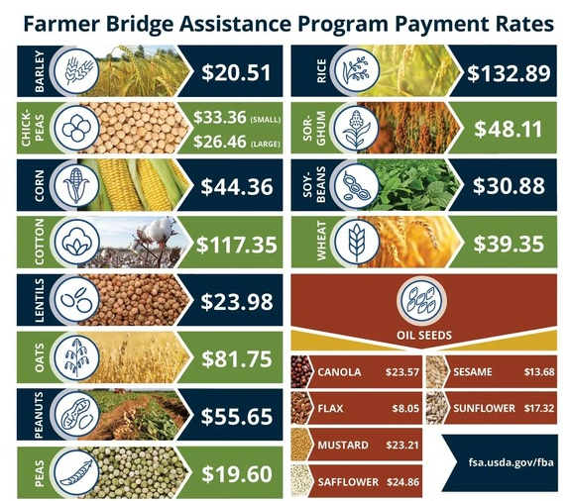

Emergency Livestock Relief Program: Provides payments to offset increased feed costs due to flooding/excessive rain in 2023 and/or 2024. We are still waiting for the National Office to calculate the payment factor.

Supplemental Disaster Relief Program (SDRP): Covers crop, tree, and vine losses due to wildfires, hurricanes, floods, derechos, excessive heat, tornadoes, winter storms, freeze (including a polar vortex), smoke exposure, excessive moisture, qualifying drought, and related conditions occurring in calendar years 2023 and/or 2024. Phase 2 of this program is now available for producers who did not receive insurance or NAP payments but suffered crop losses due to an eligible weather event. The Sign-up deadline is April 30, 2026 for both phase 1 and 2.
Milk Loss Program: Provides payments to eligible dairy operations for milk that was dumped or removed without compensation from the commercial milk market because of a qualifying weather event in 2023 and/or 2024. Deadline is Jan. 23, 2026.
On-Farm Stored Commodity Loss Program: Provides assistance to producers who suffered losses of eligible harvested commodities while stored in on-farm structures in 2023 and/or 2024 due to a qualifying natural disaster event. Deadline is Jan. 23, 2026.
Non-insured Crop Disaster Assistance Program
Upcoming deadlines to obtain coverage for 2026 are:
- February 1st – Greens, herbs, lettuce, onions
- March 15th – Spring Seeded crops
Price Support Interest Rates (January 2026):
- Marketing Assistance (Commodity) Loans: 4.625%

- Farm Storage Facility Loans:

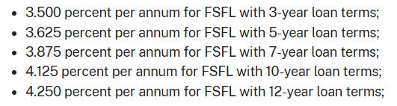

Farm Loan Program Interest Rates (January 2026):

- Operating Loans 4.625%
- Ownership Loans 5.625 %
- Emergency Loans 3.75%

Wishing all of you a Happy New Year. Feel free to reach out if you have any questions.

12. Next Meeting: February 10, 2026 @ 9AM

13. Adjournment: Motion to adjourn meeting at 10:22am: Made by Rod Lauzon, 2nd by Dennis Egan, motion carried.

Respectfully submitted:
Kelly Freeman

