Franklin County Soil and Water Conservation District
174 Finney Blvd
Malone, NY 12953
(518) 651-2097
www.fcswcd.org

ATTENDANCE:
MINUTES OF THE REGULAR MEETING OF THE BOARD OF DIRECTORS October 14, 2025

Directors:
Ralph Child
Dennis Egan
Paul Lauzon
Tommy Derouchie
Justus Martin

Staff:
Kristin Ballou
Devin Normandeau
Shayla Pfendler
Kelly Freeman

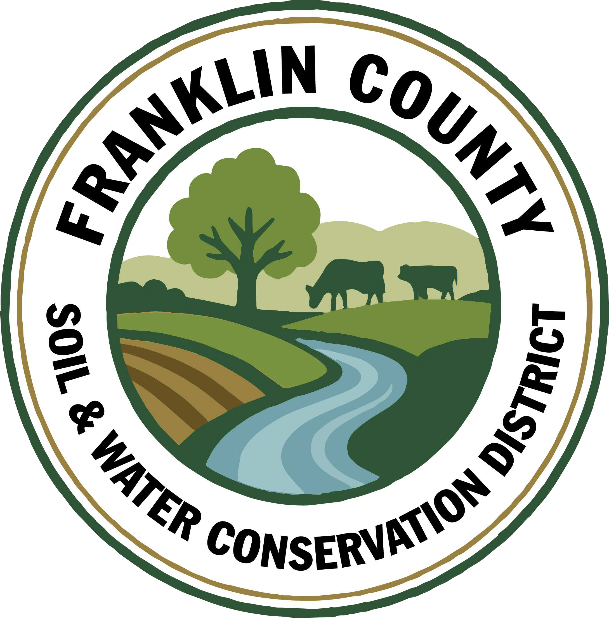
- Meeting called to order: Chairman, Ralph Child, called meeting to order at 9:05 AM - Quorum present
- Meeting Minutes: Motion to approve September 2025 Board meeting minutes: made by Dennis Egan, 2nd by Tommy Derouchie, Motion carried.
- Report of Officers:
- Chairman Report: Wayne Miller tried to contact Ralph, he will follow up with him once he has had time to review the information provided to him via Kristin.
- Board Member Reports: Paul thanks Kristin for helping with Box Elder bugs on Box Elder trees using soap and water solution.
- Correspondence: Correspondence presented
4. Business:
- Annual Plan of Work: Mine Land Reclamation Plans to have a waiting list and to be worked on as able to do so. Wait list will be addressed on a 1st come 1st served basis. Also contact John Carr to see if anyone else is available to do the renewals. Motion made by Paul Lauzon, 2nd by Dennis Egan. Motion carried.
- 2026 Part C Budget: Discussed performance measures and proposed programs for 2026. Motion made by Justus Martin, 2nd by Tommy Derouchie. Motion carried.
- Approval of Forest Roads Girl Scout Agreement: Utilizing CWICNY Forest Roads funding, the District will continue the project that began in 2024 to reduce erosion. Motion made by Justus Martin, 2nd by Dennis Egan. Motion carried.
- Approval for Devin to attend CCA Training in December(travel, hotel, meals, & registration): Motion made by Dennis Egan, 2nd by Paul Lauzon. Motion carried.
- Insurance Renewal: Excellus Blue Cross & Blue Sheild Medical Insurance for 2026. Motion made by Dennis Egan, 2nd by Paul Lauzon. Motion carried.

5. Financials:
a. Transfer Sue’s(Watershed Coordinator) portion of Paychex invoice from CWICNY Coordinator account to General Checking account($52.32): Motion made by Justus Martin, 2nd by Paul Lauzon. Motion carried.

6. Financial Report Approval: Motion made by Dennis Egan, 2nd by Paul Lauzon. Motion carried.

9. Reports:
- Kristin Ballou, District Manager
- AEM
  - Working on Forest Conservation Plans as time allows
  - Site visit with staff regarding current and future projects
- Part B – 4 Forest Management Plans – 2025 4 Forest Management Plans – 1 complete
- Meetings/Workshops/Other
  - CWICNY
  - CWICNY SWTS Meetings and event planning
  - CWICNY Watershed Coordinator meetings
  - EFRP – restoration plan development – paused due to Federal shutdown
  - Meeting with producers regarding funding opportunities
  - CSW planning
  - WQS planning
  - Working with a producer to conduct a wetland restoration project
  - Grant reporting and vouchers
- Grants:
  - Ag. NPS Round 24 – closeout approved, waiting on final reimbursement
  - Ag. NPS Round 27 – project under construction, bid solicitation of Phase 2
  - Ag. NPS Round 28 – contract expires in January 2026
  - CRF 7 – projects planning for year 2
  - CRF 8 – executed contract received
  - CAFO ENMP – 1 project awarded – executed contract received
  - EFRP – award letter signed and executed. Project site visits completed in Franklin and Warren Counties, Forest Restoration Plans being completed – paused due to federal shutdown
  - Franklin County Septic Grant – application review and closeout document review and approval. Awaiting release of Round 5 Funding announcement
  - LCBP Covered Barnyard Project – working on contractor bids
  - Lake Champlain Watershed Capacity Contract – Watershed Coordinator started July 7
  - Nature Conservancy Planting with a Purpose Grant – planning for 2026
  - RRAMP and Forest Roads 2 (CWICNY) – projects planned for 2025; need to plan on closing out at the end of 2025
  - RRAMP and Forest Roads 3 (CWICNY) – contract executed and will be implementing projects next summer, working on an extension
  - Smart Growth Grant – Year 1 field work completed
  - WQIP Hydroseeding – fieldwork underway
  - WQIP NAACC – fieldwork underway
Next Month – site visits, CWICNY SWTS event, work with CWICNY Watershed Coordinator, LCBP Covered Barnyard Project, Forest Management Plans, septic grant application and closeout material review, grant closeouts, EFRP site visits and restoration plan development, WQS prep

- Devin Normandeau, District Technician
AEM
AEM Round 18 Tier 4 Projects:
- Well drilled 6- Closed Out
- Closed Out 7- Closed Out
- Collecting bids 8- Closed Out
- Not started 9- Closed Out
- Access Road started 10- Closed Out
11- Closed Out
Tier 3A Plans and CNMP
2026-2030 AEM Strategy Plan

No Till
Great Plains used 4 times

Ag NPS
Rd. 27 (Trumble)
- Engineered designs complete
- Reviewing bids

CAFO ENMP
CARSADA Dairy
- No updates

CRF Rd 7
All farms participating this year have planted cover crops

CRF 8
Shipman planning on doing manure injection this fall; still working on bids
Met with Ingle; cover crops planted

Meetings/Trainings
Conservation Skills Workshop

Next Month
AEM Tier 4 projects/Tier 3a plans
CRF 9 application(s)
Checking cover crops

- Sarah Otis, District Technician - no report as she is out on maternity leave

- Shayla Pfendler, District Technician

Part C

Stream Crossing Permit
- permit for Trinque family submitted, awaiting approval

Soil Sampling and Home-Visits
- Assisting landowners with yard plant issues; several collections alongside Devin (also AEM)

Saranac Septic Workshop
- Successful turnout ~ 11 guests with great discussion and heavy interest in Franklin County Septic Grant for 2026

CWICNY
- Storm Water Tradeshow
  - Vendor Layout completed, registration for all attendees and vendors closed
  - Received 6 sponsors

WQIP Hydroseeding
- Hydroseeder rented to Mark Hastings (9/19)
- Hydroseeder rented to Jeremy Childs (9/26)
- Job at Bangor Town Hall Successful, Bombay Road Ditch successful

WQIP NAACC
- Roughly 30 culverts assessed - Malone & Westville nearing completion (9/17, 9/24, 9/26)

Meetings and Site Visits Attended
- CWICNY (9/18)
- Jeremy Childs Hydroseed field work (9/22)
- Saranac Lake Septic Workshop (9/22)
- NAACC
- Conskills (10/6-10/9)

*OOO from 9/29-10/3

Next Month: CWICNY, NAACC Assessments, Stormwater Tradeshow, Warren County office, Soil sampling, PWP plans, Final Tree Sale orders (fruits & Shrubs)

- Sue Hagar, Watershed Coordinator
CWINCY members still are working to develop priority projects in their respective districts. Franklin County has listed three. Work with CWICNY members is ongoing
Outreach, Event Planning, Communications
  - Continued work on the North Country Stormwater Tradeshow. Registration was full as of September 30th.
b. Attended the Salt Summit hosted by the Lake George Association
c. Confirmed LCBP was interested and willing to collaborate on the World Water Day at Champlain Centre Mall 2026
d. Participated in a septic workshop with Essex and Franklin counties to fulfill requirements of the overall watershed coordinator grant
CWICNY Project Management
  - Organizational Support grant has moved forward - quotes for professional service requested and received; all quotes have been evaluated and are being presented to the CWICNY board
b. Worked with LCBP representatives to discuss invoicing and grant requirement information

In the next month, closeout on the North Country Stormwater Trades and Conference is to be expected
Grant writing begins for next round of available grant funding (grants TBD)
Work with CWICNY to determine next steps to meet watershed coordinator grant requirements
Being World Water Day planning process if CWINCY approves collaboration

- Kelly Freeman, Secretary
Office Duties
- Payroll and deferred comp weekly
- Retirement submitted, personnel taken off that no longer work for us
- Bank transfers in QB
- Keeping up with emails
- Draft minutes from September meeting
- Added Sue and myself to LENS, deleted Allisa
- Restock Endyne bottles as needed
- Ordered office supplies and Sue’s seats & monitor
- Got paperwork for registering 26’ Chevy set
- Added tabs to Staff/Board binders for business section
- Checked on tire pricing, ordered & made appointments to have put on
- Taking over more roles from Rhonda

Training
- Trained with Rhonda on QB-voiding checks, inputting bank transfers, bank reconciliations, working budget, adjusting bank account report, & backing up QB (9/16/2025)
- NYSLRS Employer Education Seminar (9/25/2025)
- Trained with Rhonda doing reconciliations, financial report and budget (10/8/2025)

AEM Site Visits
- 2 Forestry
- 1 Wetland restoration

- Ryan Cunningham, NYS SWCC
NYS SWCC News
Climate Resilient Farming Program Round 9: CRF Round 9 RFP is available on SharePoint and on the AGM website. There is $24M available in four tracks of funding. Applications are due by 5pm on November 17th via SharePoint. Please submit questions by October 17th to Jennifer Clifford at jennifer.clifford@agriculture.ny.gov.

NEW Stream Corridor Management Program: A new Request for Proposals (RFP) for Ecosystem Based Management has been released in the State Financial System (SFS). This opportunity, entitled, Stream Corridor Management Program (RFP0365), can be found in SFS Grants under the Event ID# SCMP25. The RFP and associated documents are now available through SFS. The RFP is posted at https://agriculture.ny.gov/funding-opportunities, as well as the SWCC SharePoint. Please be sure to read all documents carefully. For many, this will be a first time using SFS Grants. Assistance can be found at https://grantsmanagement.ny.gov/, in the form of videos, instructional documents and live training events. If you are unable to access SFS, please contact the SFS Help Desk at (518) 457-7717 or (855) 233-8363 (toll free). Questions regarding the RFP must be submitted in writing to Lauren Prezorski (Lauren.Prezorski@agriculture.ny.gov) by November 21, 2025. Applications for funding must be submitted through the SFS website by 4:00 PM December 8, 2025. Stay tuned for further information regarding a Request for Proposals Webinar.

SWCC Meeting: The next meeting of the NYS Soil and Water Conservation Committee will convene on October 21st, 2025. In person location options will include Albany and Syracuse. Further details and an agenda will be available soon. Reminder – participation at a SWCC meeting is eligible toward PM1, Part C of State Aid to Districts.

2026 Annual Plan of Work (APOW): It’s time to start updating your APOW for 2026. The deadline for submittal to your AEA is November 1, 2025. This will allow time to review, provide feedback, and recommend to the SWCC for approval by the end of the calendar year. Please don’t hesitate to discuss with your Regional AEA if there are any questions or concerns.

State Aid to Districts:
- 2026 Part B Conservation Project Financial Assistance – Part B proposals are due, November 1, 2025. Projects are to be completed by December 31, 2026. Part B requests should be submitted via email to Bethany Bzduch, bethany.bzduch@agriculture.ny.gov
- 2025 Part B Conservation Projects – The end of year is fast approaching and so is the deadline to complete your 2025 Part B project. If your approved Part B project needs to be revised and/or changed for some reason, here are the steps to seek approval for a new Part B project.
- Seek approval from your SWCD Board (via resolution) to revise the scope of your 2025 Part B project.
- Re-submit by email an updated 2025 Conservation Project Financial Assistance Request form to bethany.bzduch@agriculture.ny.gov
- Approved projects need to be completed by 12/31/2025 and documented in the 2025 Conservation Project Financial Assistance Final Report and filed with the SWCC by 2/15/2026.
- 2025 Part C Performance Measures - As for Performance Measures, the end of the year is rapidly approaching and
SWCDs should be checking to make sure that your District is fulfilling their obligations for meetings, training, training plans, etc., to be able to earn all the funds that will be available. Please contact your Regional AEA with any questions.
- State Aid to Districts Forum Recording Available - The recording of the State Aid to Districts Forum is now available. The recording has been uploaded to SharePoint, but can also be accessed directly by here: State Aid to Districts Forum-20250925 1401-1 - State of NY Enterprise Webex.

National Conservation Foundations - Next Generation Leadership Institute: This is a year-long training program for District Officials currently serving a conservation district who have exhibited strong leadership and would like to carry that leadership further into service of conservation districts. Applications for the program are being accepted through October 31, 2025. To learn more visit https://www.nationalconservationfoundation.org/ngli/ or contact NYACD Executive Director Blanche Hurlbutt or NYACD President Sam Casella.

Other Events
Great Lakes Action Agenda Sub-Basin Work Group Meetings - Save the Dates: DEC Great Lakes program staff are excited
to announce the next round of Great Lakes Action Agenda (GLAA) Sub-Basin Work Group meetings will be held this fall to
provide opportunities to learn updates from NYSDEC Great Lakes Program and partners. To register for in person events, visit https://www.eventbrite.com/cc/fall-2025-glaa-sub-basin-workgroup-meetings-4637763?utm-source=cp&utm-term=odclsxcollection&utm-campaign=social&utm-medium=discovery&utm-content=creatorshare

- Virtual GLAA Work Group Kickoff Meeting, October 15th from 3:00pm-4:30pm. Register for Virtual Meeting
- Lake Erie: October 27th, 1 – 3PM, Reservoir State Park
- Northeast Lake Ontario-St. Lawrence River (LOSLR): October 28th, 1-3PM, Sackets Harbor Union Hotel
- Southeast (SE) Lake Ontario: October 29th, 1 – 3PM, Montezuma Wildlife Center
- Southwest (SW) Lake Ontario: November 3rd, 1 – 3PM, Letchworth State Park

Biochar Field Day at White Feather Farm: Join American Farmland Trust (AFT) at White Feather Farm in Saugerties, NY on Thursday, October 23, from 10:00 AM to 3:00 PM for a hands-on event that will spotlight biochar and climate-resilient farming practices. Registration is free and lunch will be provided. To learn more and to register, visit https://farmland.salsalabs.org/whitefeatherfarmfieldday/index.html

2025 Northeast Region Agribusiness & CCA Conference: Including the Basic Training track for those preparing to take the
CCA exams as well as the Advanced Training track for current CCAs. An in-person track will commence at the Embassy Suites 311 Hiawatha Blvd W, Syracuse, NY 13204, on December 9th and 10th followed by a virtual track will commence on December 16th and 17th, when additional programming will be offered. Look for full agenda and registration details in the coming weeks.

- USDA NRCS – no report
- USDA FSA – no report

- Next Meeting: November 18, 2025 @ 9am

- Adjournment: 10:04 Motion to adjourn meeting. Made by Paul Lauzon, 2nd by Justus Martin, motion carried.

Respectfully Submitted,
Kelly Freeman, Secretary
11/18/2025

