Franklin County Soil and Water Conservation District
174 Finney Blvd
Malone, NY 12953
(518) 651-2097
www.fcswcd.org

ATTENDANCE:
MINUTES OF THE REGULAR MEETING OF THE BOARD OF DIRECTORS September 16, 2025

Directors:
Ralph Child
Dennis Egan
Paul Lauzon
Tommy Derouchie
Justus Martin

Staff:
Kristin Ballou
Devin Normandeau
Shayla Pfendler
Kelly Freeman
Sue Hagar
Others:
Colin Bainbridge-USDA

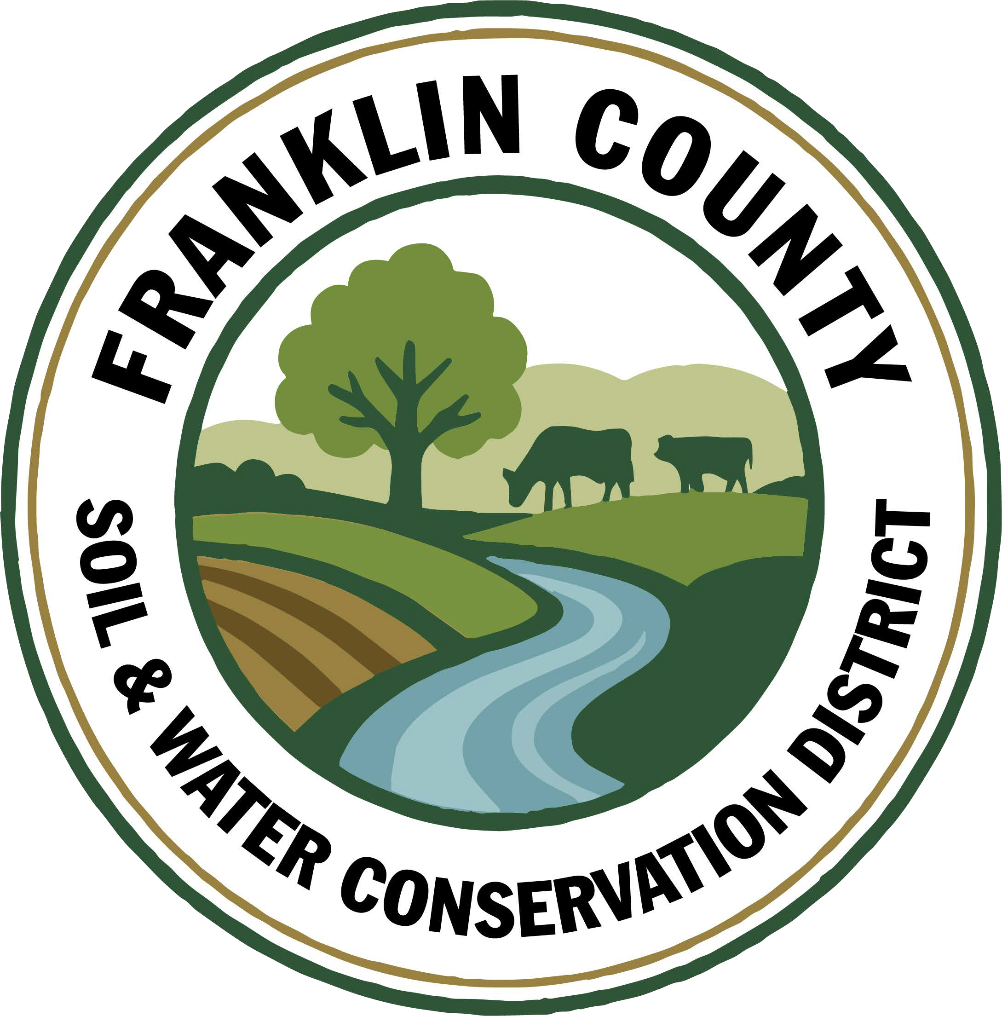
- Meeting called to order: Chairman, Ralph Child, called meeting to order at 9:01 AM - Quorum present
- Meeting Minutes: Motion to approve August 2025 Board meeting minutes: made by Paul Lauzon, 2nd by Dennis Egan, Motion carried.
- Report of Officers:
- Chairman Report: Discussed Wayne Miller’s presentation from last month’s meeting. Agreed that a single sheet fact sheet would be easier to digest.
- Board Member Reports: Nothing to report
- Correspondence: Correspondence presented
4. Business:
- NYACD Division V Representation: There is a seat available on the board if anyone happens to be interested. Information presented to the board on the position and role.
- Approval to purchase lights for the no-till up to $350: Motion made by Dennis Egan, 2nd by Paul Lauzon. Discussed that safety lights and chains normally are included. Devin to check into why they were not included originally. Tommy has a set of magnetic lights if they would work. Dennis rescinded motion. Motion made by Paul Lauzon that if the specs don’t include lights or chain(c.) to purchase them. 2nd by Dennis Egan. Motion carried.
- Approval to purchase chain for the no-till up to $50: Included in Motion for lights.
- Annual Plan of Work: Information given to board members to review. Due November 1st. To be reviewed and approved at October 14th Board Meeting.
- Part B 2026 Approval: Submit proposal for 2026 forest management plans. Look into options to collect and dispose of pesticides for future reference and a potential project in 2027. Motion made by Paul Lauzon, 2nd by Justus Martin. Motion carried.
- Approval to purchase docking station($215 per Deanne), Front seat covers for the Rogue($56), Adobe license($19.99/month), Traveling monitor($120 limited time, regularly $200), & Winter tires for Rogue(waiting for price from county highway garage)for CWICNY: Motion made by Dennis Egan, pending tire quote from the lowest retailer, 2nd by Paul Lauzon. Motion carried.
- Approval to purchase tires for the Dodge truck: Motion made by Dennis Egan, pending quote from the lowest retailer, 2nd by Paul Lauzon. Motion carried.
- CCE Request: Agreed that this is a great idea, but doesn’t pertain to SWCD. Therefore, do not wish to sponsor at this time. Motion made by Dennis Egan, 2nd by Paul Lauzon. Motion carried.
- CRF 9 Resolution: Ralph abstains. Motion made by Dennis Egan, 2nd by Paul Lauzon. Motion carried.
- Approval for 2 staff members(Kristin & Shayla) to travel to North Country Stormwater Tradeshow & Conference, including meals & travel(room is covered): Motion made by Dennis Egan, 2nd by Justus Martin. Motion carried.
- Approval to update our Farm Bureau Membership: Motion made by Dennis Egan to pay for 2026 membership, 2nd by Justus Martin. Motion carried.
- Approval for secretary to attend NYSLRS Education Seminar including room, travel & meals: Motion made by Paul Lauzon, 2nd by Dennis Egan. Motion carried.
- Approval of estimate from Loreman’s for promotional signage($589): Motion made by Dennis Egan, 2nd by Paul Lauzon. Motion carried.
- Part C Budget: information handed out, to be reviewed and approved at October 14th Board Meeting.
5. Financials:
- Approval to switch St. Lawrence River Watershed Project checking account to a savings account as we will be charged a $15 dormant fee per month if not used or closed: Motion made by Dennis Egan, 2nd by Paul Lauzon. Motion carried.
- Transfer Sue’s payroll($1275.15) and portion of Paychex invoices($43.05) from CWICNY Coordinator account to General checking account: Made by Paul Lauzon, 2nd by Justus Martin. Motion carried.
- Transfer $39.09 for Rogue fuel purchase in July from CWICNY Coordinator account to General checking account: Motion made by Justus Martin, 2nd by Tommy Derouchie. Motion carried.
- Approval to pay $1495 for Shayla’s computer: Discussed in previous meetings, put off until we had more information. Motion made by Dennis Egan, 2nd by Paul Lauzon. Motion carried.
e. Open a bank account for AEM 19 Technical Assistance: Motion made by Paul Lauzon, 2nd by Justus Martin. Motion carried.
f. Open a bank account for AEM 19 Implementation: Motion made by Paul Lauzon, 2nd by Justus Martin. Motion carried.
g. Transfer CRF Round 8 funds from General Checking account once payment is received to CRF 8 Account($42,343.75): Motion made by Dennis Egan, 2nd by Justus Martin. Motion carried.
h. Transfer AEM YR 18 funds from General Checking account once payment is received to AEM Soil Sample Account($42,210.00): Motion made by Justus Martin, 2nd by Tommy Derouchie. Motion carried.
i. Transfer CAFO ENMP Round 1 funds from General Checking once payment is received to CAFO ENMP Account($131,731.50): Motion made by Dennis Egan,2nd by Paul Lauzon. Motion carried.
j. Transfer AEM 19 Technical Assistance funds from General Checking account once payment is received to AEM 19 TA($90,000): Motion made by Justus Martin, 2nd by Paul Lauzon. Motion carried.
k. Transfer AEM 19 Implementation funds from General Checking account once payment is received to AEM 19 Implementation($270,000): Motion made by Dennis Egan, 2nd by Justus Martin. Motion carried.
l. Transfer funds from Hydroseeder account to General Checking account($27.24) for hose adapter. Motion made by Paul Lauzon, 2nd by Tommy Derouchie. Motion carried.
6. Financial Report Approval: Motion made by Dennis Egan, 2nd by Paul Lauzon. Motion carried.

9. Reports:
- Kristin Ballou, District Manager
- AEM
  - Working on Forest Conservation Plans as time allows
  - Site visit with staff regarding current and future projects
- Part B – 4 Forest Management Plans – 2025 4 Forest Management Plans – 1 complete
- Meetings/Workshops/Other
  - CWICNY
  - CWICNY SWTS Meetings and event planning
  - CWICNY Watershed Coordinator meetings and site tour
  - EFRP – restoration plan development
  - Wetland site assessments for DEC
  - Meeting with producers regarding funding opportunities
  - CSW planning
  - WQS planning
  - Working with a producer to conduct a wetland restoration project
  - Developing DRAFT 2026 Annual Plan of Work
  - Tire recycling event
- Grants:
  - Ag. NPS Round 24 – closeout approved, waiting on final reimbursement
  - Ag. NPS Round 27 – project under construction, bid solicitation of Phase 2
  - Ag. NPS Round 28 – contract expires in January 2026
  - CRF 7 – projects planning for year 2
  - CRF 8 – executed contract received
  - CAFO ENMP – 1 project awarded – executed contract received
  - EFRP – award letter signed and executed. Project site visits completed in Franklin and Warren Counties, Forest Restoration Plans being completed
  - Franklin County Septic Grant – application review and closeout document review and approval. Awaiting release of Round 5 Funding announcement
  - LCBP Covered Barnyard Project – working on contractor bids
  - Lake Champlain Watershed Capacity Contract – Watershed Coordinator started July 7
  - Nature Conservancy Planting with a Purpose Grant – planning for 2026
  - RRAMP and Forest Roads 2 (CWICNY) – projects planned for 2025; need to plan on closing out at the end of 2025
  - RRAMP and Forest Roads 3 (CWICNY) – contract executed and will be implementing projects next summer, working on an extension
  - Smart Growth Grant – Year 1 field workcompleted
  - WQIP Hydroseeding – fieldwork underway
  - WQIP NAACC – fieldwork underway
Next Month – site visits, CWICNY SWTS event prep, work with CWICNY Watershed Coordinator, LCBP Covered Barnyard Project, Forest Management Plans, septic grant application and closeout material review, grant closeouts, EFRP site visits and restoration plan development, CSW training prep, WQS planning

- Devin Normandeau, District Technician
AEM
AEM Round 18 Tier 4 Projects:
- Well drilled 6- Closed Out
- Closed Out 7- Closed Out
- Collecting bids 8- Closed Out
- Not started 9- Closed Out
- Access Road started 10- Closed Out
11- Closed Out
AEM Interim Payment
Tier 3A Plans and CNMP
2026-2030 AEM Strategy Plan
Surveying ditches and fields
No Till
Both used once
Ag NPS
Rd. 27 (Trumble)
- Engineered designs complete
- Reviewing bids
CAFO WSTSP/ENMP
CARSADA Dairy
- No updates
CRF Rd 7 CRF Rd 8
Contacting farmers for cover crop plans Shipman collecting bids for manure injection; meeting with Ingle
Part C
Assisted with flagging the Bellmont mine
Tire recycling event in Saranac Lake
Hydroseeding
Hydroseeding - Bombay
Ag District
Attended County Ag District hearing
Meetings/Trainings Next Month
Farm Bureau Policy Meeting AEM Tier 3A Plans and Tier 4 Projects
Clinton County Grazing Workshop CRF 9 Applications
Conservation Skills workshop

- Sarah Otis, District Technician - no report as she is out on maternity leave

- Shayla Pfendler, District Technician
Part C
Municipal Assistance
- 3 Successful events of 2025 complete

Invasive Species Project
- Traps taken down and data collected

Tree sale
- PWP landowners beginning planting plans and species to be selected

Stream Crossing Permit
- permit for Trinque family submitted

Soil Sampling and Home-Visits
- Assisting landowners with yard plant issues; creating a database of healthy, native plants to replace

CWICNY
- Areas of concern highlighted with Sue at South end of County
- Storm Water Tradeshow
  - Vendor Layout to be completed, collecting advertisements and info for event program

Meetings and Site Visits Attended
- Hydroseeding
- CWICNY (8/21)
- Bellmont Town Mine Flagging (8/21)
- No-Till Delivery
- WQCC Meeting (9/5)
- Tire Recycling (9/8)
- STMW Meeting (9/9)
- South End Tour (9/10)
- Surveying
Next Month: CWICNY, Saranac Lake Septic Workshop, Conservation Skill Trip in Auburn, Soil sampling, NAACC Assessments, PWP plans

- Sue Hagar, Watershed Coordinator
Events
• CWICNY partnered with Sea Grant and Lake Champlain Basin Program for a fishing clinic held on the Saranac River in Plattsburgh
• Ongoing work for the North Country Stormwater Tradeshow and Conference
Grants
• Submitted an Aquatic Organism Passage (AOP) grant for projects in Essex and Clinton Counties, including an AOP educational component for all counties
Media
• Article published in Adirondack Explorer announcing new CWICNY watershed coordinator https://www.adirondackexplorer.org/stories/new-coordinator-aims-to-unite-lake-champlain-conservation-efforts
• Request from Adirondack Explorer to participate in a phosphorous panel in November
• Participated in a water chestnut harvest in two locations in Plattsburgh. CWICNY named in Public Radio piece. https://www.wamc.org/news/2025-08-28/groups-meet-near-plattsburgh-creek-to-harvest-invasive-water-chestnut
Meetings
• Attended Franklin County Water Quality meeting
• Participated in a DWSP2 meeting for Plattsburgh Town and City
• Met with LCBP staff to develop partnership for World Water Day 2026 event
Tours
• Franklin County tour of problem/hazardous sites that require funding:
Franklin Falls
o Thatcherville Road
o Messink Road
• Visit and USFWS presentation at newly installed salmon weir on the Boquet River in Willsboro
Website
• Finalized quote request for CWICNY website and logo redesign and have begun sending to design houses
Upcoming work
• Ongoing work for the North Country Stormwater Tradeshow and Conference
• Attending Salt Summit in Lake George
• Applying for potential grants, including, but not limited to, education and outreach, planning, implementation, clean water, healthy ecosystems, and recreation
• On-site work for North Country Stormwater Tradeshow and Conference
- Kelly Freeman, Secretary
Office Duties
- Processing payroll and deferred comp weekly
- Submitted Retirement
- Updating our website
- Made appointments for trucks to be inspected
- Helping staff with any requests
- Printing checks for monthly bills
- In the process of looking into our copier lease
- Checked into snow removal (contract good until 6/6/26)
- Draft minutes from last meeting
- Preparing for Board meeting
- Keeping up with email correspondence
- Assisting customers with water and soil samples
- Got Sue’s pay straightened out in Paychex
- Need to get QB account from Paychex fixed
Housework
- Rearranged a couple file cabinet drawers
- Caught up on paperwork to be shredded
- Cleaned up weeds/grapevines in front of building
Training
- Webinar on managing email
- Training with Rhonda 9/16/25
Part C
- Helped at tire recycling event in Saranac Lake 9/8/25

- Ryan Cunningham, NYS SWCC
New York State Soil & Water Conservation Committee
Region 4 Report – September 2025
Submitted by: Ryan Cunningham – Region 4 Associate Environmental Analyst

NYS SWCC News
New SWCC Staff: Please join us in welcoming Gideon Frisbee to the SWCC team. Gideon joins our team as an Associate Environmental Analyst in the program area with Ron Bush, Brendan Jordan, Chastity Miller, and Greg Albrecht supporting technical assistance, training, and certification throughout the AEM framework to SWCD staff, AEM Certified Planners, and other Ag conservation partners. Based on Gideon’s many of years of experience he will also provide valuable insight and assistance to the entire Committee, Division, and Soil and Water Conservation team. Gideon will be based out of Delhi, New York, and work statewide. He can be reached at: gideon.frisbee@agriculture.ny.gov and (518) 646-1133.

NEW Stream Corridor Management Program: A new Request for Proposals (RFP) for Ecosystem Based Management has been released in the State Financial System (SFS). This opportunity, entitled, Stream Corridor Management Program (RFP0365), can be found in SFS Grants under the Event ID# AGM-SCMP25. The goal of this program is to improve water quality, reduce erosion and sedimentation, improve wildlife habitat, and support the long-term health of our natural riparian ecosystems. Funding from this program will support activities that improve or protect stream corridors, including stream stabilization, establishment of riparian buffers, and the reduction of roadside erosion and sedimentation due to runoff and failing culverts systems. The Stream Corridor Management Program is part of New York’s Ocean and Great Lakes Initiative. The Ocean and Great Lakes Initiative works to make connections between ocean and Great Lakes ecosystem health, economic vitality and community well-being.

The RFP and associated documents are now available through SFS. The RFP is posted at https://agriculture.ny.gov/funding-opportunities, as well as the SWCC SharePoint, https://nysemail.sharepoint.com/:f:/r/sites/Agriculture/SWCC/Ecosystem%20Based%20Management/RFP0365%20Stream%20Corridor%20Management%20Program?csf=1&web=1&e=3Ekhwm. Please be sure to read all documents carefully. For many, this will be a first time using SFS Grants. Assistance can be found at https://grantsmanagement.ny.gov/, in the form of videos, instructional documents and live training events. If you are unable to access SFS, please contact the SFS Help Desk at (518) 457-7717 or (855) 233-8363 (toll free). Questions regarding the RFP must be submitted in writing to Lauren Prezorski (Lauren.Prezorski@agriculture.ny.gov) by November 21, 2025. Applications for funding must be submitted through the SFS website by 4:00 PM December 8, 2025. Stay tuned for further information regarding a Request for Proposals Webinar.

SWCC Meeting: The next meeting of the NYS Soil and Water Conservation Committee will convene on September 16th, via Webex. Further details and an agenda will be available as in the week prior to the meeting. Reminder – participation at a SWCC meeting is eligible toward PM1, Part C of State Aid to Districts.

State Aid to Districts Forum: The SWCC will be hosting a State Aid to Districts Forum on September 25th, 2025, 10am-Noon, to discuss the State Aid to Districts Program for 2026. We will provide an update on the status of the Annual Report form and anticipated updates, review changes/updates to Part C performance measures, and have an open discussion regarding other elements of the program.
- Join meeting by clinking link below
https://meetny-gov.webex.com/meetny-gov/j.php?MTID=mefb405fab2332da36b8c24b211ef6c61
- Or join by phone +1-415-527-5035 United States Toll - Meeting number (access code): 2831 786 6720

2026 Annual Plan of Work (APOW): It’s time to start updating your APOW for 2026. The deadline for submittal to your AEA is November 1, 2025. This will allow time to review, provide feedback, and recommend to the SWCC for approval by the end of the calendar year. Please don’t hesitate to discuss with your Regional AEA if there are any questions or concerns.

State Aid to Districts:
• 2026 Part B Conservation Project Financial Assistance – Part B proposals are due, November 1, 2025. Projects are to be
completed by December 31, 2026. Part B requests should be submitted via email to Bethany Bzduch, bethany.bzduch@agriculture.ny.gov.
• 2025 Part C Performance Measures - As for Performance Measures, the end of the year is rapidly approaching and
SWCDs should be checking to make sure that your District is fulfilling their obligations for meetings, training, training plans,
etc., to be able to earn all the funds that will be available. Please contact your Regional AEA with any specific questions that
you may have.

SWCC State Programs Advisory Committee – Recording: A recording of the August 14th, 2025, SPAC meeting has been uploaded to SharePoint. The next SPCC meeting will convene October 16th, 2025, from 1:00 PM – 3:30 PM Details to follow. https://nysemail.sharepoint.com/:f:/r/sites/Agriculture/SWCC/NYS%20SWCC%20State%20Programs%20Advisory%20Committee/2025%20SPAC%20Meeting%20Materials/August%2014,%202025?csf=1&web=1&e=wDJmcq

NYS SWCC Procurement Policy – Best Practices: The purpose of the SWCC procurement policy is to ensure fair and open competition and to ensure public funds are being spent responsibly. The Policy provides guidance to Districts and details the information which is required to be documented to ensure funds are being spent in a responsible way.
- SWCDs must ensure that participating landowners are aware of the procurement requirements prior to the project implementation. Early communication with the landowners is key to procurement success.
- Projects and/or project components that exceed the $20k cost threshold must be competitively quoted.
- Competitive quotes should be reviewed by the farm operator and District and the Price Solicitation section of the form should be signed prior to construction. SWCDs must retain copies of all quotes/bids.
- SWCDs must retain copies of all quotes/bids, record them in the Price Solicitation Record and include them in the project closeout packet submitted to SWCC.
- SWCDs must retain copies of all invoices and proofs of payment for eligible expenses and record them in the Project Expenditure Summary.

Other Events
2025 NY Soil Health and Climate Resiliency Field Days: The NY Soil Health Alliance Group will convene a series of Soil Health & Climate Resiliency Field Day’s throughout the State during 2025. Registration is now live for the September 9th event in Union Springs, the September 11th event in Fillmore, the September 16th event in Rochester, and the September 23rd event in Corning/Bath. Visit, https://www.newyorksoilhealth.org/fielddays/ for more information.

Healing Our Waters Coalition 2025 Great Lakes Conference: Save the date - September 25th – 26th, 2025, at the Hyatt Regency Hotel, Rochester, NY. https://web.cvent.com/event/adc2fab0-c0f9-4015-a0a5-9a00561cbb17/summary

iMapInvasives Training Workshop: Attend to learn how you can become involved with reporting invasive species in your community. Training to convene on September 29th, 2025, 1PM – 3PM, located at the Albany SWCD office, 24 Martin Road, Voorheesville, NY. To register for this event, please contact susan.lewis@ny.nacdnet.net. Registration deadline is 9/22.25

2025 Upper Susquehanna Watershed Forum: There is still time to register for the Upper Susquehanna Watershed Forum to be held at Binghamton University on October 2, 2025. Early registration deadline is 9/10, with a cost of $20. If you register after 9/10, cost increases to $25. So please take a minute to register now! https://docs.google.com/forms/d/e/1FAIpQLSccZGgHAQfJbIlW8TQAxa0zPn0q2nt-2hOdm0v9bCq2U9hb6g/viewform

Biochar Field Day at White Feather Farm: Join American Farmland Trust (AFT) at White Feather Farm in Saugerties, NY on Thursday, October 23, from 10:00 AM to 3:00 PM for a hands-on event that will spotlight biochar and climate-resilient farming practices. Registration is free and lunch will be provided. To learn more and to register, visit https://farmland.salsalabs.org/whitefeatherfarmfieldday/index.html

- USDA NRCS – no report
- USDA FSA – no report

- Next Meeting: October 14th, 2025 @ 9am

- Adjournment: 10:24 Motion to adjourn meeting. Made by Paul Lauzon, 2nd by Justus Martin, motion carried.

Respectfully Submitted:

Kelly Freeman, Secretary

10/14/2025

