Franklin County Soil and Water Conservation District

*174 Finney Blvd*

*Malone, NY 12953*

*(518) 651-2097*

[*www.fcswcd.org*](http://www.fcswcd.org/)

**ATTENDANCE:**

**MINUTES OF THE REGULAR MEETING OF THE BOARD OF DIRECTORS August 19, 2025**

**Directors:**

Ralph Child

Dennis Egan

Paul Lauzon

Steve Gokey

Tommy Derouchie

Justus Martin-via phone

**Staff:**

Kristin Ballou

Devin Normandeau

Sarah Otis

Shayla Pfendler

Kelly Freeman

Sue Hagar

**Others:**

Wayne Miller

Sally White

Rich Gast

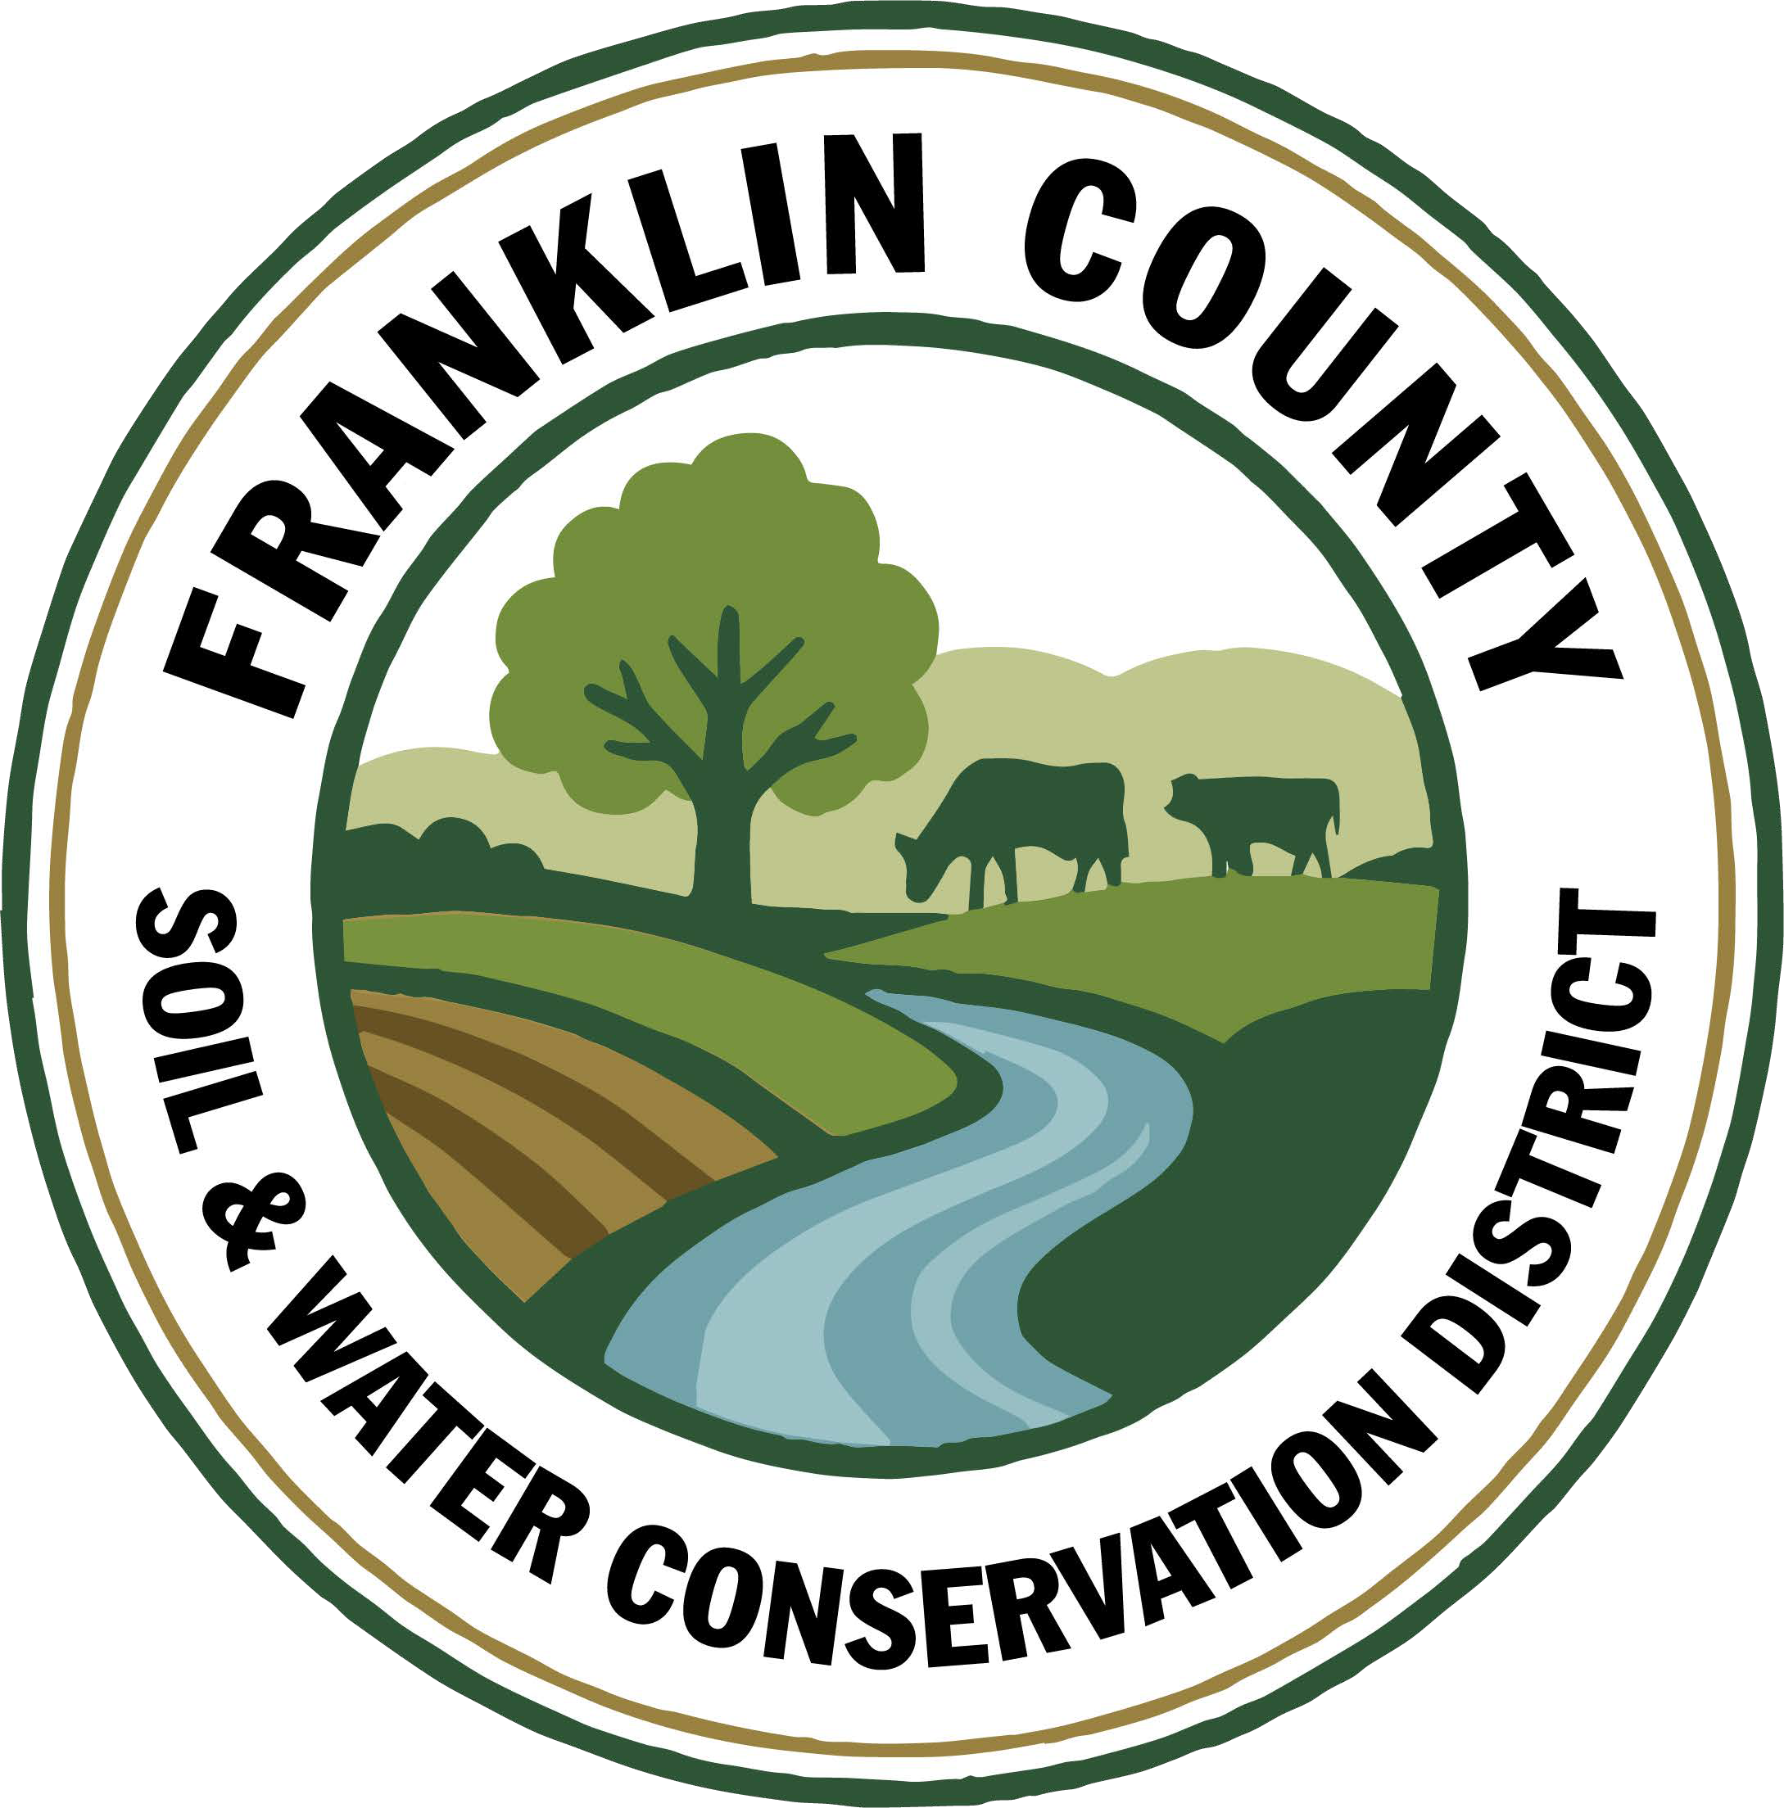

1. **Meeting was called to order:** Chairman, Ralph Child, called meeting to order at 9:06 AM - Quorum present
2. **Introductions:**
3. **Wayne Miller presentation:** Wayne did a short presentation explaining the concerns of PFAS contaminating farmlands through the spreading of Biosolids. He is asking FCSWCD to support a 5 year moratorium on the spreading of biosolids on any NY land, to take other action steps and assist with education. The Board reminded Wayne that the district is non-regulatory. The Board requested that Wayne provide peer reviewed papers that staff can share with farmers and landowners to educate them.
4. **Meeting Minutes: Motion to approve June 2025 Board meeting minutes:** made by Paul Lauzon, 2nd  by Dennis Egan, motion carried.

**Motion to approve July 2025 Board meeting minutes:** as amended, made by Paul Lauzon, 2nd by Steve Gokey, motion carried.

1. **Report of Officers:**
2. **Chairman Report:** No report
3. **Board Member Reports:** No reports
4. **Correspondence:** Passed around, nothing of note

6**.** **Business:**

1. **Approval for staff to attend Conservation Skills Workshop $50/person plus hotel & meals:** Hotel rate is $110/night. Plans to have 2 people for 4 nights & 1 person for 1 night. Made by Steve Gokey, 2nd by Paul Lauzon, motion carried.
2. **Approval to update QuickBooks to Desktop or Enterprise:** to be done pending Rhonda’s input. Made by Paul Lauzon, 2nd by Dennis Egan, motion carried.
3. **Approval for staff to attend Admin Conference $150/person in October:** Possibly 2 people if decided it would be worthwhile. Made by Dennis Egan, 2nd by Tommy Derouchie, motion carried.
4. **Approval to change date of October Board Meeting:** Meeting to be changed to October 14th @ 9am.
5. **Rate for new No Till Drill:** Agreed to keep same rate as older no till drill as the new one is smaller so will have more use per acre.
6. **Donation of Time to Sick Pool:** 40 hours donated by Devin. Made by Dennis Egan, 2nd by Paul Lauzon, motion carried.

**7.Financial Report:** Board requested that the Bank Account Report be sorted, sorting accounts by our regular accounts and grant funded accounts, and to add a third column to show the difference between the last month.

**7a.Approval of Financial Reports**: Made by Dennis Egan,2nd by Paul Lauzon, motion carried.

8. **Financials:**

1. **Approval for CWICNY Coordinator transfer from checking to cover salary expenses:** made by Steve Gokey, 2nd by Tommy Dreouchie, motion carried.
2. **Approval for Part C transfer to cover workshop expenses & soil health program charges from credit cards, once calculated, pending Rhonda returning files to office:** Made by Dennis Egan, 2nd by Paul Lauzon, motion carried.

9. **Reports:**

1. **Kristin Ballou, District Manager**

* AEM
  + Working on Forest Conservation Plans as time allows
  + Site visit with staff regarding current and future projects
* Part B – 4 Forest Management Plans – 2025 4 Forest Management Plans – 1 complete
* Meetings/Workshops/Other
  + CWICNY
  + CWICNY SWTS Meetings and event planning
  + CWICNY Watershed Coordinator meetings and onboarding
  + Project site visits with DEC
  + Meeting with producers regarding funding opportunities
  + Kids day at the Franklin County Fair
  + NRCS local working group meeting
  + CSW planning
  + WQS planning meeting
  + WQIP Applications – submitted 2
* Grants:
  + Ag. NPS Round 24 – working on closeout, submitted to ag & markets for approval
  + Ag. NPS Round 27 – project under construction, bid solicitation of Phase 2
  + CRF 7 – projects planning for year 2, voucher submitted to ag & markets for the no-till drill purchase
  + CRF 8 – executed contract received
  + CAFO ENMP – 1 project awarded – waiting on executed contract
  + EFRP – award letter signed and executed. Project site visits completed in Franklin and Warren Counties, Forest Restoration Plans being completed
  + Franklin County Septic Grant – application review and closeout document review and approval. Awaiting release of Round 5 Funding announcement
  + LCBP Covered Barnyard Project –working on contractor bids
  + Lake Champlain Watershed Capacity Contract – Watershed Coordinator started July 7
  + Nature Conservancy Planting with a Purpose Grant – planning for 2026, waiting to receive 2025 reimbursement
  + RRAMP and Forest Roads 1 (CWICNY) – Closed out
  + RRAMP and Forest Roads 2 (CWICNY) – projects planned for 2025; need to plan on closing out at the end of 2025
  + RRAMP and Forest Roads 3 (CWICNY) – contract executed and will be implementing projects this summer
  + Smart Growth Grant – field work underway
  + WQIP Hydroseeding – fieldwork underway
  + WQIP NAACC – fieldwork underway

Next Month – site visits, CWICNY SWTS event prep, work with CWICNY Watershed Coordinator, LCBP Covered Barnyard Project, Forest Management Plans, septic grant application and closeout material review, grant closeouts, EFRP site visits and restoration plan development, tire recycling event Saranac Lake, CSW training prep, WQS planning

1. **Devin Normandeau, District Technician**

AEM

AEM Round 18 Tier 4 Projects:

1- Draft Engineer Designs 6- Closed Out

2- Closed Out 7- Closed Out

3- Collecting bids 8- Closed Out

4- Not started 9- Closed Out

5- Access Road started 10- Closed Out

11- Closed Out

Tier 2

Tier 3A Plans and CNMP

2026-2030 AEM Strategy Plan

Agricultural District

Meeting held on July 30th

3 properties approved for opt-ins

Ag District hearing on 8/21 at 10:00

No Till

Sent out 1 time

Ag NPS

Rd. 27 (Trumble)

• Engineered designs complete

• Collecting bids

CAFO WSTSP/ENMP

CARSADA Dairy

• Collecting bids

• Site visit with Ryan and Mike Contessa

CRF Rd 7 CRF Rd 8

No updates No updates

Part C

Soil Samples

CCE Summer Enrichment Experience (Brushton)

Fair – Kids Day activities and Dairy Booth

Emerald Ash Borer Trap Monitoring

Hydroseeding

Hydroseeding - Bombay

Meetings/Trainings Next Month

Beekeeping Workshop – 7/16 AEM Tier 3A Plans and Tier 4 Projects

2025 Annual Field Day – 7/24 Meeting with cover crop grant participants

NRCS Working Group Meeting – 8/7

1. **Sarah Otis, District Technician**

**Part C**

* CCE Summer Enrichment Experience Chateaugay and Brushton School Programs: NYS Dairy, Stream Table, Aquatic Macroinvertebrates
* Franklin County Fair Display Set up and Kids Day programs – Stream table program and make your own nature press
* Dairy booth at fair
* Create maps for Septic Replacement Program Workshop
* Check EAB traps

**WQIP-hydroseeding**

* Lantry Road ditch in Bombay
* Franklin County Solid Waste
* Town of Bellmont Sand and Gravel Mine

**WQIP- NAACC**

* Culvert assessments in Malone

**Permits**

* Town of Bellmont Aerial Maps for sand and gravel mine

**Meetings/Trainings**

Beekeeping workshop in Hopkinton

**Next Month**

Mark out Town of Bellmont Life of mine, Hydroseed ditch in Bombay and Bangor Community Center, Tire recycling, Tie up loose ends for when I will be out of the office (School Assistance Program, mine permits, hydroseeding grant etc.)

1. **Shayla Pfendler, District Technician**

**Part C**

**Municipal Assistance**

* Saranac Lake Event scheduled and posted: Sep 8th, 1-3 pm
* Posted on Facebook & Malone Telegram Calendar

**Invasive Species Project**

* Emerald Ash Borer traps have been monitored 4X, confirmation at St. Regis Falls & Chasm Falls location
* St. Regis Falls Campground, Town of Duane Park, Chasm Falls Public site on Salmon River, Bruce Berdette (insecticide treated property}

**Tree sale**

* PWP interested landowners have been contacted, Native plant book made to share
* Potential for Pollinator Garden Program

**Stream Crossing Permit**

* permit for Trinque family working to complete

**NAACC Culvert Assessment training**

* + Continued evaluations

**North Country Stormwater Tradeshow**

* + Vendor registration open - have 9 responses and full presentation load
  + Lake sponsorships filled, contact with ADS to help with presentation

**Meetings and Site Visits Attended**

* + Beekeeping Seminar (7-16}
  + CWICNY- Elizabethtown (7-17}
  + Cooks Farm for Reforestation Grant (7-21}
  + Warren County Reforestation Projects (7-28}
  + StormwaterTradeshow Meeting (8-12}
  + Hydroseeding
  + Franklin County Fair/Dairy Booth
  + Culvert assessments
  + EAB monitoring
  + **Education Events**

**Next Month: NAACC Assessments, Hydroseeding, education events, EAB monitoring, Stormwater Tradeshow planning and meetings, CWICNY meeting, Tire recycling in Saranac Lake**

1. **Sue Hagar, Watershed Coordinator**

* Grants
  + Existing Grants
    - Reviewed all current grants for CWICNY including the Watershed coordinator grant (NYSDEC), Outreach Support grant (includes website revamp) (LCBP), Stormwater tradeshow and conference grant (LCBP)
* Upcoming LCBP grants
  + Review and inform CWICNY board of open or soon to open grant funding available through LCBP
* CWICNY Website
  + Evaluate current website
  + Develop a scope of work for website development (to be covered under Outreach Support grant noted above)
  + Compile list of recommended developers
* Developing a Lending Library
  + Received three rounds of science equipment and supplies donated by Clinton Community College, including, but not limited to, microscopes, science consumables and teaching tools
  + Inventory to be created prior to distribution to CWICNY Soil & Water Conservation District offices and the Clinton-Essex-Franklin Library System.
* Meetings and Tours
  + Initial tours with Clinton, Essex, Franklin, Warren and Washington counties completed or scheduled
  + Meetings with water quality committees scheduled
  + North Country Stormwater Tradeshow and Conference planning committee
  + Karyn Hanson NYSDEC grant coordinator meeting
  + SWCD board meetings visits to be scheduled

1. **Kelly Freeman, Secretary**

• Went to Brushton School w/Sarah to demonstrate the stream table & rain simulator

• Successfully submitted retirement

• Created a spreadsheet for retirement requirements

• Submitted newsletters to post office for distribution

• Was able to get mosquito dunks sent to us again

• Depleting pile of paperwork to be shredded

• Changing user for LENS to be able to add new employees

CWICNY Coordinator

• Trying to get Sue straightened out in Paychex

• Resolved issue with Sue’s phone caller ID

• Set up a meeting binder for Sue

• Ordered rear seat cover and floor mats for the Rogue

• Applied for Sue’s credit card

Training

• Watched 2 Paychex webinars-Time & Attendance and 2025 Tax Bill

• Learning how to do Excel Spreadsheets

• Registered for Managing Email webinar

• Registered for Website Management webinar

• Rhonda should be coming the 29th to do more training

Franklin County Fair

• Helped to set-up and take down Fair booth

• Helped with the stream table for kid’s day(Monday)

• Worked the Dairy booth at Fair 2 afternoons(Monday & Tuesday)

1. **Ryan Cunningham, NYS SWCC**

**NYS SWCC News**

**SWCC Meeting Follow Up:** The NYS Soil and Water Conservation Committee will not meet during the month of August. The next meeting will convene September 16th, via Webex. Further details and an agenda will be available as in the week prior to the meeting. Reminder – participation at a SWCC meeting is eligible toward PM1, Part C of State Aid to Districts.

The NYS SWCC met on Cornell University campus in July and heard from staff and faculty about on-going programs and initiatives that support or are complimentary to the work of Soil and Water Conservation Districts. The information below includes several training and outreach opportunities, as well as opportunities to join collaborative workgroups.

**Training Opportunities/Outreach Opportunities**

**•** 2025 Soil Health and Climate Resiliency Field Days – 16 events planned: https://www.newyorksoilhealth.org/fielddays/

• NYS Local Technical Assistance Program Center hosted by the Cornell Local Roads Program provides a variety of training events that may be applicable to District Staff for a list of current and past offerings: Webinars & Online Training | CALS

• Sign up for the Cornell Small Farms Newsletter to stay informed about events, Small Farms programming, online courses and other information pertaining to farmers and agricultural service providers: Subscribe to Emails - Cornell Small Farms

Interested in joining a workgroup to collaborate on current efforts, share information, resources and project ideas? Please consider reaching out to the contacts below to learn more.

• Aquatic Connectivity Workgroup hosted by the NYS Water Resources Institute: Jared Popoli jp2537@cornell.edu

• Agroforestry hosted by the Cornell Small Farms Program: Connor Youngerman czy2@cornell.edu

• Silvopasture hosted by the Cornell Small Farms Program: Erica Frenay ejf5@cornell.edu, Brett Chedzoy bjc226@cornell.edu

• Small Farms hosted by the Cornell Small Farms Program: Anu Rangarajan (ar47@cornell.edu)

**2026 Annual Plan of Work (APOW):** It’s time to start updating your APOW for 2026. The deadline for submittal to your AEA is November 1, 2025. This will allow time to review, provide feedback, and recommend to the SWCC for approval by the end of the calendar year. Please don’t hesitate to discuss with your Regional AEA if there are any questions or concerns.

**SWCC State Programs Advisory Committee – Recording:** A recording of the June 9th, 2025, SPAC meeting has been uploaded to Sharepoint. The next SPCC meeting will convene August 14th, 2025, from 9:30 AM - Noon. Details to follow. https://nysemail.sharepoint.com/:f:/r/sites/Agriculture/SWCC/NYS%20SWCC%20State%20Programs%20Advisory%20Committee/2025%20SPAC%20Meeting%20Materials/June%209,%202025?csf=1&web=1&e=x02gWx

**SWCD Operations Sub-Committee – Recording:** A recording of the May 15th, 2025, SWCD Operations Sub-Committee meeting has been uploaded to Sharepoint. The next sub-committee meeting will convene August 6th, 2025, via Webex. Details to follow. https://nysemail.sharepoint.com/:f:/r/sites/Agriculture/SWCC/Mangers%20Meetings/SWCD%20Operation%20Sub-Committee%20(2025)/May%2015,%202025%20Meeting?csf=1&web=1

**NRCS Local Working Group Meetings:** The Natural Resources Conservation Service (NRCS) will be holding their annual Local Working Group meetings around New York throughout the month of August. These meetings are open to the public and are also a great opportunity for SWCDs to help discuss and develop local priorities and support local partnerships. Please consider attending a LWG meeting near your SWCD and invite producers you work with as well. For more information about upcoming meetings, please visit: https://www.nrcs.usda.gov/events

**September 2025 Frank Bratt Scholarship:** If you are interested in applying through the Frank Bratt Scholarship, the next deadline for submissions is September 1, 2025. The Scholarship was initiated in 1990 to assist District employees with furthering their professional development and education. This scholarship can encompass a broad range of topics, with emphasis placed upon conservation related topics and subjects related to District function. Application materials available at, https://www.nyscdea.com/frank-bratt-scholarship/. Please email Rebecca Campbell at Wyoming County SWCD (rcampbell@wcswcd.onmicrosoft.com) with any questions.

**Other Events**

**2025 NY Soil Health and Climate Resiliency Field Days:** The NY Soil Health Alliance Group will convene a series of Soil Health & Climate Resiliency Field Day’s throughout the State during 2025. Registration is now live for the August 7th event in Seneca Falls, the August 13th event at Country Crossroads Seed & Feed in Andover, and the August 15th event at the Musgrave Research Farm in Cayuga County. Visit, https://www.newyorksoilhealth.org/fielddays/ for more information.

**Inaugural CDEA Skeet and Trap Tournament:** The first CDEA Skeet and Trap Tournament will be held on September 12th, 2025. Save the Date! More information to follow.

**NACD Northeast & NYACD Annual Event and Training Session:** Save the date! September 21st - 24th, 2025, DoubleTree Hilton, East Syracuse, NY. Register Here: https://docs.google.com/forms/d/e/1FAIpQLSfRx1pUbUGcSNLxIkXqSJIF1KNF2yLEWibJTuZJ-BrGYOJb3A/viewform

**2025 Conservation Skills Workshop –** The 2025 Conservation Skills Workshop will be held October 6th – 9th in Auburn, NY at Auburn Holiday Inn. This workshop is sponsored by the NYS Conservation District Employee’s Association, USDA Natural Resource Conservation Service, and NYS Soil and Water Conservation Committee. This year’s registration rate is $50 per person. Registrations are due no later than September 5th, 2025. https://docs.google.com/forms/d/e/1FAIpQLSfFG3u1TRRBRy-UuVB-prar5CJMPl78GPTb1VRfq-In6h-46A/closedform

**Healing Our Waters Coalition 2025 Great Lakes Conference:** Save the date - September 25th – 26th, 2025, at the Hyatt Regency Hotel, Rochester, NY. https://web.cvent.com/event/adc2fab0-c0f9-4015-a0a5-9a00561cbb17/summary

1. **USDA NRCS** – no report
2. **USDA FSA –** no report
3. **Next Meeting:** September 16,2025 @ 9am
4. **Adjournment: 10:35 Motion to adjourn meeting**. Made by Paul Lauzon, 2nd by Steve Gokey, motion carried.

Respectfully Submitted:

Kelly Freeman

Secretary