Franklin County Soil and Water Conservation District

*174 Finney Blvd*

*Malone, NY 12953*

*(518) 651-2097*

[*www.fcswcd.org*](http://www.fcswcd.org/)

**ATTENDANCE:**

**MINUTES OF THE REGULAR MEETING OF THE BOARD OF DIRECTORS July 15, 2025**

**Directors:** Ralph Child Dennis Egan

Paul Lauzon Justus Martin Steve Gokey

**Staff:**

Kristin Ballou Devin Normandeau Sarah Otis

Shayla Pfendler

Kelly Freeman

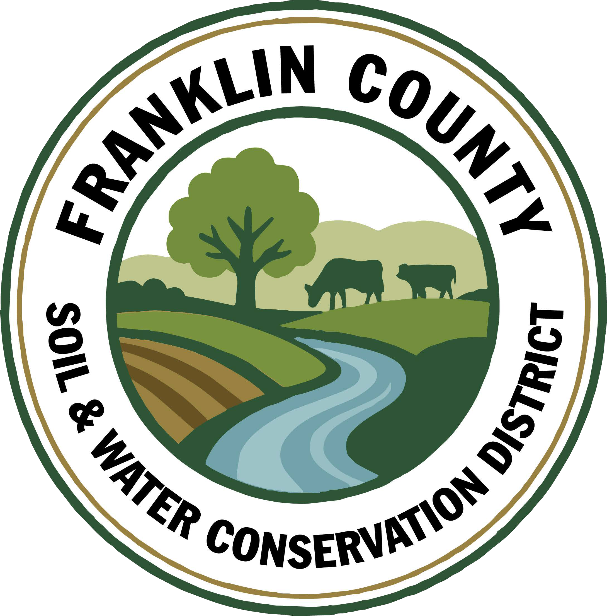

1. **Meeting was called to order:** Chairman, Ralph Child, called meeting to order at 9:01 AM - Quorum present
2. **Meeting Minutes: Motion to approve June 2025 Board meeting minutes:** made by Dennis Egan, 2nd by Paul Lauzon, motion carried. Motion withdrawn by Dennis Egan as a full quorum from the previous meeting was not present.
3. **Report of Officers:**
4. **Chairman Report:** Chairman periodically stops by the office to see if anything is needed from him. For personal reasons, he may be less available in the coming months.
5. **Board Member Reports:** Dennis Egan is willing to help out in any absences of the Chairman. Paul Lauzon and Justus Martin both received emails from Ed Lockwood concerning an NRCS contract for Jason Hastings.

Discussion ensued regarding the program.

1. **Correspondence:** 
   * 1. Devin’s received an interview through North Country Public Radio. The interview ran live on July 9,2025 and the online article is now available.
     2. Letter from Ag & Markets awarded AEM Round 19 for a total of $660,000 over a 3 year contract, to support technical assistance and project implementation.
     3. Ag Non Point Source Round 30 non-award letters received for the St. Regis Water Quality & Trout River Storage. 145 applications were received and only 50 were awarded.

4. **Business:**

a. **Sign Revised AEM 19 agreement for services term agreement with Jefferson County Soil & Water**

**Conservation District**: adjustments to the hourly rate and agreement dates set to align with 3 year AEM

1. contract dates.. Motion to renew agreement made by Paul Lauzon, 2nd by Dennis Egan, motion carried.

b.**Internal annual audit update:** Rhonda explained to Kristin that the audit was covered at the February

2025 meeting when the 2024 treasurer’s report was reviewed by the board prior to the submission to the

NYS Office of the Comptroller.Moving forward as financials are approved each month at regular board

meetings the Annual Audit requirements will be met. The board is free to request to conduct an audit at

any time they would like to further review any financial documentation.

1. **Expend Up to $100 for Senior Center Event:** Sarah is continuing to offer educational programing to

students and adults through the new Part C Environmental Education Program. Sarah would like up to $100 to use for the purchase of materials for a program at the Brushton Senior Center. Motion made by Dennis Egan, 2nd Paul Lauzon, motion carried.

1. **Apply for a District Credit Card for the Watershed Coordinator:** Approval to apply for a District Credit Card for the CWICNY Watershed Coordinator Position for use when travelling for meetings and events. Motion made by Dennis Egan, 2nd Paul Lauzon, motion carried.
2. **Permission for District Staff to sign AEM Contract:** The District received the award letter stating that the NYS Soil & Water Conservation Committee has awarded the Franklin County Soil and Water Conservation District funding for their AEM Base Program Round 19 Action Plan. The District staff requests permission to sign this contract once received. Motion made by Justus Martin, 2nd Steve Gokey, motion carried.
3. ****Submit Letter of Support for Frontier Harvest Fund Microenterprise Funding Application and support application review and ranking:** The District received a request from the Franklin County Economic Development Corporation to support their application for the Frontier Harvest Fund, a microenterprise grant program they are applying for through the New York State Office of Community Renewal. Motion made by Justus Martin, 2nd Dennis Egan, motion carried.
4. **Allow for Wayne Miller to offer a Presentation on his research of Biosolids:** Wayne Miller reached out to the District to inquire about presenting at the next SWCD Board Meeting. SWCD Board meetings are open to the public. SWCD’s are also no-regulatory. All agreed to respond to Wayne Miller’s email and ask him to attend the August 2025 meeting. However, only 5-10 minutes will be able to be allocated on the agenda for public comments.

**h. Submit County Appropriation Request for 2026:** Kristin provided a draft of the documents prepared

for the Franklin County Allocation Request. This information was reviewed by the board. Kristin is to

email all of the information to the County Manager and inquire about scheduling a meeting to discuss

the programs and services the SWCD currently offers and see how we can better work with Franklin

County to serve the residents and municipalities.

**5.Financial Report:** This was not emailed to Board members before meeting as Rhonda was not able to come

until the day before meeting. Ralph wondered if the discrepancies from before had been resolved. Kristin

explained that Rhonda switched to a new company in QuickBooks, which gave us a fresh start and all old issues

were left with the old companies. Paul appreciates that the financial reports are so clear and are no longer

repetitive making them much easier to review and understand now. Motion to approve financial report made by

Paul Lauzon, 2nd Dennis Egan, motion carried.

1. Transfer RRAMP 1 funds from General Checking to RRAMP 1 Account, once received, to Pay Outstanding Invoices-Motion made by Dennis Egan, 2nd by Steve Gokey, motion carried.
2. Close RRAMP 1 Account Once Payments Are Made and the account balance is $0-Motion made by Steve Gokey, 2nd by Paul Lauzon, motion carried.
3. Transfer Ag NPS Round 24 funds from General Checking, once received, to Ag NPS Round 24 account: These funds are to reimburse the District for Grant Administration Project Supervision, and remaining farm payments -Motion made by Dennis Egan, 2nd by Justus Martin, motion carried.
4. Approve Remaining Balance to Oakes($690.00)-Motion made by Paul Lauzon, 2nd by Dennis Egan, motion carried.
5. Transfer Remaining District Share to Savings($10,202.00)-Motion made by Paul Lauzon, 2nd by Dennis Egan, motion carried.
6. Close Ag NPS 24 Oakes Account once payments are made and the account balance is $0-Motion made by Paul Lauzon, 2nd by Steve Gokey, motion carried.
7. CRF 7
8. When Balance is Received, Transfer $28,200.00 from General checking to CRF 7 account-Motion made by Denis Egan, 2nd by Steve Gokey, motion carried.
9. Transfer $15,000.00 From CRF 7 account to Savings, to replace the funds that were used to purchase the new No-Till drill-Motion made by Justus Martin, 2nd by Paul Lauzon, motion carried.
10. Transfer $13,200.00 From CRF 7 account to No Till Account, to replace the funds that were used to purchase the new No-Till drill-Motion made by Steve Gokey, 2nd by Dennis Egan, motion carried.
11. **Reports:**
12. Kristin Ballou, District Manager

- AEM

- Working on Forest Conservation Plans as time allows

- Site visit with staff regarding current and future projects

- Part B – 4 Forest Management Plans – 2025 4 Forest Management Plans – 1 complete

- Meetings/Workshops/Other

- CWICNY

- CWICNY SWTS Meetings and event planning

- CWICNY Watershed Coordinator meetings and onboarding

- Project site visits

- Meeting with producers regarding funding opportunities

- NAACC Training

- Sexual Harassment Training

- American Tree Farm Inspector Training

- Grants:

- Ag. NPS Round 24 – working on closeout, submitted to ag & markets for approval

- Ag. NPS Round 27 – project under construction, nearing completion of Phase 1

- CRF 7 – projects planning for year 2, voucher submitted to ag & markets for the no-till drill purchase

- CRF 8 – waiting on executed contract

- CAFO ENMP – 1 project awarded – waiting on executed contract

- EFRP – award letter signed and executed. Opening meeting on 7/16/2025

- Franklin County Septic Grant – application review and closeout document review and approval

- LCBP Covered Barnyard Project –working on contractor bids

- Lake Champlain Watershed Capacity Contract – Watershed Coordinator started July 7

- Nature Conservancy Planting with a Purpose Grant – planning for 2026, waiting to receive 2025 reimbursement

- RRAMP and Forest Roads 1 (CWICNY) – Closeout paperwork submitted

- RRAMP and Forest Roads 2 (CWICNY) – projects planned for 2025; need to plan on closing out at the end of 2025

- RRAMP and Forest Roads 3 (CWICNY) – contract executed and voucher submitted will be implementing projects this summer

- Smart Growth Grant – opening meeting completed and field work has begun

- WQIP Hydroseeding – fieldwork underway

- WQIP NAACC – fieldwork underway

Next Month – site visits, CWICNY SWTS event prep, work with CWICNY Watershed Coordinator, LCBP Covered Barnyard Project, Forest Management Plans, septic grant application and closeout material review, grant closeouts, NRCS local working group meeting, NRCS state advisory committee meeting, EFRP site visits

1. Devin Normandeau, District Technician

**AEM**

AEM Round 18 Tier 4 Projects:

1. Draft Engineer Designs 6- **Closed Out**
2. **Closed Out** 7- **Closed Out**
3. Collecting bids 8- **Closed Out**
4. Not started 9- **Closed Out**
5. Access Road started 10- **Closed Out**

11- **Closed Out**

Closed out 3 Tier 4 projects

Malone Farmer’s Market outreach

AEM Strategy Plan

Tier 3a Plans

**No Till**

Sent out 3 times

New no-till drill delivered 6/6

**Ag NPS**

Rd. 24, 16-1 (Oakes) manure storage

* Close out paperwork sent in

Rd. 27 (Trumble)

* Engineer designing project

**CAFO WSTSP/ENMP**

CARSADA Dairy

* Collecting bids

**CRF Rd 7 CRF Rd 8**

No-till drill delivered 6/6 No updates

**Part C**

Soil Samples

**Next Month**

Ag District Meeting – July 30th

AEM site visits, Strategy Plan, Tier 3A plans, Tier 4 site visits

Beekeeping Workshop – July 16

NRCS Working Group Meeting

1. Sarah Otis, District Technician

AEM

• Malone Farmers Market Outreach tabling event (20 people)

• Amish produce auction

Part C

• Brushton Senior Center Herb Garden Program (8 adults)

• Check EAB traps- confirmed in Saint Regis Falls

• Spring 2025 Newsletter completed

• CCE Summer Enrichment Experience Chateaugay School NYS Dairy Program (12 students)

WQIP-hydroseeding

• Site visit to Carsada Dairy

WQIP- NAACC

• Culvert assessments in Malone

Permits

• Resubmitted permit renewal application with new mining plan and map for H & C Robinson’s sand mine

Meetings

CWICNIC

Next Month

NAACC assessments, Robinson’s Upstate Pit Expansion, hydroseeding, with Brushton Senior Center flower air freshener program, Summer Enrichment Experience weekly program with CCE in Chateaugay and Brushton on soil erosion and Aquatic Invertebrates, beekeeping training in Hopkinton, Day in the life training in Newcomb, Schedule next WQCC meeting, farmland protection meeting

1. Shayla Pfendler, District Technician

Part C

Municipal Assistance

• Saranac Lake will be later this year (September), awaiting word from Dustin Martin

Invasive Species Project

• Emerald Ash Borer traps have been monitored twice, confirmation at St. Regis Falls

• St. Regis Falls Campground, Town of Duane Park, Chasm Falls Public site on Salmon River, Bruce Berdette (insecticide treated property)

Tree sale

• Order was placed for Alpha with additional plans for PWP and streambank projects

• Potential for Pollinator Garden Program

Stream Crossing Permit

• Awaiting word for Ed Koss permit

• Second permit for Trinque family began

NAACC Culvert Assessment training

• Continued evaluations, additional assessments done ~2x per week

North Country Stormwater Tradeshow

• Vendor registration open – have 4 responses and full presentation load

• Lake sponsorships filled

Meetings and Site Visits Attended

• CWICNIC (6/18)

• Sexual Harassment Training (6/25)

• Malone Farmers Market Outreach (7/2)

• Stormwater Trade show meeting (7/8)

• Soil sampling

• Culvert assessments

• EAB monitoring

Next Month: NAACC Assessments, Hydroseeding, education events, EAB monitoring, Stormwater Tradeshow planning and meetings, Beekeeping Seminar, Elizabethtown CWICNY meeting

1. Kelly Freeman, Secretary

* Processing payroll & deferred comp weekly
* Creating invoices & receiving payments through QuickBooks
* Assisting individuals with water & soil testing
* Processing bank deposits
* Doing bank & post office runs
* Printing checks for payments
* Removing old employees as contacts
* Working on organizing personnel folders
* Fixing policy fonts & structure
* Keeping up with email correspondence
* Labelled newsletters

**Training**

* Went to SLCSWCD to train with Melissa to do monthly retirement
* Sexual harassment
* Learning how to use DANC map
* Shayla showed Sarah & I how to print address labels
* Registered for Paychex webinar on taxes(July 23rd @ 2pm)

**CWICNY Coordinator**

* Mobile phone setup started
* Ordered laptop
* Registered Rogue
* Setting Sue up in Paychex

1. Ryan Cunningham, NYS SWCC

NYS SWCC News

July SWCC Meeting: The next meeting of the NYS Soil and Water Conservation Committee will convene July 15th and 16th, in Ithaca, NY. The 1st day will consist of the general business meeting and Cornell tour. The 2nd day will consist of a morning conservation tour from 8:00AM-12:30PM in Thompkins County. Further details and an agenda for this meeting will be sent out shortly. Reminder – participation at a SWCC meeting is eligible toward PM1, Part C of State Aid to Districts.

Four Finalists Selected for the 2025 New York AEM-Leopold Conservation Award: Commissioner Ball recently announced that four farm families have been selected as finalists for New York’s Agricultural Environmental Management (AEM)-Leopold Conservation Award: Ben Wever Farm (Essex County); Chaseholm Farm (Columbia County); Fessenden Dairy (Cayuga County); and Oechsner Farm (Tompkins County). The award honors farmers and forestland owners, along with their nominating Soil and Water Conservation District (SWCD) who go above and beyond in their management of soil health, water quality and wildlife habitat on working land. The award recipient, who receives $10,000, will be revealed later this summer.

SWCC State Programs Advisory Committee – Recording: A recording of the June 9th, 2025, SPAC meeting has been uploaded to Sharepoint. The next SPCC meeting will convene August 14th, 2025, from 9:30 AM - Noon. Details to follow. https://nysemail.sharepoint.com/:f:/r/sites/Agriculture/SWCC/NYS%20SWCC%20State%20Programs%20Advisory%20Committee/2025%20SPAC%20Meeting%20Materials/June%209,%202025?csf=1&web=1&e=x02gWx

SWCD Operations Sub-Committee – Recording: A recording of the May 15th, 2025, SWCD Operations Sub-Committee meeting has been uploaded to Sharepoint. The next sub-committee meeting will convene August 6th, 2025 via Webex. Details to follow. https://nysemail.sharepoint.com/:f:/r/sites/Agriculture/SWCC/Mangers%20Meetings/SWCD%20Operation%20Sub-Committee%20(2025)/May%2015,%202025%20Meeting?csf=1&web=1

Other Events

2025 NY Soil Health and Climate Resiliency Field Days: The NY Soil Health Alliance Group will convene a series of Soil Health & Climate Resiliency Field Day’s throughout the State during 2024. Registration is now live for the July 11th event at the Hudson Valley Farm Hub in Ulster County, the July 16th event at Zeliff Farms in Orleans County, and the July 17th event at Simmons Vineyard in Yates County. Visit, https://www.newyorksoilhealth.org/fielddays/ for more information and to register for each event.

2025 Annual CDEA Golf Tourney: The 24th Annual NYS CDEA Golf Tournament is being held on August 7th, 2025, at the Casolwood Golf Course, Canastota, NY. Team registration is now open! Questions can be directed to Doug Kierst @ (315) 252-4171, Extension 4. Deadline to register is August 4th, 2025.

Inaugural CDEA Skeet and Trap Tournament: The first CDEA Skeet and Trap Tournament will be held on September 12th, 2025. Save the Date! More information to follow.

NACD Northeast & NYACD Annual Event and Training Session: Save the date! September 21st - 24th, 2025, DoubleTree Hilton, East Syracuse, NY. Details and information to follow soon.

Healing Our Waters Coalition 2025 Great Lakes Conference: Save the date - September 25th – 26th, 2025, at the Hyatt Regency Hotel, Rochester, NY. https://web.cvent.com/event/adc2fab0-c0f9-4015-a0a5-9a00561cbb17/summary

Other Funding

Consolidated Funding Application is Open: The Consolidated Funding Application (CFA) includes programs such as the Water Quality Improvement Projects and the Local Waterfront Revitalization Program (LWRP). More information regarding each program can be found by clicking on the link provided. The deadline to apply is July 31, 2025. https://apps.cio.ny.gov/apps/cfa/

1. USDA NRCS-no report
2. USDA FSA

**County Committee Elections:** This year the FSA Committee election is being held to elect a representative for the area consisting of Brainardsville, Burke & Chateaugay. Nomination forms are due to the FSA office by August 1st.

**Supplemental Disaster Relief Program (SDRP):** SDRP was part of the Americn Relief Act 2025 to cover crop, tree, and vine losses due to wildfires, hurricanes, floods, derechos, excessive heat, tornadoes, winter storms, freeze (including a polar vortex), smoke exposure, excessive moisture, qualifying drought, and related conditions occurring in calendar years 2023 and/or 2024. Sign-up began July 7th. The first phase of the program covers those producers who received a payment through Federal Crop Insurance or the Non-insured Crop Disaster Assistance Program (NAP). Eligibile producers will receive an application in the mail.

**Acreage Reporting:** The deadline to report most crops for the 2025 growing season is July 15, 2025. Producers who were prevented from planting due to the weather, can also report those acres for possible prevented planting credit. The FSA deadline for reporting prevented planting acreage was extended to July 15th. Due to the excessive rain resulting in delayed planting, FSA in New York is waiving late-file crop reporting fees until August 14th. ***This does not change the reporting deadline for producers with Crop Insurance.***

**Emergency Commodity Assistance Program (ECAP):** Signup continues through through August 15, 2025. Producers who did not file 2024 crop reports with FSA, can do late-file reports for ECAP purposes only at no charge. Documentation to support the existence and use of the crop is required.

**Price** **Support Interest Rates (July 2025):**

* Marketing Assistance (Commodity) Loans: 5.125%
* Farm Storage Facility Loans:

**Farm Loan Program Interest Rates (July 2025):**

* Operating Loans 5.00%
* Ownership Loans 5.875 %
* Emergency Loans 3.75%

Feel free to reach out if you have any questions!

1. **Next Meeting:** August 19, 2025
2. **Adjournment: 10:12 Motion to adjourn meeting:** Made by Paul Lauzon, 2nd Justus Martin, motion carried.

Respectfully submitted by: Kelly Freeman, Secretary